SULLIVAN TOWNSHIP

ZONING ORDINANCE
Muskegon County, Michigan

January 3, 1999
(with amendments effective through October 3, 2023)

TABLE OF CONTENTS
Sullivan Township Zoning Ordinance
(Adopted 1/3/99, with amendments effective through July 23, 2020)

CHAPTER 1 TITLE AND PURPOSE 1
SECTION 1.01 SHORT TITLE 1
SECTION 1.02 PURPOSE 1
SECTION 1.03 THE EFFECT OF ZONING 1
CHAPTER 2 DEFINITIONS 3
SECTION 2.01 RULES APPLYING TO TEXT 3
SECTION 2.02 DEFINITIONS – A 4
SECTION 2.03 DEFINITIONS – B 5
SECTION 2.04 DEFINITIONS – C 6
SECTION 2.05 DEFINITIONS – D 7
SECTION 2.06 DEFINITIONS – E 8
SECTION 2.07 DEFINITIONS – F 9
SECTION 2.08 DEFINITIONS – G 10
SECTION 2.09 DEFINITIONS – H 10
SECTION 2.10 DEFINITIONS – I 10
SECTION 2.11 DEFINITIONS – J 11
SECTION 2.12 DEFINITIONS – K 11
SECTION 2.13 DEFINITIONS – L 11
SECTION 2.14 DEFINITIONS – M 13
SECTION 2.15 DEFINITIONS – N 14
SECTION 2.16 DEFINITIONS – O 15
SECTION 2.17 DEFINITIONS – P 15
SECTION 2.18 DEFINITIONS – R 16
SECTION 2.19 DEFINITIONS – S 18
SECTION 2.20 DEFINITIONS – T 20
SECTION 2.21 DEFINITIONS – U 20
SECTION 2.22 DEFINITIONS – V 21
SECTION 2.23 DEFINITIONS – W 22
SECTION 2.24 DEFINITIONS – Y 23
SECTION 2.25 DEFINITIONS – Z 24
CHAPTER 3 GENERAL PROVISIONS 25
SECTION 3.01 REQUIRED AREA, SPACE, AND USE CONDITIONS AND EXCEPTIONS 25
SECTION 3.02 HEIGHT EXCEPTIONS 25
SECTION 3.03 PRINCIPAL USE 25
SECTION 3.04 STREET ACCESS 26
SECTION 3.05 BASIS OF DETERMINING FRONT YARD REQUIREMENTS 26
SECTION 3.06 MINIMUM LOT WIDTH FOR IRREGULAR SHAPED LOTS 26
SECTION 3.07 PROJECTIONS INTO YARDS 27
SECTION 3.08 ACCESSORY BUILDING AND USES 27
SECTION 3.09 REGULATIONS APPLICABLE TO ALL SINGLE FAMILY DWELLINGS 29
SECTION 3.10 TEMPORARY USES OR BUILDINGS REQUIRING ZONING ADMINISTRATOR AUTHORIZATION 30
SECTION 3.11 FENCES 31
SECTION 3.12 GREENBELTS AND LANDSCAPING 33
SECTION 3.13 INSTALLATION OF LANDSCAPING 33
SECTION 3.14 CLEAR VISION AREAS 33
SECTION 3.15 ESSENTIAL SERVICES 34
SECTION 3.16 TEMPORARY STORAGE OF USED MATERIALS 34
SECTION 3.17 ILLEGAL DWELLINGS 34
SECTION 3.18 EXCAVATIONS, HOLES, OR PONDS 34
SECTION 3.19 OUTDOOR STORAGE IN RESIDENTIAL DISTRICTS 36
SECTION 3.20 SATELLITE DISH ANTENNAS 36
SECTION 3.21 EXTERIOR LIGHTING 37
SECTION 3.22 HOME OCCUPATIONS 37
SECTION 3.23 SEASONAL USES 38
SECTION 3.24 NONCONFORMING BUILDINGS, STRUCTURES, AND USES 38
SECTION 3.25 DEMOLITION PERMITS 41
SECTION 3.26 PRIVATE STREETS 41
SECTION 3.27 DRIVEWAYS SERVING ONE LOT OR DWELLING UNIT 58
SECTION 3.28 MAXIMUM WIDTH TO DEPTH RATIO 59
SECTION 3.29 SITE CONDOMINIUMS 59
SECTION 3.30 KEEPING OF ANIMALS 60
SECTION 3.31 SWIMMING POOLS 60
SECTION 3.32 STORAGE AND REPAIR OF VEHICLES 61
SECTION 3.33 OUTDOOR WOOD BOILERS 61
SECTION 3.34 MEDICAL MARIHUANA FACILITIES AND RECREATIONAL MARIHUANA ESTABLISHMENTS PROHIBITED 64
SECTION 3.35 SOLAR ENERGY COLLECTORS 64
SECTION 3.36 WIND ENERGY CONVERSION SYSTEMS (WECS) 65
CHAPTER 4 R-A - RURAL RESIDENTIAL/AGRICULTURAL DISTRICT 71
SECTION 4.01 PURPOSE 71
SECTION 4.02 PERMITTED USES 71
SECTION 4.03 SPECIAL LAND USES 71
SECTION 4.04 DISTRICT REGULATIONS 72
CHAPTER 5 R-R - RURAL RESIDENTIAL DISTRICT 74
SECTION 5.01 PURPOSE 74
SECTION 5.02 PERMITTED USES 74
SECTION 5.03 SPECIAL LAND USES 74
SECTION 5.04 DISTRICT REGULATIONS 75
CHAPTER 6 R-1 - LOW DENSITY RESIDENTIAL DISTRICT 76
SECTION 6.01 PURPOSE 76
SECTION 6.02 PERMITTED USES 76
SECTION 6.03 SPECIAL LAND USES 76
SECTION 6.04 DISTRICT REGULATIONS 77
CHAPTER 7 R-2 - MEDIUM DENSITY RESIDENTIAL DISTRICT 78
SECTION 7.01 PURPOSE 78
SECTION 7.02 PERMITTED USES 78
SECTION 7.03 SPECIAL LAND USES 78
SECTION 7.04 DISTRICT REGULATIONS 79
CHAPTER 8 R-3 - HIGH DENSITY RESIDENTIAL DISTRICT 80
SECTION 8.01 PURPOSE 80
SECTION 8.02 PERMITTED USES 80
SECTION 8.03 SPECIAL LAND USES 80
SECTION 8.04 DISTRICT REGULATIONS 81
CHAPTER 9 R-4 - MANUFACTURED HOME PARK DISTRICT 82
SECTION 9.01 PURPOSE 82
SECTION 9.02 PERMITTED USES 82
SECTION 9.03 REGULATIONS 82
SECTION 9.04 INSTALLATION AND OCCUPATION OF MANUFACTURED HOMES 82
SECTION 9.05 APPLICATION PROCEDURES 83
SECTION 9.06 STANDARDS AND REGULATIONS 83
SECTION 9.07 UTILITY STANDARDS 85
SECTION 9.08 MANUFACTURED HOME STANDARDS 86
SECTION 9.09 MANUFACTURED HOME SALES 86
CHAPTER 10 NC - NEIGHBORHOOD COMMERCIAL DISTRICT 87
SECTION 10.01 PURPOSE 87
SECTION 10.02 PERMITTED USES 87
SECTION 10.03 SPECIAL LAND USES 87
SECTION 10.04 DISTRICT REGULATIONS 88
CHAPTER 11 SC - SULLIVAN CORNERS 89
SECTION 11.01 PURPOSE 89
SECTION 11.02 PERMITTED USES 89
SECTION 11.03 SPECIAL LAND USES 89
SECTION 11.04 DISTRICT REGULATIONS 90
CHAPTER 12 LI - LIGHT INDUSTRIAL 91
SECTION 12.01 PURPOSE 91
SECTION 12.02 PERMITTED USES 91
SECTION 12.03 SPECIAL LAND USES 92
SECTION 12.04 DISTRICT REGULATIONS 93
CHAPTER 13 SPECIAL LAND USES 94
SECTION 13.01 SCOPE 94
SECTION 13.02 APPLICATION AND REVIEW PROCEDURES 94
SECTION 13.03 GENERAL STANDARDS 95
SECTION 13.04 SPECIAL LAND USE SPECIFIC REQUIREMENTS 96
CHAPTER 14 SITE PLAN REVIEW 126
SECTION 14.01 PURPOSE 126
SECTION 14.02 SITE PLANS REVIEWED 126
SECTION 14.03 SITE PLAN REVIEW REQUIREMENTS 126
SECTION 14.04 APPLICATION AND REVIEW 128
SECTION 14.05 PLAT REQUIREMENTS 129
SECTION 14.06 ADMINISTRATIVE FEES 129
SECTION 14.07 CHANGES IN THE APPROVED SITE PLAN 129
SECTION 14.08 REVIEW STANDARDS 130
SECTION 14.09 CONDITIONS OF APPROVAL 131
SECTION 14.10 APPEAL 132
CHAPTER 15 PARKING AND SIGN REQUIREMENTS 133
SECTION 15.01 SCOPE 133
SECTION 15.02 LOCATION OF PARKING 133
SECTION 15.03 PARKING LOT REQUIREMENTS 133
SECTION 15.04 PARKING LOT PLANS 135
SECTION 15.05 PARKING RESTRICTIONS 135
SECTION 15.06 OFF-STREET PARKING REQUIREMENTS 136
SECTION 15.07 OFF-STREET LOADING REQUIREMENTS 138
SECTION 15.08 SIGNS - DESCRIPTION AND PURPOSE 138
SECTION 15.09 SIGNS - DEFINITIONS 139
SECTION 15.10 SIGNS PROHIBITED 140
SECTION 15.11 SIGNS EXEMPTED 140
SECTION 15.12 MEASUREMENT OF SIGNS 140
SECTION 15.13 SIGN APPLICATION AND PERMITS 141
SECTION 15.14 SIGN REGULATIONS APPLICABLE TO ALL DISTRICTS 141
SECTION 15.15 NONCONFORMING SIGNS 142
SECTION 15.16 SIGNS IN RESIDENTIAL DISTRICTS 142
SECTION 15.17 SIGNS IN COMMERCIAL AND INDUSTRIAL DISTRICTS 143
SECTION 15.18 SIGNS FOR OTHER LAND USES 144
CHAPTER 16 ZONING BOARD OF APPEALS 145
SECTION 16.01 AUTHORIZATION 145
SECTION 16.02 MEMBERSHIP - TERMS OF OFFICE 145
SECTION 16.03 DUTIES AND POWERS 145
SECTION 16.04 MEETINGS 146
SECTION 16.05 APPLICATIONS AND HEARINGS 146
SECTION 16.06 DECISIONS 146
SECTION 16.07 APPEALS 147
SECTION 16.08 REVIEW STANDARDS FOR VARIANCES 148
CHAPTER 17 ADMINISTRATION AND ENFORCEMENT 149
SECTION 17.01 REPEAL OF PRIOR ORDINANCE 149
SECTION 17.02 ZONE DISTRICTS 149
SECTION 17.03 ZONING MAP 149
SECTION 17.04 AREAS NOT INCLUDED WITHIN A DISTRICT 150
SECTION 17.05 INTERPRETATION 150
SECTION 17.06 REMEDIES AND ENFORCEMENT 150
SECTION 17.07 PUBLIC NUISANCE PER SE 151
SECTION 17.08 ZONE CHANGES AND AMENDMENTS 151
SECTION 17.09 CONDITIONAL REZONING 151
SECTION 17.10 PERFORMANCE GUARANTEES 155
SECTION 17.11 FEES 155
SECTION 17.12 STOP WORK ORDERS 156
SECTION 17.13 PROPERTY SURVEYS 156
SECTION 17.14 RIGHTS AND REMEDIES 156
SECTION 17.15 SEVERABILITY 156
SECTION 17.16 GENERAL RESPONSIBILITY 156
SECTION 17.17 ENACTMENT 157
APPENDICES 158
APPENDIX 1: PRIVATE STREET ILLUSTRATIONS 159
APPENDIX 2: SAMPLE PRIVATE STREET MAINTENANCE AGREEMENT 167
APPENDIX 3: INDEX OF ORDINANCE TEXT AMENDMENTS 172
APPENDIX 4: PLANNING COMMISSION BY-LAWS 179
APPENDIX 5: ZONING MAP 180
APPENDIX 6: TOWNSHIP CHARGES & FEES 181
APPENDIX 7: PLANNING COMMISSION APPLICATION FORMS 182
APPENDIX 8: TOWNSHIP COMPLAINT FORMS 183
APPENDIX 9: TOWNSHIP GENERAL ORDINANCE LAWS 184

CHAPTER 1
TITLE AND PURPOSE

SECTION 1.01 SHORT TITLE

This Ordinance shall be known as the “Sullivan Township Zoning Ordinance.”

SECTION 1.02 PURPOSE

The purpose of this Ordinance is to promote and safeguard the public health, safety, morals, prosperity and general welfare of the people. The provisions are intended to, among other things:

- encourage the use of lands, waters and other natural resources in the Township in accordance with their character and most suitable use;
- to limit the improper use of land and resources;
- to provide reasonable terms under which the lawful use of nonconforming buildings, structures, and land may be continued;
- to reduce hazards to life and property;
- to provide for orderly development within the Township;
- to avoid overcrowding of the population;
- to provide for adequate light, air and health conditions in dwellings and buildings hereafter erected or altered;
- to lessen congestion on the public roads and streets;
- to protect and conserve natural recreational areas, agricultural, residential, and other areas naturally suited to particular uses;
- to facilitate the establishment of an adequate and economic system of transportation, sewage disposal, safe water supply, education, recreation and other public requirements; and
- to conserve the expenditure of funds for public improvements and services to conform with the most advantageous uses of land, resources, and properties.

SECTION 1.03 THE EFFECT OF ZONING

- For the purpose of this Ordinance, except as hereafter specifically provided, no lot, land or premises shall be used, maintained or occupied, and no building or structure or part thereof shall be constructed, erected, moved, placed, maintained, reconstructed, used, extended, enlarged or altered, except in conformity with the regulations for the Zoning District in which it is located; these limitations being the minimum legislation necessary to promote and protect the general safety and welfare of the community.

- In case any land, building, structure, or part thereof is used, erected, altered or occupied contrary to Law or to the provisions of this Ordinance, such use of land, building or structure shall be unlawful and shall be declared a nuisance and such use of land may be required to cease and buildings or structures may be required to be vacated, torn down, or abated by any legal means and such land, building, or structure shall not be used or occupied until brought into conformance.

- If construction on a building or structure is lawfully begun prior to adoption of this Ordinance, nothing in this Ordinance shall be deemed to require any change in the planned or designed use of any such building, provided that actual construction is being diligently carried on, and further provided that such building shall be entirely completed for its planned or designed use within two (2) years from the effective date of this Ordinance.

CHAPTER 2
DEFINITIONS

SECTION 2.01 RULES APPLYING TO TEXT

- If any portion of this Ordinance or the application thereof to any person or circumstances shall be found to be invalid by a court, such invalidity shall not affect the remaining portions or applications of the portion which can be given effect without the invalid portion or application, providing such remaining portions are not determined by the court to be inoperable, and to this end all portions of this Ordinance are declared to be severable.

- If the meaning of this Ordinance is unclear in a particular circumstance, then the body charged with interpreting or applying the Ordinance shall construe the provision to carry out the intent of the Ordinance, if such intent can be discerned from other provisions of the Ordinance or law.

- The word “shall” is always mandatory and not discretionary. The word “may” is permissive.

- All words and phrases shall be construed and understood according to the common preferred usage of the language; but technical words and phrases and such as may have acquired a peculiar and appropriate meaning in the law shall be construed and understood according to such peculiar and appropriate meaning.

- Words used in the present tense shall include the future; and words used in the singular number shall include the plural; and the plural the singular, unless the context clearly indicates the contrary.

- A “building” or “structure” includes any part thereof.

- The word “person” includes an individual, a corporation, a partnership, an incorporated association, or any other similar entity.

- Unless the context clearly indicates the contrary, the conjunctions noted below shall be interpreted as follows.

  - “And” indicates that all connected items, conditions, provisions, or events shall apply.
  - “Or” indicates that the connected items, conditions, provisions or events may apply singularly or in any combination.
  - “Either...or” indicates that the connected items, conditions, provisions or events shall apply singularly but not in combination.

- In computing the number of days, the first day is excluded and the last day is included. If the last day of any period during which an application, filing, or request is required to be made to the Township or other governmental agency is a Saturday, Sunday, or legal holiday, the period is extended to include the next day which is not a Saturday, Sunday, or legal holiday.

SECTION 2.02 DEFINITIONS – A

ACCESSORY BUILDING

A building or portion of a building supplementary and/or subordinate to a main building on the same lot occupied by or devoted exclusively to an accessory use. When an accessory building is attached to a main building in a substantial manner, such as a wall or roof, the accessory building shall be considered a part of the main building.

ACCESSORY USE

A use naturally and normally incidental and subordinate to, and devoted exclusively to the main use of the land or building.

AGRICULTURAL LABOR CAMPS

A tract of land and all tents, vehicles, buildings, dwellings, or other structures pertaining thereto, part of which is established, occupied, or used as living quarters for five or more migratory laborers engaged in agricultural activities, including related food processing. [Amended August 20, 2017]

AGRICULTURAL LABOR CAMP OPERATOR

A person who owns, establishes, operates, conducts, manages, or maintains an agricultural labor camp or who causes or permits the occupancy or use of an agricultural labor camp whether or not rent is charged for housing and facilities. [Amended August 20, 2017]

AGRICULTURE

The use of land for tilling the soil, raising tree or field crops, or animal husbandry as a source of income.

ALTERATIONS

Any change, addition or modification in construction or type of use of occupancy; any change in the supporting structural members of a building, such as walls, partitions, columns, beams, girders, or any change which may be referred to herein as “altered” or “reconstructed.”

ARCHITECTURAL FEATURES

Architectural features of a building shall include cornices, eaves, gutters, belt courses, sills, lintels, bay windows, chimneys and decorative ornaments.

AVERAGE GRADE

The average finished ground elevation at the center of all walls of a building established for the purpose of regulating the number of stories and the height of buildings. The building grade shall be the level of the ground adjacent to the walls of the building if the finished grade is level. If the ground is not entirely level, the grade shall be determined by averaging the elevation of the ground for each face of the building or structure being measured.

SECTION 2.03 DEFINITIONS – B

BASEMENT OR CELLAR

A portion of a building having more than one-half (½) of its height below grade.

BED AND BREAKFAST ESTABLISHMENT

A use within a detached single family dwelling in which transient guests are provided a sleeping room, breakfast and access to bathing and lavatory facilities in return for payment.

BOARD, TOWNSHIP

As used in this Ordinance, this term means the Sullivan Township Board of Trustees.
BOARD OF APPEALS, or BOARD

As used in this Ordinance, this term means the Sullivan Township Zoning Board of Appeals.

BUILDABLE AREA

The space remaining within a lot after the minimum setback and open space requirements of this Ordinance have been met.

BUILDING

An independent structure, either temporary or permanent, having a roof supported by columns, walls, or any other support used for the enclosure of persons, animals, or chattels, or carrying on business activities or other uses. When any portion thereof is completely separated from every other part thereof by division of walls from the ground up, and without openings, each portion of such building shall be deemed a separate building.

BUILDING HEIGHT

The building height is the vertical distance measured from the established average grade (excluding the side of a walk-out basement) to the highest point of the roof surface if a flat roof; to the deck of mansard roofs; and to the mean height level between eaves and ridge of gable, hip and gambrel roofs. When the terrain is sloping, the ground level is measured at the wall line. [Amended Oct. 3, 2023]

BUILDING, MAIN

A building in which is conducted the principal use of the lot on which it is situated.

BUILDING PERMIT

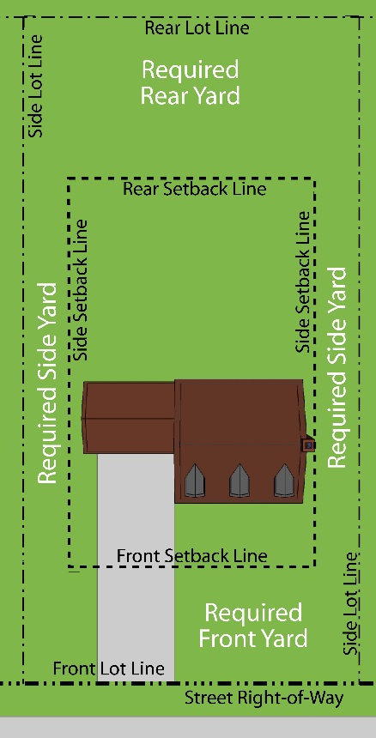
A written authority as issued by the Building Inspector on behalf of the Township permitting the construction, moving, alteration or use of a building in conformity with the provisions of this Ordinance and the Township's Building Code.

BUILDING SETBACK LINES

Lines marking the setback distance from the lot lines which establish the minimum permitted front, side, or rear yards.

- Front Building Setback Line. The line marking the setback distance from the front lot line which establishes the minimum front yard setback area.

- Rear Building Setback Line. The line marking the setback distance from the rear lot line which establishes the minimum rear yard setback area.

- Side Building Setback Lines. Lines marking the setback distance from the side lot lines which establish the minimum side yard setback area.

SECTION 2.04 DEFINITIONS – C

CLINIC

A building or group of buildings where human patients are admitted for examination and treatment by more than one (1) professional, such as a physician, dentist, or the like, except that human patients are not lodged therein overnight.

COMMERCIAL

This term relates to the use of property in connection with the purchase, sale, barter, display, or exchange of goods, wares, merchandise or personal services or the maintenance of service offices or recreation or amusement enterprise or garage/basement sales operating more than twelve (12) days during any one (1) twelve (12) month period.

COMMERCIAL WIRELESS TELECOMMUNICATION SERVICES

Licensed telecommunication services including cellular, personal communication services (PCS), specialized mobilized radio (SMR), enhanced specialized mobilized radio (ESMR), paging, and similar services that are marketed to the general public.

COMMISSION, PLANNING

As used in this Ordinance, this term means the Sullivan Township Planning Commission.

SECTION 2.05 DEFINITIONS – D

DAY CARE, COMMERCIAL

A facility, other than a private residence, receiving minor children or adults for care for periods of less than 24 hours in a day, for more than two (2) weeks in any calendar year. Child care and supervision provided as an accessory use, while parents are engaged or involved in the principal use of the property, such as a nursery operated during church services or public meetings, or by a fitness center or similar operation, shall not be considered Commercial Day Care.

DAY CARE FACILITY

A. FAMILY DAY CARE FACILITY

A single family residence, occupied as such, in which care is provided for more than one (1) but less than (7) minor children or adults for periods of less than twenty four (24) hours per day, unattended by a parent or legal guardian. Care for persons related by blood, marriage or adoption to a member of the family occupying the dwelling is excluded from this definition.

B. GROUP DAY CARE FACILITY

A single family residence, occupied as such, in which care is provided for at least seven (7) but not more than twelve (12) minor children or adults for periods of less than twenty four (24) hours per day, unattended by a parent or legal guardian. Care for persons related by blood, marriage, or adoption to a member of the family occupying the dwelling is excluded from this definition.

DISTRICT, ZONING

A portion of the Township within which certain uses of land and/or buildings are permitted and within which certain regulations and requirements apply under the provisions of this Ordinance.

DRIVEWAY

A means of access from a public or private street that serves a single lot, dwelling unit, or use. [Amended March 7, 2007]

DRIVE-IN ESTABLISHMENT

A commercial establishment whose retail/service character is significantly dependent on providing a driveway approach and service windows or facilities for vehicles in order to serve patrons while in or momentarily stepped away from the vehicle. Examples include banks, cleaners, and restaurants, but not including automobile service stations.

DWELLING, OR DWELLING UNIT

A dwelling unit is any building or portion thereof having cooking and housekeeping facilities, which is occupied wholly as the home, residence or sleeping place of one (1) family, either permanently or transiently, but in no case shall a motor home, trailer coach, garage, automobile chassis, tent, or portable building be considered a dwelling. In case of mixed occupancy, where a building is occupied in part as a dwelling unit, the part so occupied shall be deemed a dwelling unit and shall comply with the applicable provisions of this Ordinance.

DWELLING, MULTIPLE FAMILY

A building or portion thereof, used or designed for use as a residence for three (3) or more families living independently of each other and each doing their own cooking and housekeeping.

DWELLING, TWO-FAMILY

A detached building used or designed for use exclusively by two families living independently of each other and each doing their own cooking and housekeeping. It may also be termed a duplex.

DWELLING, SINGLE FAMILY (DETACHED)

A detached building used or designed for use exclusively by one (1) family.

SECTION 2.06 DEFINITIONS – E

ERECTED

The word “erected” includes built, constructed, reconstructed, moved upon, or any physical operations on the premises required for the building. Excavations, fill, drainage, and the like, shall be considered a part of the term “erect.”

ESSENTIAL SERVICES

The erection, construction, alteration, or maintenance by public utilities or municipal departments or commissions of underground, surface, or overhead gas, electrical, steam, or water transmission or distribution systems, collection, communication supply or disposal systems, including mains, drains, sewers, pipes, conduits, wires, cables, fire alarm boxes, traffic signals, hydrants, towers, poles, and other similar equipment, and accessories in connection therewith reasonably necessary for the furnishing of adequate service by such public utilities or municipal departments or commissions or for the public health or general welfare, but not including buildings other than such buildings as are primarily enclosures or shelters of the above essential service equipment. Cellular telephone or communications towers shall not be considered essential services.

EXCAVATING

Excavating shall be the removal of soil below the average grade of the surrounding land and/or road grade, whichever shall be highest, excepting common household gardening.

SECTION 2.07 DEFINITIONS – F

FAMILY
A. An individual or group of two (2) or more persons related by blood, marriage, or adoption, together with foster children and servants of the principal occupants who are domiciled together as a single housekeeping unit in a dwelling unit; or

B. A collective number of individuals domiciled together in one (1) dwelling unit whose relationship is of a continuing, non-transient domestic character and who are cooking and living as a single nonprofit housekeeping unit. This definition shall not include any society, club, fraternity, sorority, association, half-way house, lodge, coterie, organization, group of students, or other individual whose domestic relationship is of a transitory or seasonal nature, is for an anticipated limited duration of s school term or during a period of rehabilitation or treatment, or is otherwise not intended to be of a permanent nature.

FARM

The use of land for cultivation or for raising of livestock for commercial purposes, including greenhouses, nurseries and orchards, but not including intensive livestock operations, stone quarries, or gravel, dirt, or sand removal operations.

FENCE

This shall mean any structure of wood, metal, masonry, plastic or other synthetic materials designed, used and erected and affixed to the real estate for the purpose of enclosing or separating any portion of the real estate from adjoining land whether or not such fence is located on the boundary line of the property to which it appertains. [Amended April 19, 2005]

FLOOR AREA, GROSS (GFA)

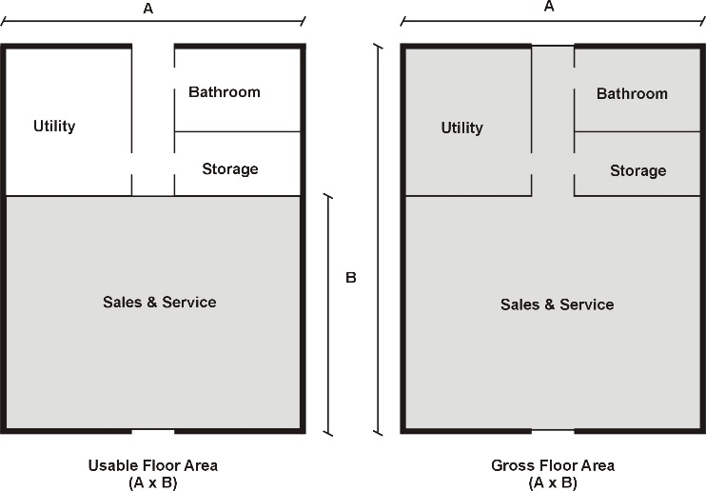
The sum of the gross horizontal area of the several floors of the building measured from the exterior faces of the exterior walls or from the center line of walls separating two (2) buildings. The gross floor area of a building shall include the basement floor area only if more than one-half (½) of the basement height is above finish lot grade. (See Basement.)

Gross floor area shall not include attic space having headroom of seven and one half (7½) feet or less, or interior balconies or mezzanines. Any space devoted to off-street parking or loading shall not be included in floor area. Areas of basements (except as provided above), breezeways, porches, or attached garages are not included.

FLOOR AREA, USABLE (UFA)

That area used for or intended to be used for the sale of merchandise or services, or for use to serve patrons, clients, or customers; or area used in a dwelling unit for living purposes. Floor area which is used or intended to be used principally for the storage or processing of merchandise, for hallways, or for utilities shall be excluded from the computation of usable floor area. Measurement of usable floor area shall be the sum of the horizontal areas of the several floors of the building measured from the interior faces of the exterior walls.

FRONTAGE (See Lot Width)

SECTION 2.08 DEFINITIONS – G

GARAGE, DETACHED

A detached accessory building primarily used for the storage of motor vehicles and incidental storage of goods and materials owned by the occupant of the principal residential dwelling. In the case where a garage is attached to a principal residential dwelling by a breezeway, portico, covered colonnade, or similar architectural element greater 20 feet in length, it is considered a detached garage.

[Amended July 14, 2020]

SECTION 2.09 DEFINITIONS – H

HOME OCCUPATION

An occupation customarily conducted in a dwelling unit that is clearly an incidental and secondary use of the dwelling. Without limiting the foregoing, a single family residence used by an occupant of that residence to give instruction in a craft or fine art within the residence shall be considered a home occupation.

HOSPITAL

An institution providing health services, primarily for in-patients and medical or surgical care of the sick or injured, including as an integral part of the institution, such related facilities as laboratories, out-patient departments, training facilities, central service facilities and staff offices.

HOTEL

A building occupied or used as a predominantly temporary abiding place by individuals or groups of individuals, with or without meals.

SECTION 2.10 DEFINITIONS – I

INOPERATIVE VEHICLES

Any motor vehicle which is currently not capable of being started and safely and properly operated on the highway.

INTENSIVE LIVESTOCK OPERATIONS

A. A total of seven hundred fifty (750) dairy cattle (all classes); seven hundred fifty (750) slaughter or feeder cattle, one thousand eight hundred (1,800) swine (all classes), one hundred thousand (100,000) poultry (all classes); five thousand (5,000) sheep or goats (all classes); or two hundred (200) horses (all classes); or

B. A population per acre of at least four (4) dairy cattle, four (4) slaughter or feeder cattle, twenty (20) swine, seven hundred (700) poultry, ten (10) sheep or goats, or four (4) horses.

SECTION 2.11 DEFINITIONS – J

JUNK

For the purpose of this Ordinance, this term shall mean any motor vehicles, machinery, appliances, products, or merchandise with parts missing; or scrap metals or materials that are damaged or deteriorated; or vehicles or machines in a condition which precludes their use of the purpose for which they were manufactured.

JUNK YARD

The term “junk yard” includes automobile wrecking yards and salvage areas and includes any area of more than two hundred (200) square feet for the storage, sale, processing, keeping or abandonment of junk, including scrap metals, other scrap materials or reclaimed materials, or for the dismantling, demolition, or abandonment of automobiles or other vehicles or machinery or parts thereof for profit, but does not include uses established entirely within enclosed buildings.

SECTION 2.12 DEFINITIONS – K

KENNEL

Any lot or premises on which four (4) or more animals, four (4) months of age or older are kept temporarily or permanently for the purpose of breeding, boarding or sale.

SECTION 2.13 DEFINITIONS – L

LOADING SPACE

An off-street space on the same lot with a building or group of buildings, for temporary parking for a commercial vehicle while loading or unloading merchandise or materials. Off-street loading space is not to be included as off-street parking space in computation of required off-street parking.

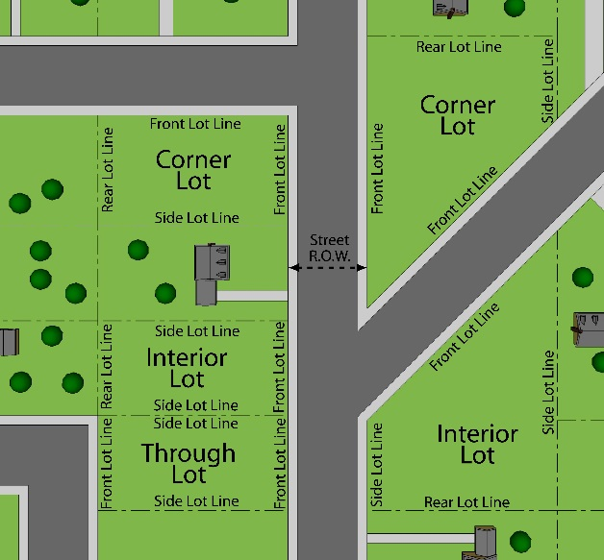
LOT

A parcel of land occupied or intended for occupancy by a use permitted in this Ordinance, including one (1) main building with its accessory buildings, and providing the open spaces, parking spaces, and loading spaces required by this Ordinance. The word “lot” shall include plot or parcel. A lot need not be a “lot of record.” A lot may also mean a portion of a condominium project, as regulated by Public Act 59 of 1978, as amended, designed and intended for separate or limited ownership and/or use.

LOT AREA

The total horizontal area within the lot lines of a lot excluding road right-of-way.
LOT, CORNER

A lot located at the intersection of two (2) streets or a lot bounded on two (2) sides by a curving street, any two (2) cords of which form an angle of one hundred thirty five (135) degrees or less.

LOT COVERAGE

The part or percent of the lot occupied by buildings or structures, including accessory buildings or structures.

LOT, DEPTH

The mean horizontal distance from the front lot line to the rear lot line, or the two (2) front lines of a through lot.

LOT, DOUBLE FRONTAGE (THROUGH)

A lot other than a corner lot having frontage on two (2) more or less parallel streets.

LOT, INTERIOR

A lot other than a corner lot with only one (1) lot line fronting on a street.

LOT LINES
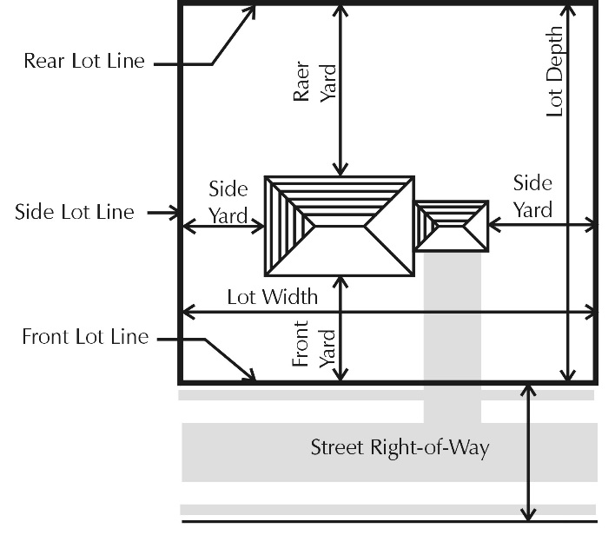
The property lines or other described lines bounding the lot.

- Front Lot Line. In the case of an interior lot, abutting upon one (1) public or private street, the front lot line shall mean the line separating such lot from such street right-of-way.

- Rear Lot Line. Ordinarily, that lot line which is opposite and most distant from the front lot line of the lot. In the case of an irregular or triangular shaped lot, a line at least ten (10) feet in length entirely within the lot parallel to and at the maximum distance from the front lot line of the lot shall be considered to be the real lot line for the purpose of determining depth of rear yard. In cases where none of these definitions are applicable, the Zoning Administrator shall designate the rear lot line.

- Side Lot Line. Any lot line not a front lot line or a rear lot line. A side lot line separating a lot from another lot or lots is an interior side lot line.

- Street Lot Line. A lot line separating the lot from the right-of-way of a street or an alley.

LOT OF RECORD

A lot which actually exists in a subdivision plat as shown on the records of the County Register of Deeds, or a lot or parcel described by metes and bounds, the description of which has been so recorded as required by law.

LOT WIDTH (Frontage)

The horizontal distance between the side lot lines, as measured at the front yard setback line.

SECTION 2.14 DEFINITIONS – M

MANUFACTURED HOME

A residential building, dwelling unit, dwelling room or rooms, or a building component which is designed for long term occupancy as a dwelling unit or portion of a dwelling unit, and is wholly or substantially constructed at an off-site location, transported to a site and erected. The term includes the terms “mobile home” or “modular home.”

MANUFACTURED HOME PARK

A parcel or tract of land under the control of a person upon which two (2) or more manufactured homes are located on a continual, non-recreational basis and which is offered to the public for that purpose regardless of whether a charge is made therefor, together with any building, structure, enclosure, street, equipment, or facility used or intended for use incident to the occupancy of a manufactured home.

MANUFACTURED HOME SPACE

A plot of ground within a manufactured home park designed for the accommodation of one (1) manufactured home.

MASTER PLAN

The Master Plan currently adopted by Sullivan Township, including graphic and written materials, indicating the general location for streets, parks, schools, public buildings, and all physical development of the Township, and includes any unit or part of such plan and any amendment to such plan.

MEDICAL MARIHUANA DISPENSARY

Any business, facility, association, cooperative, location, or operation, whether fixed or mobile, where medical marihuana is made available to, sold, grow, processed, delivered, or distributed by or to one or more of the following:

  - A primary caregiver (as defined by Michigan Initiated Law 1 of 2008, as amended, being MCL 333.26421, et seq., as amended).

  - A qualifying patient (as defined by initiated Law 1 of 2008, as amended, being MCL 333.26421, et seq., as amended).
  - Member of the public

A medical marihuana dispensary shall also include any place, location, facility, or operation, whether fixed or mobile, where medical marihuana is smoked or consumed where either three or more persons are present and smoking or consuming medical marihuana or such medical marihuana smoking or consumption is occurring on the property of a business, association, cooperative, or commercial operation or facility.

A medical marihuana dispensary shall not include the lawful dispensation of medical marihuana by a primary caregiver personally dispensing to not more than five (5) qualified patients (as defined by Michigan Initiated Law 1 of 2008, as amended, being MCL 333.26421, et seq., as amended) so long as the primary caregiver personally delivers the lawful amount of medical marihuana to the qualifying patient where the qualifying patient resides and it is done in full compliance with not only this Ordinance and any other applicable Sullivan Township ordinances, but also all applicable Michigan and federal laws and regulations.

[Amended December 22, 2011]

MOTEL

A series of attached, semi-attached, or detached rental units providing overnight lodging for transients, open to the traveling public for compensation.

MOTOR HOME

A motorized vehicular unit primarily designed for temporary dwelling in connection with travel and/or recreational usage. This term does not include manufactured homes.

SECTION 2.15 DEFINITIONS – N

NONCONFORMING BUILDING

A building or portion thereof lawfully existing at the effective date of this Ordinance or amendments thereto, and which does not conform to the provisions of the Ordinance in the Zoning District in which it is located.

NONCONFORMING LOTS OF RECORD

A platted lot that conformed with all Township zoning requirements at the time of recording of said plat, which no longer conforms to the zoning regulations and requirements for lot area, lot width, or both; or a lot outside a recorded plat that conformed with all Township zoning requirements at one time, and which has not been subdivided or reduced in size subsequent to the time it did conform to the Zoning Ordinance, which no longer conforms with the zoning requirements for lot area, lot width, or both.

NONCONFORMING USE

A use which lawfully occupied a building or land at the effective date of this Ordinance or amendments thereof, and that does not conform to the use regulations of the Zoning District in which it is located.

NONRESIDENTIAL DISTRICT

The Neighborhood Commercial (NC), Sullivan Corners (SC), or Light Industrial (LI) Zoning Districts.

NURSING HOME

A home for the care of the aged or infirm, or a place of rest for those suffering bodily disorders, wherein persons are provided care for compensation. Said home shall conform to, and qualify for, license under applicable State law.

SECTION 2.16 DEFINITIONS – O

OPEN AIR BUSINESS

Uses operated substantially in the open air, including, but not limited to:

- Bicycle, utility truck or trailer, motor vehicle, boats, or home equipment sale, repair, rental, or storage services.

- Outdoor display and sale of garages, motor homes, manufactured homes, snowmobiles, farm implements, swimming pools, and similar activities.

- Retail sale of trees, fruits, vegetables, shrubbery, plants, seeds, topsoil, humus, fertilizer, trellises, lawn furniture, playground equipment, and other home garden supplies and equipment.

- Tennis courts, archery courts, shuffleboard, horseshoe courts, rifle ranges, miniature golf, golf driving ranges, children's amusement park or similar recreation uses (transient or permanent).

SECTION 2.17 DEFINITIONS – P

PARKING LOT

A facility providing vehicular parking spaces, along with adequate drives, aisles, and maneuvering space to allow unrestricted ingress and egress to at least two (2) vehicles.

PARKING SPACE

An off-street space of at least one hundred eighty (180) square feet exclusive of driveways, aisles, or maneuvering areas, suitable to accommodate one (1) motor vehicle and having direct unobstructed access to a street or alley.

PERSONAL SERVICE ESTABLISHMENTS

Any commercial business conducting services that are performed primarily on the premises.

PLANNED UNIT DEVELOPMENT

A development of land that is planned and developed as a whole in a single development operation or programmed series of development stages. The development may include streets, circulation ways, utilities, buildings, open spaces, and other site features and improvements.

POND

An outdoor body of standing water, accumulated in a natural or artificially constructed basin or depression on any Lot or parcel of land, either above or below or partially above or partially below grade, capable of holding water to a depth of greater than two (2) feet when filled to capacity. [Amended Oct. 3, 2023]

PORCH, ENCLOSED

A covered entrance to a building or structure which is totally enclosed, and projects out from the main wall of said building or structure and has a separate roof or an integral roof with the main building or structure to which it is attached.

PORCH, OPEN

A covered entrance to a building or structure which is unenclosed except for columns supporting the porch roof, and projects out from the main wall of said building or structure and has a separate roof or an integral roof with the main building or structure to which it is attached.

PUBLIC UTILITY

Any person, firm, corporation, municipal department, board, or commission duly authorized to furnish, under Federal, State or municipal regulations, to the public, electricity, gas, steam, communications, telegraph, transportation, or water services.

SECTION 2.18 DEFINITIONS – R

RECREATION VEHICLE OR EQUIPMENT

A vehicle or equipment intended for temporary or periodic use for recreational or leisure pursuits. Such vehicles shall include boats, airplanes, special purpose automobiles, floats, rafts, trailers, snowmobiles, camping or travel trailers, motorized homes, detachable travel equipment of the type adaptable to light trucks, and other equipment or vehicles of a similar nature.

RESIDENTIAL DISTRICT

Residential District shall refer to the Rural Residential/Agricultural (R-A), Low Density Residential (R-1), Medium Density Residential (R-2), High Density Residential (R-3), and Manufactured Home Park (R-4) Zoning Districts, as described in this Ordinance.

ROADSIDE STAND

A farm building or separate structure used for the display or sale of agricultural products grown on the premises upon which the stand is located.

SECTION 2.19 DEFINITIONS – S

SALVAGE YARD
An open space where waste, surplus, discarded, or salvaged materials are brought, sold, exchanged, stored, baled, cleaned, packed, disassembled, or handled, including house wrecking and structural steel materials and equipment and automobile wrecking.

SATELLITE DISH ANTENNA, OR DISH ANTENNA

An apparatus capable of receiving communications from a transmitter or a transmitter relay located in planetary orbit.

SEASONAL WORKER CAMP

Also known as an agricultural labor camp by the State of Michigan, means a tract of land and all tents, vehicles, buildings, dwellings, or other structures pertaining thereto, part of which is established, occupied, or used as living quarters for seasonal and migratory laborers engaged in agricultural activities, including related food processing. [Amended June 14, 2016]

SEASONAL WORKER CAMP OPERATOR

A person who owns, establishes, operates, conducts, manages, or maintains a seasonal worker camp or who causes or permits the occupancy or use of a seasonal worker camp whether or not rent is charged for housing and facilities. [Amended June 14, 2016]

SETBACK; SETBACK AREA

The minimum required horizontal distance measured from the front, side, or rear lot line, as the case may be, which describes an area termed the required setback area on a lot or parcel.

SIGNIFICANT NATURAL FEATURE

Any natural area as designated by the Planning Commission, Township Board, or the Michigan Department of Natural Resources, or other appropriate governmental agency which exhibits unique topographic, ecological, hydrological, or historical characteristics such as a wetland, floodplain, water features, or other unique natural features.

SOLAR ENERGY COLLECTOR

A panel or structure containing solar (photovoltaic) cells that collect sunlight and convert it to electric current; including all batteries, wiring and electrical equipment appurtenant to the collection system. [Amended September 20, 2012]

STATE LICENSED RESIDENTIAL FACILITY

A residential care facility licensed by the State of Michigan under Act 218 of 1979 of the Public Acts of Michigan, as amended, or Act 116 of 1973 of the Public Acts of Michigan, as amended, which provides resident care services under twenty four (24) hour supervision or care for persons in need of that supervision or care. This term does not include to such facilities licensed by the State of Michigan for care and treatment of persons released from or assigned to adult correctional institutions. [Amended March 7, 2007]

- A Family Facility includes a state licensed residential facility providing resident services to six (6) or fewer persons.

- A Group Facility includes a state licensed residential facility providing resident services to more than six (6) persons.

STORY

That portion of a building, other than a basement or mezzanine, included between the surface of any floor and the floor next above it, or if there is no floor above it, then the space between the floor and the ceiling next above it. For the purpose of this Ordinance, a basement or cellar shall be counted as a story only if over fifty percent (50%) of its height is above the level from which the height of the building is measured, or, if it is used for business purposes.

STORY, HALF

That part of a building between a pitched roof and the uppermost full story, said part having a floor area which does not exceed one-half (½) the floor area of said full story, provided the area contains at least two hundred (200) square feet and which contains a clear height of at least seven and one-half (7½) feet, at its highest point.

STREET, PRIVATE

A privately owned and maintained thoroughfare including any rights-of-way and traveled surfaces which afford traffic circulation and principal means of access to abutting property, including avenue, place, way, drive, lane, boulevard, highway, road and other thoroughfare. A private street shall include any drive or roadway which is not a dedicated public right-of-way, and which provides or has the potential for providing access to two (2) or more existing parcels and/or main buildings. [Amended April 19, 2005]

STREET, PUBLIC

A public thoroughfare including any rights-of-way and traveled surfaces which afford traffic circulation and principal means of access to abutting property, including avenue, place, way, drive, lane, boulevard, highway, road, and other thoroughfare; except an alley.

STRUCTURE

Anything constructed or erected, the use of which requires location on the ground or attachment to something on the ground.

SUBSTANTIAL IMPROVEMENT

Any repair, reconstruction or improvement of a structure, where costs equal or exceed fifty percent (50%) of the market value of the structure either before improvement or repair is started or if the structure has been damaged and is being restored before the damage occurred. For the purposes of this definition, "substantial improvement" is considered to occur when the first alteration of any wall, ceiling, floor, or other structural part of the building commences, whether or not that alteration affects the external dimensions of the structure.

The term does not, however, include either any project for improvement of a structure to comply with existing state or local health, sanitary or safety code specifications which are solely necessary to assure safe living conditions, or any alteration of a structure listed on the National Register of Historic Places or the Michigan Register of Historic Places.

SECTION 2.20 DEFINITIONS – T

TEMPORARY BUILDING OR USE

A structure or use permitted by the Zoning Administrator to exist during periods of construction of the main building or for special events as permitted by this Ordinance.

TRAVEL TRAILER

A vehicular, portable unit built on a chassis designed to be used as a temporary dwelling for travel and recreational purposes, not exceeding eight (8) feet in width or thirty five (35) feet in length. It includes folding campers and truck mounted campers.

SECTION 2.21 DEFINITIONS – U

USES, ADULT

The term shall include adult book stores, adult cabarets, adult motion picture theaters, massage establishments, and nude artist and photography studios. These terms shall have the following indicated meanings:

A. Adult Book Store

An establishment having as a substantial or significant portion of its stock in trade, books, magazines, and other periodicals which are distinguished or characterized by their emphasis on matter depicting, describing or relating to “specified sexual activities” or “specified anatomical areas”, as defined herein, or an establishment with a segment or section devoted to the sale or display of such material.

B. Adult Cabaret

An establishment including, but not limited to, a cafe, restaurant or bar which features go-go dancers, erotic dancers, strippers, male or female impersonators, or similar entertainers.

C. Adult Motion Picture Theater

An establishment used for presenting material distinguished or characterized by an emphasis on matter depicting, describing, or relating to “specified sexual activities” or “specified anatomical areas,” as defined herein, for observation by patrons therein.

D. Massage Establishment

Any establishment having a fixed place of business where massages are administered by pay, including but not limited to massage parlors, health clubs, sauna baths, and steam baths. This definition shall not be construed to include a hospital, nursing home, medical clinic, or the office of a physician, surgeon, chiropractor, osteopath, or physical therapist duly licensed by the State of Michigan, nor barber shops or beauty salons in which massages are administered only to the scalp, the face, the neck or the shoulder. This definition shall not be construed to include a non-profit organization operating a community center, swimming pool, tennis court, or other educational, cultural, recreational, and athletic facilities for the welfare of the residents of the area. A Massage is defined as a method of treating the external parts of the human body by rubbing, stroking, kneading, tapping or vibrating with the hand or any instrument.

E. Nude Artist and Photography Studio

Any building, structure, premises or part thereof used solely or primarily as a place which offers as its principal activity the providing of models to display “specified anatomical areas” as defined herein for artists and photographers for a fee or charge.

F. Specified Anatomical Areas

Specified anatomical areas are defined as less than completely and opaquely covered:

1. Human genitals, pubic region, buttock, and female breast below a point immediately above the top of the areola; and
2. Human male genitals in a discernible turgid state, even if completely and opaquely covered.

G. Specified Sexual Activities

Specified sexual activities are defined as:

  - Human genitals in a state of sexual stimulation or arousal;
  - Acts of human masturbation, sexual intercourse or sodomy;
  - Fondling or other erotic touching of human genitals, pubic region, buttock or female breast.

USE, PRINCIPAL

The primary purpose for which land or premises, or a building thereon, is designed, arranged, or intended, for which it is occupied, or maintained, let, or leased.

SECTION 2.22 DEFINITIONS – V

VEHICLE REPAIR

Any major activity involving the general repair, rebuilding or reconditioning of motor vehicles, engines, or trailers; collision services, such as body, frame, or fender straightening and repair; overall painting and vehicle rust proofing; refinishing or steam cleaning.

VEHICLE SERVICE STATION

A building and lot or parcel designed or used for the retail sale of fuel, lubricants, air, water or other operating commodities for motor vehicles (including trucks, aircraft and boats) and including the customary space and facilities for the installation of such commodities on or in such vehicles and including space for storage, hand washing, minor repair, and servicing, but not including vehicle repair as defined in this Chapter.

VEHICLE WASH ESTABLISHMENT

A building, or portion thereof, the primary purpose of which is that of washing motor vehicles.

SECTION 2.23 DEFINITIONS – W
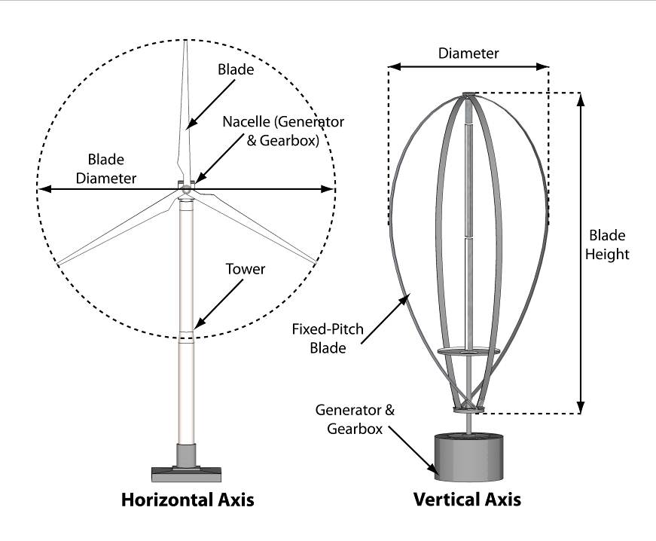
Wind Energy Conversion Systems
WIND ENERGY CONVERSION SYSTEM (WECS):

- A wind energy conversion system (see graphic) is a combination of:

  - A surface area (typically a blade, rotor, or similar device), either variable or fixed, for utilizing the wind for electrical power; and
  - A shaft, gearing, belt, or coupling utilized to convert the rotation of the surface area into a form suitable for driving a generator, alternator, or other electricity-producing device; and
  - The generator, alternator, or other device to convert the mechanical energy of the surface area into electrical energy, generally housed in a nacelle; and
  - The tower, pylon, building mount or other structure upon which any, all, or some combination of the above are mounted.
  - Other components not listed above but associated with the normal construction, operation, and maintenance of a WECS.
  - A WECS may have a horizontal axis, with a rotor that spins perpendicular to the ground, or a vertical axis, with a rotor that spins parallel to the ground.

- Commercial WECS

Any WECS within a wind farm or any other WECS meant to provide power which is utilized off the site on which the WECS is located.

- On-site Service WECS

A single WECS placed upon a lot or parcel with the primary intent to service the energy needs of only the structures and uses on the same lot or parcel.

- WECS Height

The distance measured between the ground (at normal grade) and the highest point of a WECS. For a horizontal axis WECS, the measurement shall be to the tip of the rotor blade when the blade is in the full vertical position. The height of a building mounted WECS shall be measured from the grade of the building upon which it is attached to the highest point of the WECS as described above.

- WECS Testing Facility: A structure and equipment used to determine the potential for the placement of a WECS.

Wind Farm: Clusters of two (2) or more WECS placed upon a lot or parcel with the intent to sell or provide electricity to a site or location other than the premises upon which the WECS are located. The WECS facilities may or may not be owned by the owner of the property upon which the WECS is placed. [Amended September 20, 2012]

SECTION 2.24 DEFINITIONS – Y

YARD

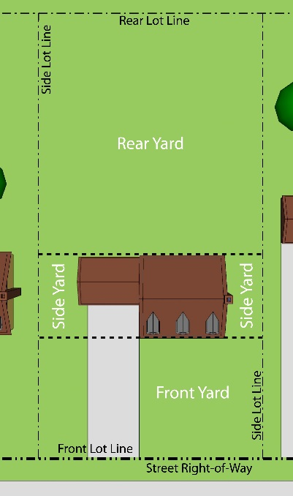
A yard is an open space on the same land with a building or group of buildings, which open space lies between the building or group of buildings and the nearest lot line and is unoccupied and unobstructed from the ground upward, except as otherwise provided herein.

- A Front Yard is an open space extending the full width of the lot, the uniform depth of which is measured at right angles to the front lot line.

- A Rear Yard is an open area extending across the full width of the lot, the uniform depth of which is measured at right angles to the rear lot line.

- A Side Yard is an open unoccupied area between a main building and the side lot lines, extending from the front yard area to the rear yard area. The width of the side yard shall be measured horizontally from and at right angles to the nearest point of the side lot line.

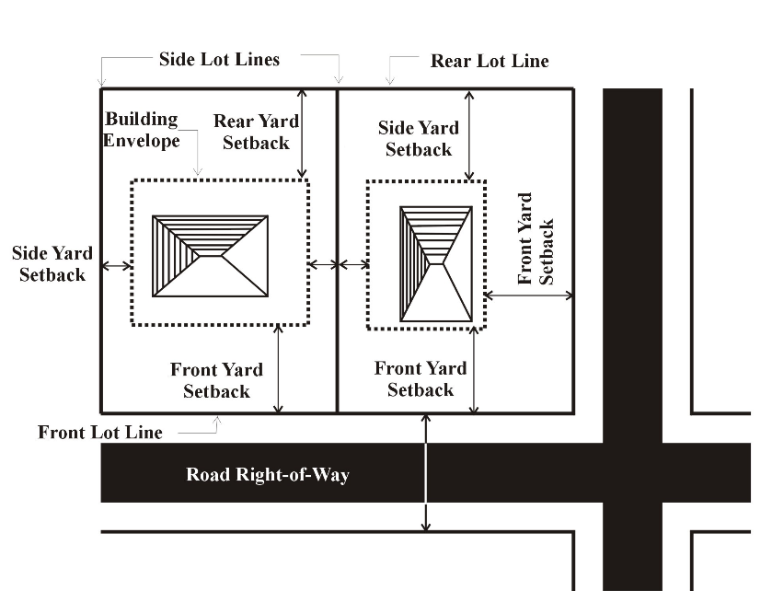
YARD, REQUIRED

The required yard shall be that set forth in the applicable chapters of the Sullivan Township Zoning Ordinance as the minimum yard requirement for each zoning district.

SECTION 2.25 DEFINITIONS – Z

ZONING ACT

The Michigan Zoning Enabling Act, Act 110 of 2006 of the Public Acts of Michigan, as amended. [Amended March 7, 2007]

ZONING ADMINISTRATOR

The person designated by the Township Board to administer the provisions of this Zoning Ordinance.

ZONING BOARD OF APPEALS, OR BOARD.

The Zoning Board of Appeals of Sullivan Township.

CHAPTER 3
GENERAL PROVISIONS

SECTION 3.01 REQUIRED AREA, SPACE, AND USE CONDITIONS AND EXCEPTIONS

- No lots or lots in common ownership and no yard, parking area or other space shall be so divided, altered or reduced as to make such area or dimension less than the minimum required under this Ordinance. If already less than the minimum required under this Ordinance, said area or dimension shall not be further divided or reduced.

- A lot which is platted, or otherwise lawfully of record as of the effective date of this Ordinance, may be used as specified in the District in which it is located, provided the lot conforms to the requirements of the Muskegon County Health Department. The main building on such lot shall be located so that it meets the yard setback requirements of the zone district in which it is located.

- If two (2) or more lots of record or combination of lots and portions of lots of record, in existence at the time of the passage of this Ordinance, or an amendment thereto, are:

  - in common ownership;
  - adjacent to each other or have continuous frontage, and;
  - individually do not meet the lot width or lot area requirements of this Ordinance,

the lands involved shall be considered to be an undivided parcel for the purposes of this Ordinance. Such parcels shall be combined into such lot or lots meeting the lot width and lot size requirements of this Ordinance. No portion of such parcel shall be used or divided in a manner which diminishes compliance with lot width and area requirements of this Ordinance.

SECTION 3.02 HEIGHT EXCEPTIONS

- The following buildings and structures shall be exempt from height regulations in all Districts: parapet walls not exceeding four (4) feet in height, chimneys, cooling towers, elevator bulkheads, fire towers, grain elevators, silos, stacks, elevated water towers, stage towers, scenery lofts, monuments, cupolas, domes, spires, penthouses housing necessary mechanical appurtenances, wind powered electrical generator, and television and radio reception and transmission antennas, and towers for commercial wireless telecommunication services which do not exceed one hundred (100) feet in height.

- Additions to existing buildings and structures which now exceed the height limitations of their District may be constructed to the height of the existing building to which the addition is attached if the lot is large enough to encompass a circular area with a radius at least equal to the height of the tallest structure or building.

SECTION 3.03 PRINCIPAL USE

- No lot or parcel of land shall contain more than (1) main building or one (1) principal use.

- Land and buildings may be considered a principal use collectively if the following conditions are met.

  - The land and buildings are planned and designed as a single integral development, including joint parking, compatible architecture, shared driveways, shared signs, and other similar features.
  - All uses, if not the same, shall be similar in function and/or operation.

SECTION 3.04 STREET ACCESS

Any lot of record created after the effective date of this Ordinance shall front upon a public street or private street right-of-way meeting the requirements of Section 3.26 for the minimum lot width required by this Ordinance.
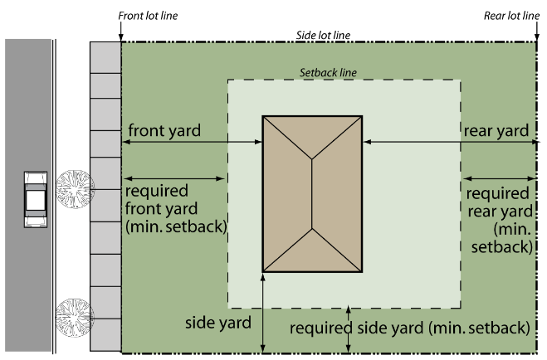

SECTION 3.05 BASIS OF DETERMINING FRONT YARD REQUIREMENTS

- The front yard setback line shall be measured from the right-of-way line or property line, to an imaginary line across the width of the lot drawn at the minimum required front setback distance for that district, excepted as noted in Section 3.05.B.
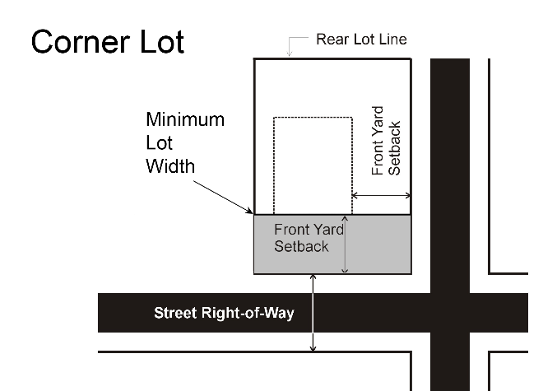
- Where an average setback line less than that required by this Ordinance has been established by existing buildings located within two hundred (200) feet of the proposed building on the same side of the street, such average setback shall apply.

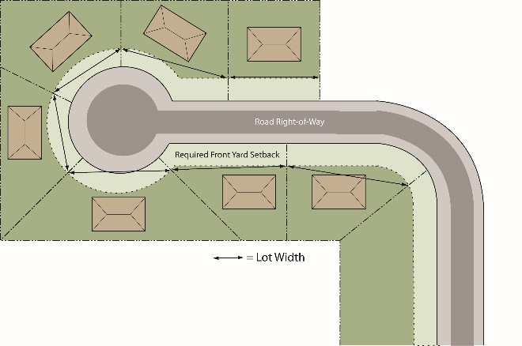
- On corner and through lots, the front yard requirements shall apply on both streets. In the case of a row of double frontage lots, one (1) street will be designated as the front street for all lots. If there are existing structures in the same block fronting on one (1) or both of the streets, the required front yard setback shall be observed on those streets where such structures presently front.
Cul-de-Sac

SECTION 3.06 MINIMUM LOT WIDTH FOR IRREGULAR SHAPED LOTS

The minimum lot width for a lot on a cul-de-sac or other irregularly shaped lot shall be measured at the front yard setback line and shall not be diminished throughout the rest of the lot. Such lots shall have a minimum lot width of forty (40) feet at the front property line.

SECTION 3.07 PROJECTIONS INTO YARDS

- Architectural features may project a maximum of four (4) feet into a front or rear yard setback area, but shall not project into the side yard setback.

- Porches, terraces, decks, balconies, window awnings, and similar structures which are open on all sides, unenclosed, and uncovered:

  - may project a maximum of ten (10) feet into a front yard setback area;
  - may project a maximum of fifteen (15) feet into a rear yard setback area; but
  - shall not project into a side yard setback area; nor
  - be placed closer than ten (10) feet to any front or rear lot line.

- If such structures are permanently enclosed on any side or covered in any manner they shall be considered part of the main building.

SECTION 3.08 ACCESSORY BUILDING AND USES

- Accessory buildings attached to dwellings or other main buildings, including enclosed porches and garages, shall be deemed a part of such buildings and must conform to all regulations of this Ordinance applicable to such main buildings.
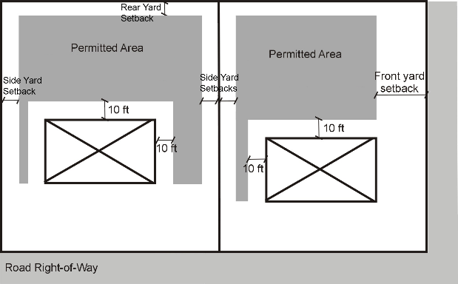
- On corner lots, where the side lot line is a continuation of the front lot line of the lot to its rear, accessory buildings or uses shall be located no nearer than the front yard setback line of the lot behind the corner lots.

- An accessory building or use shall only be permitted on lot which contains a principal use or main building. Buildings related to active farming operations are exempt from this requirement.

- No part of an accessory building shall be used as a dwelling for residential purposes.

- Detached accessory buildings shall be located:

  - a minimum of ten (10) feet from any main building;
  - at the same front yard setback as required for the main building,
  - for buildings of less than one thousand (1,000) square feet GFA: a minimum of fifteen (15) feet to any side or rear lot line;
  - for buildings greater than one thousand (1,000) square feet GFA: a minimum of thirty (30) feet to any side or rear lot line.

- Side yard setbacks shall be measured to the eaves of the building.

- Maximum floor area and height of detached accessory buildings and detached garages are subject to the requirements of this section.

  - Maximum floor area and height (as measured from the ground to the highest point of the roof) for buildings accessory to single and two family dwellings are subject to the following requirements:

Lot Size | Maximum Square Footage and Height by Zoning District
 | R-A, R-R, R-1, R-2 | R-3
Less than one (1) acre | 800 s.f., 26 ft. in height | 800 s.f., 14 ft. in height
1-2.99 acres | 1,400 s.f., 26 ft. in height | 960 s.f., 14 ft. in height
3-4.99 acres | 1,800 s.f., 26 ft. in height | 960 s.f., 14 ft. in height
5-9.99 acres | 2,800 s.f., 26 ft. in height | 960 s.f., 14 ft. in height
10-19.99 acres | 3,000 s.f., 26 ft. in height | 960 s.f., 14 ft. in height
20 acres or more | 3,800 s.f., 26 ft. in height | 960 s.f., 14 ft. in height

  - The first 800 square feet of floor area of a detached garage, as defined, shall not count against the maximum square footage of floor area required by this section.
  - Maximum floor areas for buildings accessory to other uses:

    - Buildings accessory to agricultural operations: no size limitation.
    - Multiple family developments: nine hundred sixty (960) square feet, excluding garages for the use of residents.
    - Manufactured home parks: as required by Chapter 9.
    - Other uses in Nonresidential Districts and nonresidential uses in Residential Districts: not to exceed twenty five percent (25%) of the floor area of the main building(s).

  - A lot or parcel with one or more detached accessory buildings shall not be reduced to a size that would create nonconforming detached accessory building square footage.
  - Requests for oversized detached accessory buildings shall be reviewed by the Planning Commission and may be approved in accordance with this section. In addition to any other conditions that may be appropriate, the Planning Commission may increase minimum setbacks or require adjustment to the proposed location of the oversized accessory buildings as a condition of approval. When considering oversized detached accessory building square footage, the following factors shall be considered:

    - The intended use of the detached accessory building(s) is a permitted or special land use authorized within the applicable zoning district.
    - The size, type of construction, and general architectural character of the detached accessory building(s) are compatible with buildings in the vicinity.
    - The resulting increase of size and scale of the detached accessory building(s) does not result in a visible impact that is overly obtrusive to neighboring residents.
    - Proposed setbacks from lot lines and separation from dwellings on the adjacent properties are appropriate based on the size and scale of the proposed detached accessory building(s).
    - If the property is divided in the future, the location of the detached accessory building(s) shall not impact the ability to divide the land in a compliant manner while maintaining required setbacks from the building(s).
    - The increase in square footage does not result in adverse stormwater runoff impact and degradation of sensitive natural resources.

  - Detached garages shall be constructed to be compatible with the principal dwelling, including but not limited to architectural character, building materials, and construction type.
  - A heating wood storage shelter, not greater than 200 square feet, with no more than three sides walls and used exclusively for heating wood shall be exempt from total accessory building maximum footage.

[Amended July 14, 2020]

- Accessory buildings used for agricultural operations are not subject to the maximum area or height requirements. Accessory buildings in Nonresidential Districts may be constructed to the permitted maximum height for the zoning district in which it is located and are not subject to the maximum area requirements.

[Amended July 14, 2020]

SECTION 3.09 REGULATIONS APPLICABLE TO ALL SINGLE FAMILY DWELLINGS

It is the intent of this Section to establish minimum standards of construction and appearance for all single family dwellings placed in the Township, whether constructed on a lot or a manufactured home. Construction and/or placement of a single family dwelling on any lot or parcel shall be permitted only if the dwelling complies with all of the following standards:

- If the dwelling unit is a manufactured home, the manufactured home must either be:

  - new and certified by the manufacturer and/or appropriate inspection agency as meeting the Mobile Home Construction and Safety Standards of the U.S. Department of Housing and Urban Development of 1976, as amended, or any similar successor or replacement standards which may be promulgated; or
  - used and certified by the manufacturer and/or appropriate inspection agency as meeting the standards referenced in subsection (1) above, and found, on inspection by the Building Inspector or his designee, to be in excellent condition and safe and fit for residential occupancy.

- The dwelling unit shall comply with all applicable building, electrical, plumbing, fire energy and other similar codes which are or may be adopted by the Township, and with applicable federal or state standards or regulations for construction. Appropriate evidence of compliance with such standards or regulations shall be provided to the Building Inspector.

- The dwelling unit shall comply with all restrictions and requirements of this Ordinance, including, without limitation, the lot area, lot width, residential floor area, yard, and building height requirements of the District in which it is located.

- The dwelling unit shall be firmly attached to a permanent continuous foundation which complies with applicable provisions of the building code adopted by the Township.

- If the dwelling unit is a manufactured home, the manufactured home shall be installed with the wheels and towing mechanism removed.

- The dwelling unit shall have a minimum horizontal dimension across any front, side or rear elevation of twenty (20) feet at time of manufacture, placement or construction.

- The dwelling unit shall be connected to public sewer and water supply systems, or to private facilities for potable water and disposal of sewage approved by the Muskegon County Health Department.

- The foregoing standards shall not apply to a manufactured home located in a manufactured home park licensed by the Michigan Mobile Home Commission and approved by the Township according to the provisions contained in Chapter 9 of this Ordinance except to the extent required by state or federal law.

SECTION 3.10 TEMPORARY USES OR BUILDINGS REQUIRING ZONING ADMINISTRATOR AUTHORIZATION

- Upon application, the Zoning Administrator may issue a permit for the following temporary buildings or uses. Each permit shall specify a location for such building or use and shall be valid for a period of not more than twelve (12) calendar months. Permits may be renewed by the Zoning Administrator for one (1) additional successive period of six (6) calendar months or less at the same location and for the same purpose.

  - Temporary office building or construction yard incidental and necessary to construction at the site where located.
  - Temporary sales office or model home incidental and necessary for the sale or rental of real property in a new subdivision or housing project. In any case, such temporary office or model home shall be removed when fifty percent (50%) or more of the lots or units have been sold or leased.

- The Zoning Administrator may issue a permit to an individual to park and occupy a temporary manufactured home in any Residential District only after finding the conditions outlined in subsection 3.10. B.1-.10, below, to be true. Such permit shall be valid for a period of not more than six (6) calendar months. However, permits may be renewed by the Zoning Administrator for one (1) additional successive period of two (2) calendar months or less at the same location and for the same purpose.

  - The manufactured home will be used only as a temporary dwelling for the property owner while they are constructing a permanent residence.
  - A building permit has been issued for the construction of a permanent residence to the individual applying for the temporary dwelling permit, and construction of the permanent residence shall be significantly underway, so that the Zoning Administrator is reasonably satisfied that is will be completed within the time limited by the building permit.
  - The manufactured home dwelling meets the requirements of the Muskegon County Health Department and all applicable Township ordinances.
  - The temporary dwelling is sufficiently secured to the ground to prevent overturning through the actions of high winds or other natural conditions.
  - A performance guarantee may be required as outlined in Section 17.08.
  - In considering authorization for any temporary uses or structures, the Zoning Administrator shall consider the following standards:

    - That there will be no unsanitary conditions or other detrimental effects upon the property, occupants, or adjacent properties;
    - That, in the case of occupancy during construction, the use or structure is reasonably necessary for the convenience and safety of the construction proposed;
    - That the use or structure does not impact the nature of the surrounding neighborhood;
    - That access to the use, area, or structure is located at the least offensive point on the property; and
    - That a hardship exists which necessitates the use of a temporary structure during construction of a permanent structure.

  - The Zoning Administrator may attach reasonable conditions to temporary uses or structures to ensure that the standards of this Section are met.
  - All temporary dwellings, buildings, and uses shall be removed from the premises following the expiration of the permit and any extensions, or upon completion of the permanent building or structure, whichever first occurs.
  - A performance guarantee may be required as outlined in Section 17.08, to ensure the proper removal of the temporary dwelling, following the expiration of the permit and any extensions, or upon completion of the permanent building or structure.
  - Upon applying for a temporary manufactured home permit, the applicant shall pay a fee to the Township Treasurer as determined by the Township Board. The fee shall also be collected for any extensions granted by the Zoning Administrator.

SECTION 3.11 FENCES

- Definition: See Section 2.07, Fence

- General Requirements for Fences

No fence shall be installed, erected, and/or maintained except in strict compliance with the following requirements:

  - Metal Fences – shall consist of materials manufactured and/or treated in a manner to prevent rust and corrosion.
  - Wood Fences – shall be constructed of materials which are painted, stained or naturally preserved in a manner to maintain the fence in good structural condition and with an appearance that is aesthetically pleasing.
  - Plastic or Synthetic Material Fences – where any of these materials are used as a fence, or part thereof, materials shall be treated and maintained in a manner to maintain the fence in good structural condition and with an appearance that is aesthetically pleasing. Further, such materials shall be of a design and constructed or integrated with the fence to which they are a part in a manner that will not be destroyed or torn apart from the fence by climatic elements. For example, metal or synthetic material slats inserted in a fence shall be done in a manner not to allow them to be blown away, or removed by wind or other weather conditions.
  - Masonry Fences – shall be constructed in a neat and workmanship manner.
  - Barbed Wire or Electrically Charged Fences – no fence shall contain any barbed wire or electrification unless necessary for agricultural purposes or for security in a Nonresidential District or for the protection of public utility buildings or improvements. The barbed portion of a security fence shall be at least six (6) feet from the ground, in which case the height of a fence may extend to a maximum of seven (7) feet.
  - Living Fences (hedges, shrubbery, etc.) – obscuring walls, berms or signs, located in a required front yard setback, that may obstruct the vision of traffic for persons exiting from a driveway, alley, etc., shall not exceed a height of three (3) feet.
  - Swimming Pool Fences – Reference Section 3.30.D.
  - Unless specifically provided for elsewhere in this Ordinance, a fence may not exceed a height of three (3) feet within any front yard setback area, or a height of six (6) feet in any other area, except as noted in Section 3.11.B.5 and B.7.
  - Fences used to enclose vacant land or land used for agricultural purposes may be erected within any yard up to a height of six (6) feet. Such fences shall be of an open type so as to not obstruct vision.
  - Fences shall not be constructed in any public right-of-way.
  - Grade – fences shall be constructed at or near the grade of surrounding land.
  - Finish – surface finishes on any fence shall be non-glare and non-reflective.
  - Maintenance of Fences – all fences shall be maintained in a manner to prevent rust, corrosion and deterioration so as to not become a public or private nuisance, dilapidated or a danger to adjoining property owners and the public.
  - Existing Fences – any fence existing upon the effective date of this Ordinance may not be enlarged, extended or replaced except in compliance with this Ordinance.
  - The Zoning Administrator may permit the construction of customary or necessary fences, which enclose tennis courts or other areas of sport activity where such fences will not impede vision or unnecessarily block the view from any adjacent property.

- Materials and Appearance for Fences

  - It shall be unlawful to erect a fence of objectionable appearance, consisting or constructed of tires, vehicle or motor vehicle component parts, tree stumps, rotting lumber or any materials capable of providing habitat or harborage for pests or vermin. It shall also be unlawful to erect a fence constructed or consisting of refuse, rubbish, trash or junk as defined by the Sullivan Township’s Refuse, Storage and Disposal Ordinance #11, adopted July 1987.

[Amended April 19, 2005)

SECTION 3.12 GREENBELTS AND LANDSCAPING

- In order to provide protective screening for Residential Districts or uses adjacent or near Nonresidential Districts or uses, a landscaped greenbelt may be required by the Township to be installed on the Nonresidential District or use property. The greenbelt shall be a strip at least ten (10) feet in width planted and maintained with evergreens, such as spruce, pines, or firs at least five (5) feet in height, or a hedge of evergreens at least four (4) feet in height, at time of planting, and situated so as to provide an effective sound and visual permanent buffer. The portion of the landscaped area not covered by plantings shall be kept in a healthy growing condition, neat and orderly in appearance.

- Any shrubs, bushes or other growing plants which project into or across adjacent land may be trimmed back to the property line by the adjacent property owner.

SECTION 3.13 INSTALLATION OF LANDSCAPING

Any site on which a use permitted by this Ordinance is established shall install a lawn or other type of living ground cover for land areas disturbed as a result of construction and not covered by impervious surfaces within six (6) months after a certificate of occupancy is issued. A performance guarantee may be required by the Township to ensure that landscaping is installed within the six (6) month period. No landscape materials other than lawn and street trees approved by the Muskegon County Road Commission shall be planted within any public street right-of-way.

SECTION 3.14 CLEAR VISION AREAS
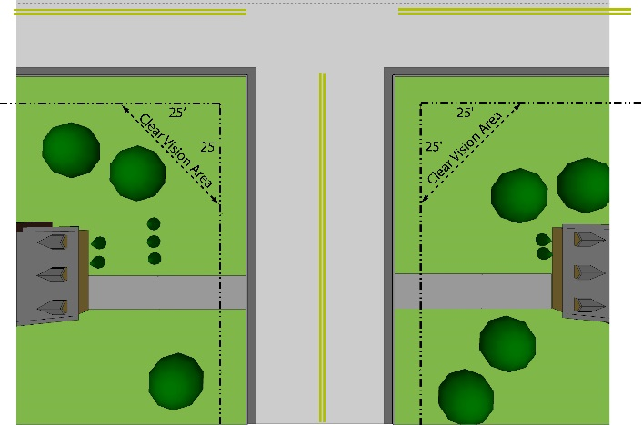
- No plantings, fencing, or other structures shall be established or maintained on any corner lot which will obstruct the view of a vehicle driver approaching the intersection. Such unobstructed corner shall mean a triangular area formed by the street property lines and a line connecting them at points twenty five (25) feet from the intersection of the street lines or in the case of a rounded property corner from the intersection of the street property lines extended. This shall not prohibit the planting of shrubbery which will not achieve a height at maturity of more than thirty (30) inches.

- No vegetation or structure shall be maintained in any setback area which, in the opinion of the Zoning Administrator, will obstruct the view from of vehicles entering or leaving the site from driveways or adjacent roadways.

SECTION 3.15 ESSENTIAL SERVICES

The erection, construction, alteration or maintenance of essential services, shall be permitted as authorized or regulated by law and other ordinances in any District, it being the intention hereof to exempt such erection, construction, alteration, and maintenance from the application of this Ordinance.

SECTION 3.16 TEMPORARY STORAGE OF USED MATERIALS

The storage, collection, or placing of used or discarded material, such as lumber, scrap iron, ashes, slag or other commercial or industrial byproducts or waste is prohibited without a Temporary Permit obtained from the Zoning Administrator, which shall be accompanied by a performance guarantee. In reviewing such request, the Zoning Administrator shall consider the length of time requested, the visibility of such storage area from surrounding properties, potential safety concerns, the ability to provide adequate security fencing and aesthetic screening, and other factors relevant to the specific location.

SECTION 3.17 ILLEGAL DWELLINGS

The use of any basement for dwelling purposes is forbidden in any Zoning District unless said basement meets the appropriate building codes for the Township and the remainder of the dwelling has been completed and available for occupancy. Buildings erected as garages or accessory buildings shall not be occupied for dwelling purposes.

SECTION 3.18 EXCAVATIONS, HOLES, OR PONDS

- The construction, maintenance, or existence within the Township of any unprotected, un-barricaded, open, or dangerous excavations, holes, pits, wells, or water impoundments which constitute or are likely to constitute a danger or menace to the public health, safety, or welfare are hereby prohibited; provided, however, this Section shall not prevent any excavation for an outdoor pond or farm manure lagoon that has first been approved by the Township; this Section shall not apply to streams, natural bodies of water, or to ditches, reservoirs, and other such bodies of water created or existing by authority of governmental units or agencies; and provided further that this Section shall not include excavations related to approved operations for the removal and processing of topsoil, stone, rock, sand, gravel, lime or other soil or mineral resources as regulated by Section 13.04.I of the Zoning Ordinance.

- If the creation of a pond results in 300 cubic yards or more of material being removed from the site, the project must also undergo concurrent review of Commercial Removal and Processing of Topsoil, Stone, Rock, Sand, Gravel, Lime or other Soil or Mineral Resources per Section 13.04.I of the Zoning Ordinance.

- Ponds less than three (3) acres shall require a zoning permit and administrative review. Ponds three (3) acres or larger shall require a Special Land Use. Applications for either type shall contain the information required in Section 13.04.NN.

- No explosives may be used in the creation of a pond.

E. A pond shall be a minimum of thirty (30) feet from any lot line, except that any pond used as a farm manure lagoon shall not be located less than three hundred (300) feet from adjacent lot lines or road right-of-way lines. For ponds greater than five acres, the Planning Commission may increase the minimum setbacks for ponds when in its discretion such is determined to be necessary to minimize potential public health and safety concerns or nuisance conflicts with adjoining properties.

F. A pond may be located in any zoning district and may be considered as a principal or an accessory use.

G. Ponds on parcels of less than three acres in size shall be enclosed by a fence. Ponds requiring Special Land Use approval may also require a fence if the Planning Commission determines in the course of its approval of a pond that the protection of the general public requires that the pond be enclosed. A fence enclosing a pond shall:
1. Be not less than four (4) feet above the grade line;
2. Be designed so that a child cannot pass through, or under, or climb over the fence, wall, or other enclosure except at a gate or door.

H. All gates or doors leading to a pond, except a door in any building forming part of the enclosure, shall be kept closed when the pond is not in actual use or when the proprietor is absent or away. The gates and doors shall be fitted with a positive latching device which automatically latches when the gate or door is closed.

I. A Soil Erosion permit from the Muskegon County Department of Public Works shall be provided if required. Muskegon County Water Resources Commissioner approval shall be provided if required.

J. No pond shall be wholly or partially emptied in any manner that will cause water to flow on the land of another, and no pond shall be wholly or partially emptied on any land if a storm drain is readily accessible to the premises on which the pond is located. Discharge into the public sanitary sewer is prohibited.

K. The slopes of the banks or sides of the pond shall be constructed so that for each one (1) foot of rise there shall be a minimum of three (3) feet of run. This minimum slope angle must be maintained and extended into the pond water to a depth of five (5) feet.

L. Finished slopes above the ordinary high water mark must be seeded and established with vegetation to prevent erosion.

M. All outdoor ponds or farm manure lagoons shall be constructed to completion within one year from the date of zoning permit issuance. A one-year extension may be granted, provided progress is shown. During construction of the pond, edges of the pond that do not maintain a 1:3 slope shall be barricaded.

N. For ponds of five acres or larger, all applicants shall provide a certification from a licensed professional engineer that the pond complies with the Sullivan Township Outdoor Ponds standards prior to final approval. For ponds three acres or greater the Planning Commission shall retain the right, at their discretion, to require a certification from a licensed professional engineer that the pond complies with the Sullivan Township Outdoor Ponds standards prior to final approval. The Planning Commission shall show good cause for the requirement of certification. [Amended Oct. 3, 2023]

SECTION 3.19 OUTDOOR STORAGE IN RESIDENTIAL DISTRICTS

The outdoor storage or parking of recreational vehicles in all Residential Districts shall be subject to the following minimum conditions:

- All such vehicles, if parked outside, shall not be located in any front or side yard setback area.

- Storage or parking shall be limited to a lot or parcel of land upon which is located an inhabited dwelling. The lease of space for storage or parking of recreational vehicles for compensation shall not be permitted in a Residential District.
- Travel trailers and other vehicles or equipment intended or adaptable for sleeping purposes shall remain unoccupied and shall not be connected to sanitary sewer facilities or have a fixed connection to electricity, water, or gas, provided that such equipment may be parked and used for living or housekeeping purposes for a period not exceeding fourteen (14) days in any six (6) month period, provided that running water or indoor sewage facilities within such equipment is not utilized.

SECTION 3.20 SATELLITE DISH ANTENNAS

- In any Nonresidential District, the following restrictions shall apply:

  - The dish antenna shall be permitted in the side and rear yard or mounted on top of a building, and securely anchored.
  - The nearest part of the antenna shall be at least five (5) feet from any property line.
  - The height shall not exceed the height restrictions in the district in which the proposed device is to be located.
  - No portion of the dish antenna shall contain any name, message, symbol, or other graphic representation.
  - A site plan shall be prepared and submitted to the Building Inspector for approval prior to issuance of a building permit. The site plan shall include the proposed location and an elevation drawing showing the proposed height and foundation details.

- In any Residential District, the following restrictions shall apply:

  - The dish antenna shall be permitted in the rear yard only.
  - The nearest part of the antenna shall be at least (5) feet from any property line.
  - The unit shall be securely anchored as determined by the Building Inspector.
  - The maximum height measured from the ground to the top edge of the dish shall be fourteen (14) feet.
  - The antenna shall be an unobtrusive color, as approved by the Building Inspector. Nor shall any portion of the dish antenna contain any name, message, symbol, or other graphic representation.
  - A site plan shall be submitted to the Building Inspector for approval prior to the issuance of a building permit. The site plan shall include the proposed location of the antenna and an elevation drawing showing the proposed height, color, and foundation details.

- These regulations shall not apply to dish antennas that are one (1) meter (39.37 inches) or less in diameter in Residential Districts or two (2) meters or less in diameter in Nonresidential Districts.

- These regulations are formulated to ensure that adequate protection measures are provided in the Ordinance for ensuring that sight distance is not impaired, that such dish antennas are located and constructed in a manner which will not afford the potential for injury, and to ensure that the intent and purposes of this Ordinance are met.

- The Zoning Administrator shall permit any waivers or modifications of these restrictions to the minimum extent necessary to permit full reception and use of the dish antenna, if existing buildings, vegetation, topography, or other factors cause interference with reception.

SECTION 3.21 EXTERIOR LIGHTING

- All lighting of a high intensity nature, intended to illuminate broad areas, shall be directed away from, and if necessary shall be shielded to prevent the shedding of light onto adjacent properties or roadways.

- Light poles used to illuminate parking lots or storage areas shall be limited to fifteen (15) feet in height.

SECTION 3.22 HOME OCCUPATIONS

- Home occupations shall be approved by the Zoning Administrator. An application for a permit for a home occupation shall be accompanied by a letter from the applicant indicating the nature of the home occupation and sufficient facts to indicate that the home occupation will comply with the requirements of this Section.

- No persons other than the resident occupants shall be engaged in the home occupation.

- The use of the dwelling unit for the home occupation shall be clearly incidental and subordinate to its use for residential purposes by its occupants. The home occupation shall be operated in its entirety within the principal dwelling, but shall not in any case, exceed a total floor area equal to not more than twenty five percent (25%) of the floor area of the dwelling unit. No articles or materials used in connection with such home occupation shall be stored other than in the main building so used.

- No merchandise or articles for sale shall be displayed for advertising purposes and no sign or device relative to the sale of such merchandise shall be displayed on the premises. Only those materials produced on the premises as a result of such home occupation or are clearly related and incidental to the home occupation may be provided for sale.

- There shall be no change in the outside appearance of the building or premises, or other visible evidence of the conduct of such home occupation other than one (1) sign, not exceeding four (4) square feet in area, non-illuminated. Such sign may be mounted flat against the wall of the main building or located in the front yard, provided that such sign does not exceed three (3) feet in height.

- Any traffic generated by such home occupation shall not be so great as to cause serious adverse effects within or upon the surrounding neighborhood. Parking areas for such home occupation shall be located off the street and other than in a front yard setback area.

- No equipment or process shall be used in such home occupation which creates noise, vibration, glare, fumes, odors, or electrical interference detectable to the normal senses off the premises, if the occupation is conducted in a single family dwelling, or outside the dwelling unit if conducted in other than a single family dwelling. In case of electrical interference, no equipment or process shall be used which creates visual or audible interference in any radio or television receivers off the premises, or cause fluctuation in line voltage off the premises.

- No traffic, business or function of the home occupation that is discernible outside of the structure shall operate between the hours of 10 PM and 7 AM. [Amended March 7, 2007]

SECTION 3.23 SEASONAL USES

- The Zoning Administrator may issue a permit for the temporary sale of merchandise in any district, related to a seasonal or periodic event. Such seasonal uses shall include the sale of Christmas trees, fireworks, and similar activities, but shall not include roadside stands.

- In considering a request for a temporary permit, the Zoning Administrator must determine that the operation of such a use is seasonal in nature and will not be established as a permanent use. The Zoning Administrator will also determine:

    - that the use does not have an unreasonable detrimental effect upon adjacent properties;
    - that the use does not impact the nature of the surrounding neighborhood;
    - that access to the area will not constitute a traffic hazard due to ingress or egress; and
    - that adequate off-street parking is available to accommodate the use.

- Each permit shall be valid for a period of not more than two (2) calendar months and may be renewed by the Zoning Administrator for up to one (1) additional successive month, provided the season or event to which the use relates is continued.

SECTION 3.24 NONCONFORMING BUILDINGS, STRUCTURES, AND USES

- General Conditions

  - Except where specifically provided to the contrary, and subject to the provisions of this Section, the lawful use of any building or structure or of any land or premises which is existing and lawful on the effective date of this Ordinance, or in the case of an amendment to this Ordinance, then on the effective date of such amendment, may be continued even though such use does not conform with the provisions of this Ordinance or any amendment thereto.
  - Except where specifically provided to the contrary and subject to the provisions of this Section, a building or structure which is existing and lawful on the effective date of this Ordinance, or, in the case of an amendment of this Ordinance, then on the effective date of such amendment, may be maintained and continued even though such building or structure does not conform with the provisions of this Ordinance or any amendment thereto.

- Extensions, enlargements, alterations, remodeling, or modernization.
  - Non Residential Districts – Buildings and Structures
    - Nonconforming buildings or structures in Nonresidential Districts may be extended, enlarged, altered, remodeled or modernized when the Zoning Board of Appeals determines that the following conditions are met:

      - The building or structure complies with all height, area, and/or parking and loading provisions with respect to such extension, enlargement, alteration, remodeling or modernization.
      - Such alteration, remodeling, or modernization does not substantially extend the life of any nonconforming building or structure.
      - The enlargement or extension is limited to the same parcel the nonconforming use was located on at the time of the adoption of the existing Sullivan Township Zoning Ordinance.
      - The enlargement or extension does not interfere with the use of other properties in the vicinity.
      - The enlargement or extension does not exceed fifty percent (50%) of the GFA of the original building when it became nonconforming.

    - Any building or structure which is nonconforming by reason of parking or loading provisions and which thereafter provides additional parking and/or loading spaces shall not thereafter be permitted to use such additional spaces to meet requirements for any extension, enlargement, or change of use which requires additional parking and/or loading spaces.

  - Residential Districts and uses.

    - Nonconforming residential buildings or structures may be extended, enlarged, altered, remodeled or modernized when the Zoning Administrator determines that the following conditions are met:

      - The enlargement or extension is limited to the same parcel the nonconforming building or structure was located on at the time of the adoption of the existing Sullivan Township Zoning Ordinance.
      - The enlargement or extension will not interfere with the use of other properties in the vicinity.
      - The enlargement or extension shall not further encroach into any setback area.

- Restoration and Repair

  - Subject to the provisions of this Section, nothing in this Ordinance shall prevent the strengthening or restoring to a safe condition of any part of any building or structure which is unsafe.
  - All repairs and maintenance work required to keep a nonconforming building or structure in sound condition may be made but it shall not be structurally altered to permit the use of such building or structure beyond its natural life except for repairs necessary to maintain public safety.
  - Nonresidential buildings or structures damaged by fire, wind, Act of God or public enemy:

    - Such buildings or structures may be rebuilt or restored if the cost thereof does not exceed fifty percent (50%) of the true cash value of the nonconforming building or structure prior to its damage or destruction.
    - If the cost of restoration or repair would exceed fifty percent (50%) of the true cash value of the nonconforming building or structure prior to its damage or destruction, a substantial improvement or rebuilding shall only be permitted if first authorized by the Zoning Board of Appeals. In considering such authorization, the Board of Appeals shall consider the following standards:

      - Whether such substantial improvement will significantly extend the probable duration of the nonconforming use.
      - Whether or not the land previously occupied by the nonconforming use can be reasonably used for a use permitted in the applicable District.

  - Residential buildings or structures damaged by fire, wind, Act of God or public enemy:

    - Such buildings or structures may be rebuilt or restored in its original nonconforming condition provided if its replacement cost is less than fifty percent (50%) of the true cash value of the nonconforming building or structure prior to its damage or destruction.
    - If the replacement costs of such buildings or structures would exceed fifty percent (50%) of the true cash value of the nonconforming building or structure prior to its damage or destruction the dwelling may be rebuilt or restored in its original nonconforming condition, provided, that reconstruction is commenced and is proceeding diligently within one (1) year of the date on which the structure was damaged. If such construction is not commenced and proceeding diligently at the end of one (1) year, the dwelling may be rebuilt or restored provided that all yard and requirements of the District in which it is located are met, or the necessary variances obtained from the Zoning Board of Appeals.

- Nonconforming Uses - Change or Discontinuance

  - Except as noted in G, below, the nonconforming use of a building or structure or of any land or premises shall not be:

    - Reestablished after it has been changed to a conforming use.
    - Reestablished after abandoned or discontinued for a continuous period of six (6) consecutive months, or for eighteen (18) months within any three (3) year period. A nonconforming use shall be determined to be abandoned if one (1) or more of the following conditions exists, and which shall be deemed to constitute an intent on the part of the property owner to abandon the nonconforming use:

      - Utilities, such as water, gas and electricity to the property, have been disconnected;
      - The property, buildings, and grounds, have fallen into disrepair;
      - Signs or other indications of the existence of the nonconforming use have been removed;
      - Removal of equipment or fixtures which are necessary for the operation of the nonconforming use;
      - Other actions, which in the opinion of the Zoning Administrator, constitute an intention of the part of the property owner or lessee to abandon the nonconforming use.

- Any building or structure shall be considered existing and lawful and for purposes of Section 3.24, A, to have been in use for the purpose for which constructed if on the effective date of this Ordinance, a building permit has been obtained therefore, if required, or, if no building permit is required, a substantial start has been made toward construction and construction is thereafter pursued diligently to conclusion.

- Any structures or uses which fail to conform to the previous Sullivan Township Zoning Ordinance, were not permissible, nonconforming uses or structures thereunder, and which violate the Zoning Ordinance shall not be considered permissible nonconforming uses under this Ordinance but shall be considered impermissible nonconforming uses and subject to the enforcement provisions of this Ordinance.

- A building, structure, or premises used for a nonconforming use may be converted to a more conforming use which is less intensive or objectionable use, determined as follows:

  - The building or premises may be changed to a use permitted by right in the same district in which the existing nonconforming use would be permitted, if the new use is required by the Zoning Ordinance to have the same, or less, parking and if the new use will be totally enclosed within a building.
  - The use of the building or premises may be changed to another nonresidential use which would be permitted by right in a more restricted zoning district. For this purpose, the least restrictive district is the LI District.

SECTION 3.25 DEMOLITION PERMITS

No buildings shall be razed until a permit has been obtained from the Building Inspector who shall be authorized to require a performance bond in such amount according to a schedule as determined by the Township Board. Such bond shall be conditioned on the applicant completing the razing within a reasonable period as prescribed in the permit and complying with such requirements as to health and safety as the Building Inspector may prescribes, including, but not limited to, filling excavations and proper termination of utility connections.

SECTION 3.26 PRIVATE STREETS

- Definition: See Section 2.19, Street, Private.

- Scope

The Township has determined that as large tracts of land are divided, sold, transferred and developed, private access streets are being created to provide access to the newly divided properties. The Township determines that it is in the best interest of the public health, safety and welfare to regulate the construction, improvement, extension, relocation and use of private streets. Private streets shall meet the requirements of this Ordinance as well as the design specifications of the Sullivan Township Private Street Design and Construction Standards (please refer to the associated private street illustrations in the Appendix). These regulations shall be enforced to assure that:

  - Private streets shall be designed and located to be consistent with the Master Plan and long term development policies of Sullivan Township.
  - Private streets shall be designed with sufficient width, surface, and grade to assure safe passage and maneuverability of private vehicles, police, fire, ambulance and other safety vehicles.
  - Private streets shall be constructed and maintained to be passable in all weather conditions and shall readily afford emergency access to the dwellings, buildings or other structures serviced by the private street.
  - Private streets shall be constructed of suitable materials to ensure minimal maintenance and safe passage.
  - Private streets shall be constructed to protect against or minimize soil erosion and prevent damage to lakes, streams, wetlands, and other significant natural features of the Township.
  - A private street, or any combination of interconnected private streets, shall not provide access to more than twenty (20) lots. Streets providing access to more than twenty (20) lots must be a public street.
  - Any lot not having the required minimum lot width on a public street shall have such required lot width upon a private street.
  - A private street shall not exceed one thousand three hundred twenty (1,320) feet in length as measured along the centerline of the private street. Any private street exceeding this length shall provide for at least one (1) additional access to a public street.

- Application

An applicant wishing to construct a private street must make application to the Township for a private street construction permit. This application shall include ten (10) complete sets of construction plans; however, an application for a private street serving only two (2) lots shall be required to submit three (3) sets. No individual, association, corporation or entity, either public or private, shall construct or extend a private street without first having obtained a private street construction permit from the Township. An application for a private street construction permit shall be submitted and an escrow account established to review the following:

  - Private Streets Serving Two Lots: A private street serving two (2) lots may be approved by the Zoning Administrator upon review of an application accompanied by the following:

    - A plan drawn and sealed by a civil engineer licensed by the State of Michigan, showing all lots to be served, the location and width of the private street easement, the width of the proposed road surface, the materials to be used for road surface, the frontage and width of all lots served by the private street, and any drainage or utility structures to be located in the easement. Plans shall conform to the design requirements of Section 3.26, I.. [Amended July 14, 2020]
    - The applicant of the proposed private street shall provide a copy of a private street maintenance agreement that is satisfactory to the Township executed by all parties having a right to use the private street and recorded with the Muskegon County Register of Deeds, which shall provide for and assure that the private street shall be regularly maintained, repaired and snow plowed so as to assure that the private street is safe for travel at all times and the cost thereof paid. The Township will provide a Private Street Maintenance Agreement. Substitutions for the agreement may be reviewed and accepted by the Township attorney.
    - If the private street intersects a public street or State trunk highway, permits from the appropriate agency shall be submitted. If the street intersects an existing private street, written permission from the owners, association or authority that owns the private street shall be submitted.

  - Private Streets Serving Three (3) to Twenty (20) Lots: An application for a private street serving 3 to 20 lots shall include the following:

    - Completed private street construction permit application form, provided by the Township, and an application fee established by the Township Board.
    - A detailed written description of the development to be served by the private street, including a description of the association or other party to be responsible for the operation and maintenance of the private street.
    - Ten (10) copies of construction plans prepared in accordance with Section 3.26, I, Private Street Design Standards. [Amended July 14, 2020]
    - A survey of the right-of-way by a registered land surveyor, together with surveys for each parcel to be served by the private street.
    - The location of all public utilities, including, but not limited to, water, sewer, telephone, gas, electricity, and television cable to be located within the private street right-of-way; copies of the instruments describing and granting such easements shall be submitted with the application.
    - The location of any lakes, streams, wetlands and drains within the proposed right-of-way or within one hundred (100) feet thereof.
    - The location of any other buildings and structures located within one hundred (100) feet of the private street right-of-way.
    - The applicant of the proposed private street shall provide a copy of a private street maintenance agreement that is satisfactory to the Township executed by all parties having a right to use the private street and recorded with the Muskegon County Register of Deeds, which shall provide for and assure that the private street shall be regularly maintained, repaired and snow plowed so as to assure that the private street is safe for travel at all times and the cost thereof paid. The Township will provide a Private Street Maintenance Agreement. Substitutions for the agreement may be reviewed and accepted by the Township attorney.
    - Private streets shall meet the requirement of this Ordinance and be designed and constructed according to the requirements and specifications Section 3.26, I. [Amended July 14, 2020]
    - Review comments from the Muskegon County Drain Commissioner, Muskegon County Road Commission, Fruitport Fire Department, and Muskegon County Department of Public Works.
    - Soil Erosion and Sedimentation Permit.
    - A narrative (shown on the site plan or submitted separately) describing in general terms the overall description of the proposal and the proposed method of providing sanitary sewer, water service, storm sewers and surface water drainage facilities, as well as other public and private utilities, including details of structures, light fixtures, etc.

- The Township shall require, as a condition of the private street construction permit, that the applicant provides a financial guarantee of performance in accordance with Section 17.08 of this ordinance.
- Special Assessment Provision: The Private Street Maintenance Agreement shall contain a provision to permit the Township Board to authorize the repair of any private street which is not being maintained adequately to permit safe access by users and emergency vehicles, and to assess the cost of such repair, including the costs of engineering and administration, to the signatories of the Agreement on a equitable basis. The decision to authorize repair of a private street shall be at the Township Board’s sole discretion in accordance with its legislative powers.

- Notification of Area Residents

Following the submittal of a completed application for a private street construction permit, the Township will notify adjacent property owners by first class mail of pending hearings for construction of Private Streets within a reasonable time prior to the hearing.

- Planning Commission Review

  - Findings. The Planning Commission shall review all private street applications (for private streets serving 3 to 20 lots) and make a recommendation to the Township Board. In making its recommendation, the Planning Commission shall find that the proposed private street:

    - Will not be detrimental to the public health, safety or general welfare.
    - Will not adversely affect the use of land.
    - Will be constructed to assure a safe and unimpeded route of travel for motor vehicles, pedestrians and emergency vehicles in all weather conditions.
    - Will be constructed so as to protect against or minimize soil erosion and prevent damage to lakes, streams, wetlands and the natural environment of the Township.
    - Will be in conformance with the Master Plan.
    - Will be in conformance with special conditions, as deemed necessary by the Planning Commission, such as greenbelts, landscaping, street lighting and other items, which have a reasonable relationship to the health, safety and general welfare of the Township.
    - Is designed in accordance with the Private Street Design Requirements of Section 3.26, I. [Amended July 14, 2020]

  - On a case by case basis, the Planning Commission may waive certain review requirements, as site conditions warrant. [Amended March 7, 2007]

- Township Board Approval

Upon receipt of the recommendation by the Planning Commission, the Township Board shall approve, approve with conditions, or deny the private street application. The record shall include the basis of the Township Board’s decision. [Amended March 7, 2007]

- Private Street Design Requirements: The minimum design and construction standards for private streets serving more than two lots or dwelling units, as well as any street or drive serving a commercial or industrial use are as follows:

  - General

    - All private streets shall be designed with sufficient width, surface, grade, drainage and signs to assure safe passage and maneuverability of private and commercial vehicles, fire, police, ambulance and other safety vehicles. All private street design and construction plans submitted for approval shall be prepared under the supervision of, sealed by and signed by a Professional Civil Engineer, Registered in the State of Michigan.
    - The name and address of the firm responsible for the preparation of the plans is to be clearly indicated on the plans.
    - The name, address and telephone number of the property owner and applicant (if different from the owner) is to be clearly indicated on the plans.
    - The standards set forth herein are considered minimums. It is acceptable to use a higher standard than the minimum specified within each requirement.
    - Streets must respect local topography.
    - Private street rights-of-way shall be located no closer to existing structures than the front yard set backs as set forth in this Ordinance.
    - Drawings must be to a scale of 1” = 50’ scale or larger. (i.e. a drawing with a scale of 1” = 40’ will be accepted but a drawing with a scale of 1” = 60’ is not acceptable.)
    - Show North arrow on all drawings along with an overall site location map indicating adjacent streets etc. The location map is to show the surrounding streets with the project area highlighted.
    - Show a minimum of one benchmark per plan sheet.
    - Plans are to indicate the latest revision date.
    - Property lines, dimensions and access points of parcels are to be indicated for the lots being serviced by the private street.
    - Clearly label and dimension the proposed property lines, utility easements, ingress and egress easements and street right-of-way.
    - Show proposed cross section on the plan indicating details such as widths, depths, slopes, etc.
    - The bottom of the aggregate base course is to be set no closer than two (2) feet above the historical high water elevation. Soil borings shall be provided indicating historical high water elevations.
    - Provide notes, as needed, to ensure the proposed project will meet the required Township Standards.
    - The location of the existing and proposed pavement and the right-of-way of all streets impacted by the construction of the private street shall be clearly indicated on the construction drawings. Dimension of the right-of-way, pavement widths, deceleration/acceleration lanes and radii are to be clearly labeled.
    - Private streets that intersect with existing or proposed private streets or public street rights-of-way should intersect at a 90 degree angle. When constrained by environmental features, the Planning Commission may allow a reduced angle of intersection but in no case shall the angle be less than 70 degrees.
    - Entrance to the public street shall require a permit from Muskegon County Road Commission.
    - In cases where the private street is adjacent to a property line, existing vegetation adjacent to the property line within the right-of-way shall not be removed. Replacement vegetation or new vegetation may be allowed or required at the discretion of the Planning Commission.
    - At least three hundred (300) feet distance should be maintained between intersections of public and/or private streets. This offset may be reduced to one hundred fifty (150) feet within the development as approved by the Township, subject to approval by the Muskegon County Road Commission, if the street is under the County’s jurisdiction.

  - Drainage

    - Show all drainage improvements including but not limited to ditches, drainage structures, culverts, storm sewer piping, retention basins, detention basins and applicable overflow structures.
    - Culverts will be placed at all natural drainage courses or other waterways.
    - The developer shall provide a storm water system to carry the 25 year, 24 hour frequency storm through the development from the tributary area. All ditches and culverts shall be designed using a design frequency of twenty five (25) year, twenty four (24) hour rainfall event and a minimum time of concentration of 15 minutes.
    - Ditch slopes at IV:4H fore slope and IV:3H back slope. A steeper back slope may be approved by the Planning Commission as specific site conditions warrant.
    - The developer shall submit hydrologic and hydraulic calculations, along with a topographic map to support the storm water discharge plan.
    - Storm water management techniques used by the developer shall comply with Best Management Practices (BMP). Best Management Practices are standardized techniques used for storm water control, such as rip-rap, vegetation, silt fence, etc. and are recommended according to various slope, degree of difficulty, etc.
    - Leaching Basins will not be allowed.
    - Closed storm sewer systems are to be designed to convey the 10 year, 24 hour storm event. The minimum pipe size for the closed storm sewer system is twelve (12) inches. No surcharging shall be present for the 10 year, 24 hour rain event.
    - Storm sewer material is to be per the Muskegon County Drain Commission excluding corrugated metal or aluminum.
    - Maximum catch basin spacing within the street: 350 feet.
    - The front edge of the storm sewer casting is to be set at 10.5 feet from centerline. Gutter-line of casting is to be set .31’ lower than centerline elevation.
    - Minimum cover over storm sewer: 2.5 feet from top of pipe.
    - Rainfall Data to be taken from Bulletin 71 “Rainfall Frequency Atlas of the Midwest” by Floyd A. Huff and James R. Angel.
    - Outlets of storm sewers, ditches, and areas where concentrations of runoff occur shall be protected against erosion by placement of sod, placing rip-rap, or other means approved by the Township Engineer hired when applicable.
    - Soil permeability rates are required for all retention ponds including ditches if the ditches are to be considered for retention purposes. Soil permeability rates may be established by on-site testing or may be based on 50% of the value taken from the current United States Department of Agriculture Soil Survey.

  - Drive Culverts

    - Plans are to show the approximate location of proposed drive culverts.
    - Drive culverts are required only if the ditches are designed to convey water.
    - The minimum size of a drive culvert is to be twelve (12) inches.
    - Material: Reinforced concrete pipe C-76 Class IV, corrugated metal/aluminum (16 gauge) or smooth line corrugated plastic (AASHTO M-294 Type S Polyethylene). All material installed must be new.

  - Restoration

    - All disturbed areas outside of the gravel or Hot Mix Asphalt Pavement (HMA) limits will be restored with a minimum of 4” of topsoil, seed, mulch and fertilizer nutrient.
    - Areas with slope steeper than IV:3H shall use mulch blanket in lieu of regular mulch.

  - Construction Materials

    - Granular Material: MDOT Class II. If existing on-site material meets MDOT Class II or Class IIA requirements no sand sub-base is required.

Sieve Analysis Total % Passing
 | 3” | 1” | No. 100 | LBW/No. 200
Class II | 100 | 60-100 | 0-30 | 0-7
Class IIA | 100 | 60-100 | 0-35 | 0-10
    - Aggregate Base: MDOT 22A, 22A Modified or 21AA Modified. Crushed concrete, slag, or other commonly found non-native aggregates may be substituted for the natural aggregate. The crush requirement is 95% min.
    - Aggregate/Gravel Surface: MDOT 23A Modified. Crushed concrete, slag or other commonly found non-native aggregates may be substituted for the natural aggregate. The crush requirement is 95% min.
    - HMA (Hot Mix Asphalt Pavement): MDOT Mixture No. 13A, PG 58-28
    - Crown Point of the street to be at the centerline with a 2% cross slope.
    - Where existing sub-grade material is not granular meeting MDOT Class II, a minimum of 12” Class II material will be placed and sub-grade drainage is to be addressed with the use of sub-grade under-drain or edge drain and proper outlet.
    - Soil Borings are to be submitted with the street plan during the review and approval process. The locations of the soil borings are to be clearly indicated on the drawing submitted. Maximum spacing of the soil borings is every 1000’ or closer as field and design conditions dictate. Sub base correction in addition to that shown on the typical cross sections shall be provided where directed by the Township Engineer hired when applicable.

  - Signage

    - Provide street and stop signage at the entry point of private street to public street and at all intersections within the development and identify their location on the site plan.
    - All required signs will be installed at the owner’s expense and will be in accordance with the current Michigan Manual of Uniform Traffic Control Devices and MDOT Construction Specifications; however, the Planning Commission may approve another type of design for consistency with the character of the development.
    - Private Streets will be named and identified. Names shall not be duplicated with any other street in Muskegon County, except for existing street extensions. Street signs shall be provided at all intersections. These signs shall contrast in terms of color with public street signs to indicate that the street is private.
    - The Muskegon County Road Commission Central Dispatch and Sullivan Township shall approve all street names. Any proposed street which is an extension of, or in a direct line with, an existing street shall carry the name of the street that is in existence at the time the proposal is made. Proposed names will be checked against other existing streets within the County for potential conflicts that may be confusing to emergency services.

  - Minimum Design Requirements. The minimum design requirements are as listed below and are listed according to the number of lots or dwelling units served by the contiguous development and not solely by one street within the development. Driveways serving commercial and industrial uses shall conform to the requirements of a driveway serving 15 to 20 lots or dwelling units. If a multi-phased development adds lots and falls within the next design category, all pre-existing work within that development will meet the required design conditions. Multi-phase projects should always be constructed to the details according to the ultimate project size.

    - All intersection(s) shall have no more than four (4) separate legs.
    - All conduits being used for future utility crossings are to be installed prior to the base course of asphalt. The developer is to coordinate the locations of the conduits with the appropriate utility companies.
    - Corner lots on both the private street and a public street shall not access the public street. All lots on the private street shall have an address on the private street. However, where corner lots are not a part of the private street development, the lot may access either the new private street or the public street. If access is to the private street, the owner of such lot is subject to participate in the maintenance of the private street.

  - Private Street Serving 2 Lots or Dwelling Units (see Appendix, Figure 1)

    - The minimum cul-de-sac radius is 40 feet.
    - Right-of-Way

      - Fifty-foot right-of-way width with provisions for all utilities within right-of-way or 10 feet on either side.
      - Cul-de-sac equals 60 feet radius

    - Minimum Cross Sectional Requirements

      - Width

        - Aggregate Surface: 18 feet
        - Sand Sub-base: 20 feet
        - Passing Lane: private streets serving two lots that are at least 400 feet but less than 800 feet in length shall provide a passing lane, sixty (60) feet in length, with an aggregate surface of 20 feet wide and a sand sub-base of 22 feet wide. Private streets serving 2 lots that exceed 800 feet shall provide a passing lane for each 400 feet in total length.

      - Slope: Aggregate surface and sand sub-base 2% cross slope
      - Depth

        - Aggregate Surface: 6 inches
        - Sand Sub-base: 12 inches

    - Maximum longitudinal grade is 10%.
    - There shall be a maximum grade of 1% for a distance of 50 back from edge of a public street. There shall be a maximum grade of 6% slope for a minimum distance of 50 feet back from an intersection of a private street.
    - Existing contours are to be shown on submittal drawing with two foot maximum contour intervals. If a site visit is scheduled, this requirement may be waived at the discretion of the Township or its Engineer.
    - Thirty (30) foot cleared minimum maintained area with fourteen (14) foot trimmed height over roadbed. Center of cleared area is to be generally centered on street and right-of-way centerline. Lateral clearing limits may be modified on a case-by-case basis to ensure an overall pleasing appearance to the final development, while maintaining a safe and functional street.
    - Minimum intersection radius: 25 feet

  - Private Streets Serving 3 to 14 Lots or Dwelling Units (See Appendix, Figure 2)

    - The minimum cul-de-sac radius is 40 feet.
    - Right-of-Way

      - Sixty-six foot right-of-way width with provisions for all utilities within right-of-way or 10 feet on either side.
      - Cul-de-sac equals 60 feet radius

    - Minimum Cross Sectional Requirements

      - Width

        - HMA Surface: 18 feet
        - Aggregate Base: 24 feet
        - Sand Sub-base: 26 feet
        - Gravel shoulder is to be 3 feet wide

      - Slope

        - HMA, aggregate base and sand sub-base 2% cross slope
        - Gravel Shoulder: 4% cross slope

      - Depth

        - HMA: 330 lbs/syd.
        - Aggregate Base: 6 inches
        - Sand Sub-base: 12 inches
        - Gravel Shoulder: 6 inches (min.)

    - Vertical alignment shall have a design speed of 25 mph or greater.
    - Forty (40) foot cleared minimum maintained area with fourteen (14) foot trimmed height over roadbed. Center of cleared area is to be generally centered on street and right-of-way centerline. Lateral clearing limits may be modified on a case-by-case basis to ensure an overall pleasing appearance to the final development, while maintaining a safe and functional street.
    - Minimum street grade shall be 0.6% and maximum street grade shall be 6%, except that the Township may allow up to 10% maximum street grade, if the applicant submits adequate justification that such grade will not adversely affect public safety or would cause undue clearing of land or damage to natural features. The Township may allow grades less than 0.6% if adequate justification that such grade will not cause adverse drainage impacts on adjacent properties and street.
    - There shall be a maximum grade of 1% slope for a distance of 50 feet back from edge of a public street. There shall be a maximum grade of 6% slope for a minimum distance of 50 feet back from an intersection of a private street.
    - Existing contours shall be shown on the drawing with minimum contour intervals of 2 feet. Significant natural features and other natural characteristic, including but not limited to open space, stands of trees, water bodies, floodplains, rock outcrops, utilities and other topographic features.
    - Show street centerline profile indicating proposed and existing centerline elevations.
    - Minimum intersection radius: 25 feet

  - Private Streets Serving 15 to 20 Lots or Dwelling Units and Driveways Serving Commercial and Industrial Uses (See Appendix, Figure 3 or 4)

    - The minimum cul-de-sac radius is 40 feet.
    - Right-of-Way

      - Sixty-six foot right-of-way widths with provisions for all utilities within right-of-way or 10 feet on either side.
      - Cul-de-sac equals 60 feet radius.

    - Minimum Cross Sectional Requirements

      - Width

        - HMA Surface:

          - With gravel shoulder: 20 feet
          - With HMA Valley Gutter: 24 feet

        - Aggregate Base:

          - With gravel shoulder: 28 feet
          - With HMA Valley Gutter: 26 feet
        - Sand Sub-base:

          - With gravel shoulder: 30 feet
          - With HMA Valley Gutter: 28 feet

        - Gravel shoulder is to be 4 feet wide

      - Slope

        - HMA, aggregate base and sand sub-base 2% cross slope.
        - Gravel Shoulder: 4% cross slope.

      - Depth

        - HMA: 330 lbs/syd.
        - Aggregate Base: 6 inches
        - Sand Sub-base: 12 inches
        - Gravel Shoulder: 6 inches (min.)

    - Vertical alignment shall have a design speed of 25 mph or greater.
    - Forty (40) foot cleared minimum maintained area with fourteen (14) foot trimmed height over roadbed. Center of cleared area is to be generally centered on street and right-of-way centerline. Lateral clearing limits may be modified on a case-by-case basis to ensure an overall pleasing appearance to the final development, while maintaining a safe and functional street.
    - Minimum street grade shall be 0.6% and maximum street grade shall be 6%, except that the Township may allow up to 8% maximum street grade, if the applicant submits adequate justification that such grade will not adversely affect public safety or would cause undue clearing of land or damage to natural features. The Township may allow grades less than 0.6% if adequate justification that such grade will not cause adverse drainage impacts on adjacent properties and street.
    - There shall be a maximum grade of 1% for a distance of 50 feet back from edge of a public street. There shall be a maximum grade of 6% for a minimum distance of 50 feet back from an intersection of a private street.
    - Existing contours shall be shown on the drawing with minimum contour intervals of one foot. Significant natural features and other natural characteristic, including but not limited to open space, stands of trees, water bodies, floodplains, rock outcrops, utilities and other topographic features shall be indicated on the private street construction plan sheet.
    - Show street centerline profile indicating proposed and existing centerline elevations.
    - Minimum intersection radius: 25 feet
    - Speed limits shall be posted.
    - Valley gutters are encouraged to be used on streets with longitudinal slopes of 2% and greater.
    - Concrete Curb and Gutter:

      - Concrete curb and gutter is to be used on all radii and cul-de-sacs when adjacent section consists of an HMA Valley Gutter.
      - Five and one-half (5½) sack air entrained concrete is to be used on all curbs.
      - White membrane curing compound is to be placed on all concrete curbing once the free moisture has left the surface. Upon stripping the forms, the remainder of the surface shall be sprayed with the curing compound.

  - Private Street Serving 21 or More Lots or Dwelling Units. All streets serving 21 lots or more shall be dedicated to the public and be designed to the governing agency’s standards. The street will be maintained by the governing agency.

  - Construction Requirements

    - Tolerances and Testing Requirements:

      - Compaction (Based on the Michigan One Point Cone Test)

        - Aggregate Base: 98%
        - Aggregate Surface: 98%
        - Gravel Shoulder: 95%
        - Sand sub-base: 95%
        - Hot Mix Asphalt Pavement (HMA): 92%-96% of the Theoretical Maximum Density

      - Tolerances

        - Grade on Sub-grade: +/-3/4”
        - Grade on Aggregate Base and Sub-base: +/-1/2”
        - Aggregate depth: +/-1/2”

      - Pavement depth:

        - In no instance shall the finished bituminous thickness be more than ½” thinner than plan thickness.
        - The average pavement thickness is to be no more than ¼” thinner than plan thickness.
        - In no case shall any area in a single course of HMA be less than 75% of plan thickness. Areas thinner than this will be removed and replaced at no expense to the Township.
    - Provide load tickets showing date of delivery, quantity of product, type of material, location of source and drivers name for all aggregates, granular material and HMA product brought to the site. Material shall be provided by a state certified pit or owner may pay for an independent laboratory to sample onsite material and provide independent testing proving that the requirements are met.
    - All castings located within the HMA surface shall be raised to grade between the leveling and the top course of asphalt and shall be adjusted to ¼” below the finished paved surface.
    - Bond coat is to be applied between successive courses of asphalt and to all surfaces that the pavement will be in contact with, including existing pavement edges, edges of concrete curb, etc.
    - A minimum of two rollers will be used for compacting and finishing HMA surface. There shall be no visible roller marks on the finished surface of all courses of HMA.
    - Pavement cores may be taken for density determination if it appears that there is not enough compaction effort being made during paving operations. Cost for testing and repair will be the responsibility of the owner if the tests indicate the pavement surface falls below the specifications listed in this section.
    - Total yield will be calculated based from the area of pavement and the HMA delivery tickets. If the yield calculations warrant, pavement will be cored to determine thickness. Owner is responsible to correct any work that is outside the specified tolerances. A proposed repair/replacement plan or any other alternative is to be submitted to the Township for review within two weeks of notification that the work is not within the required tolerances. No repair work shall proceed prior to authorization by the Township.
    - Contractor is to submit HMA mix design prior to paving.
    - HMA Temperature: Minimum – 250 degrees Fahrenheit.
    - Sub-grade is to be proof rolled prior to placing sub-base material. Any areas indicating signs of yielding are to be undercut and filled and compacted with material meeting MDOT Class II requirements.
  - Lighting

    - Street lighting may be required by the Township Ordinance and will be at no expense to the Township. Township indemnity and hold harmless agreements may be required.
    - Streetlights are required at all intersections.
    - All outdoor fixtures shall be full cut-off fixtures as defined by the IESNA.
    - Unless otherwise approved by the Township, lighting sources shall be high-pressure sodium.
    - The applicant shall submit the specifications for the lights, poles, fixtures, and light sources for approval.
    - Lighting shall be directed so that it is confined internally to the development site.
    - Light sources or light lenses shall not be visible beyond the boundaries of the development.
  - Sidewalks

    - Sidewalks may be required at the discretion of the Township Planning Commission.
    - All sidewalks are to meet current “ADA Standards for Accessible Design” requirements.
    - Concrete sidewalks will be a minimum of 5 feet wide.
    - Maximum Grade:

      - Longitudinal: 8%
      - Cross Slope: 2%

    - Concrete thickness must be a minimum of four inches.
    - Where sidewalks are also driveways or other driving surfaces, the thickness shall be six inches.
    - Jointing

      - Control joints: Not less than five or more than six feet apart.
      - Expansion Joints:

        - ½” expansion joint required at 50 foot maximum intervals.
        - ½” expansion joint required at transitions. (Example: 4” to 6” transitions at driveways).
        - 1” expansion joints where sidewalk ramp meets the back of concrete curbing.
        - The sidewalk edge shall be one foot inside of the street right of way line.

    - Broom sidewalks transversely to slightly roughen the surface.
    - White membrane curing compound is to be evenly applied over the entire sidewalk surface immediately after the free moisture has dissipated from the surface of the concrete.
  - Utilities

    - All utilities available at the public street intersection with the private street shall also be provided to the private street.
    - All utilities including but not limited to gas, telephone, electric and cable are to be run underground within the given utility easement.

[Amended March 7, 2007]

- Extension of Existing Private Streets

Prior to the extension of a private street, the Planning Commission shall review an application submitted in accordance with the requirements of this Section. Extension of private streets shall be subject to the following requirements:

  - If the extension of the existing street increases the number of dwelling units served, such that an increase in the design standard is required, the entire street shall be brought up to those design and construction standards.
  - A private street maintenance agreement that is satisfactory to the Township must be section 4.03executed by all parties having a right to use the private street and shall be recorded with the Muskegon County Register of Deeds. Existing private street maintenance agreements or restrictive covenants must be modified to include all new parties proportionately for the entire length of the private street.

- Permitting, Inspection and Final Acceptance Provisions

  - Periodic Inspection

    - Private streets shall be inspected for compliance by the Township or its designated representative. The applicant, before final approval of the private street, shall pay all inspection costs.
    - From time to time, the Township or its designated representative may inspect the construction of the private street to ensure compliance with the approved development site plan and the design and construction standards of the Township.
    - If during any inspection, the Township or its designated representative determines that the work is not acceptable according to the approved site plan and the Design and Construction Standards of the Township, the applicant will be advised in writing of specific defects to be remedied before final acceptance. The applicant shall have thirty (30) days to file an appeal to the Zoning Board of Appeals.

  - Request for Inspections

    - It shall be the applicant’s responsibility to notify the Township at certain critical points to give the Township adequate time to inspect the quality of work and compliance with approved plans and Township Design and Construction Standards. The following work items require that the applicant notify the Township during placement and construction of:
      - Storm sewer systems and structures, including under-drains if required
      - Sand sub-base
      - Aggregate base
      - Bituminous surface
      - Restoration of vegetation
    - Upon request for a final inspection, the applicant shall provide the Township with copies of the contractor’s construction documentation records, including the following, as applicable:
      - Aggregate/Bituminous Material Specification documentation from supplier, including point of origin
      - Delivery tickets for all bulk materials, including amount and tonnage for individual loads and the net for the project
      - Moisture Density Records
      - Bituminous Density Records and mix type
      - Concrete Field Tests or Cylinder Strength Records and mix type
      - Grade Checking documentation
      - Contractor Corrective Action Reports
      - Inspection Reports with depth checks, etc.
      - Other items as deemed necessary to determine compliance with this Section and other applicable regulations.

  - Field Inspection

    - After review of all data, documentation and licensed professional engineer’s certification, the Township or its designated representative will make a final inspection.
    - If during any inspection, the Township or its designated representative determines that the work is not acceptable according to the approved site plan and the design and construction standards of the Township, the applicant will be advised in writing of specific defects to be remedied before final acceptance. The applicant shall have thirty (30) days to file an appeal to the Zoning Board of Appeals.

  - Final Approval and Acceptance

    - The construction of the private street must conform to the requirements of this Section. It will be necessary for the applicant to provide a certification from a licensed professional engineer that the private street complies with the Sullivan Township Design and Construction Standards. Verification of such conformance will be provided by the applicant’s licensed professional engineer by submission of a set of as-built drawings and a statement certifying that the private street has been constructed in accordance with the requirements of the permit. As-built drawings will be provided in a digital format, if the project was so designed.
    - The Building Inspector shall not issue building permits for any building on lots served by a private street until construction of the private street has been inspected and approved and following submittal of a Completion Certificate signed by the applicant’s licensed professional engineer indicating that the street has been completed in accordance with the requirements of this Section.
    - Upon final acceptance, the Township shall notify the applicant in writing of such approval.
    - The financial guarantee will be released once restoration is complete to the extent that vegetation no longer requires temporary soil control measures and the project is deemed acceptable and approved for use by the Township, and will be contingent upon the final release of the Soil Erosion and Sedimentation Control Permit issued by the County.
    - Construction of the private street is to be completed within one (1) year of issuance of the permit. If construction is not completed within this period, the permit shall expire and if the applicant later decides to proceed, the applicant shall reapply as provided in this Section. If construction has commenced but not been completed within one (1) year, the Township may exercise the financial guarantee to complete the street. The period within which construction must be completed is subject to extension by the Township Zoning Administrator for good cause shown and, as a condition of extension, the Township may increase the amount of performance guarantee required.

- Miscellaneous

  - The Township Board shall set fees for the permits and all escrows required herein from time to time, by resolution.
  - By making application for, or securing a permit to construct a private street, the applicant agrees to indemnify and hold the Township harmless from any and all claims for personal injury and/or property damage arising out of the use of the private street or for failure to properly construct, maintain, use, repair and replace the private street.
  - Zoning and Building permits, for up to ten percent (10%) of the development or at least one permit in all cases, may be issued prior to the completion of the private street, at the discretion of the Planning Commission for good cause shown, (such as weather, or other unforeseen circumstances), after approval of the private street construction permit, provided a financial guarantee of performance assuring the completion of the private street has been submitted in accordance with the requirements of this Section. In no event shall an occupancy permit be issued until the private street has been completed in accordance with 3.26.G.4(b).

[Amended April 19, 2005; March 7, 2007]

SECTION 3.27 DRIVEWAYS SERVING ONE LOT OR DWELLING UNIT

- Purpose. The purpose of this section is to ensure driveways are constructed in a manner that allows safe passage of cars and emergency vehicles during all seasons of the year.

- Applicability. In the AG District and in the Residential Districts, all new, extended, and expanded driveways serving single lots or dwelling units shall conform to the requirements of this section.

- General:

  - All curb cuts shall be constructed in accordance with Muskegon County Road Commission standards.
  - The Zoning Administrator shall approve the driveway design prior to issuance of building permits. No certificate of occupancy will be granted until the driveway is inspected and approved by the Zoning Administrator.
  - All driveways shall be continuously maintained to allow accessibility by emergency vehicles in all weather conditions. All costs for the maintenance and repair of a driveway shall be the responsibility of the property owner served by the driveway. Maintenance includes, but is not limited to, snow removal, grading, tree trimming, and driveway reconstructing and repair. Driveways shall be kept free of roots, brush, shrubs, trees, debris, and any other obstruction.
  - Signage. The address of a lot served by a driveway shall be permanently displayed on the dwelling located on the lot and on any accompanying mailbox. If the address displayed on the dwelling is not visible from the road, then a permanent address must be placed where the driveway meets the public or private road. Cost of all signs shall be the responsibility of the land owner.

- Driveways One Hundred Fifty (150) Feet in Length or Less: Driveways that are one hundred and fifty (150) feet or less, measured along the centerline of the drive from the property line to the end of the driveway, shall comply with the following:

  - All driveways shall be a minimum of twelve (12) feet wide.
  - All unpaved or gravel driveways shall consist of a minimum of six (6) inches of gravel upon a compacted sub-base.
  - All paved or hard-surfaced driveways shall consist of a minimum of six (6) inches of compacted aggregate or similar material, with a minimum of four (4) inches of concrete or asphalt.

- Driveways over One Hundred Fifty (150) Feet: Driveways that are over one hundred and fifty (150) feet shall comply with the following requirements:

            - All unpaved or gravel driveways shall consist of a minimum of six (6) inch aggregate base course of compacted gravel, crushed concrete, slag, or similar material upon a twelve (12) inch compacted granular material sub-base.
            - All paved or hard-surfaced driveways shall consist of a minimum of six (6) inches of compacted aggregate or similar material, with a minimum of four (4) inches of concrete or asphalt.
            - Driveway surface shall be a minimum of fourteen (14) feet wide with a two (2) foot clear area on each side of the driveway surface.
            - Driveways shall have a minimum lateral crown of two (2) percent and a maximum lateral crown of seven (7) percent.
            - A vertical clearance of at least thirteen (13) feet and six (6) inches shall be maintained for the entire length of the driveway.
            - Passing Lane: A driveway that is at least four hundred (400) feet but less than eight-hundred (800) feet in length shall provide a passing lane, sixty (60) feet in length, with a sub-base and surface of twenty (20) feet wide. A driveway that exceeds eight hundred (800) feet shall provide a passing lane for each four hundred (400) feet in total length. These passing lanes shall be constructed in the same manner as the driveways, with the same materials.

- Driveways that serve more than one lot or dwelling unit, or driveways that serve nonresidential uses, shall be subject to the Private Street requirement of Section 3.26.

[Amended November 8, 2018]

SECTION 3.28 MAXIMUM WIDTH TO DEPTH RATIO

- In all Residential Districts, no lot shall be created whose lot depth exceeds four (4) times its width, except for residentially zoned lots or parcels that have more than one half (½) of their street frontage on a cul-de-sac. For purposes of this Section, the beginning points of a cul-de-sac shall be deemed to be the intersections of the radius of the cul-de-sac with the right-of-way lines of the street connected to the cul-de-sac.

- In the case of an unimproved corner lot or corner parcel, the depth of a lot or parcel shall be measured midway between the side lot lines and from the front lot line to the rear lot line along the dimension of the lot comprising the greatest distance.

- The Planning Commission may permit the creation of a lot or parcel to be used for the construction of a building which does not comply with this Section. In determining whether to grant such approval, the Planning Commission shall first find that:

  - the greater depth is necessitated by conditions of the land in question, such as topography, street access, soils, wetlands, or floodplain; and
  - that creation or use of such lot will not conflict with other Township ordinances and regulations, unless an appropriate variance is received from such other Ordinances or regulations.

SECTION 3.29 SITE CONDOMINIUMS

- A site condominium unit shall be a unit created by the division of land on the basis of condominium ownership which is not subject to the provisions of the Land Division Act, Public Act 288 of 1967, as amended.

- A site condominium unit shall be treated as a separate lot or parcel and may have such buildings constructed thereon and such uses conducted thereon as allowed in such zoning district provided such unit meets the District Regulations for the zoning district in which it is located.

- A site plan, including all the condominium documents required for the establishment of a condominium, shall be reviewed and approved by the Planning Commission in accordance with Chapter 14.

SECTION 3.30 KEEPING OF ANIMALS

- The keeping of domestic or farm animals shall be considered customary to, and commonly associated with, the operation of the Permitted Uses or Special Land Uses, subject to the requirements of this Section.

- Any land, building, or structure where four (4) or more cats and/or dogs six (6) months of age or older are boarded, housed, or bred for commercial purposes shall be considered a kennel. Kennels shall only be permitted after approval as a special land use on the lot or parcel on which it is proposed.

- Any other provision of this Ordinance notwithstanding, the keeping, housing, raising, or use of land for medical care for fowl or animals other than house pets of an occupant of the premises, is subject to the following provisions:

  - Any pen or building or structure housing these animals shall be a minimum of fifty (50) feet from any property line and a minimum of one hundred fifty (150) feet from any dwelling unit.
  - On lots of one half (½) acre, but less than one (1) acre: raising and keeping fowl and/or rabbits and/or other small animals for pets, not to exceed three (3) per family;
  - On lots of greater than one (1) acre, but less than two (2) acres: raising and keeping fowl and/or rabbits and/or other small animals commonly raised for human consumption in numbers no greater than is required to satisfy the personal needs of the human occupiers of the premises;
  - On lots of greater than two (2) acres the uses permitted by paragraph 2, above; and one (1) horse, or one (1) cow, or one (1) pig for each full acre over two (2).

- Where animals other than house pets of the owner or occupant of the premises are kept or allowed outside, a fence of such construction as to keep said animals from leaving the premises at will shall be provided and regularly maintained.

SECTION 3.31 SWIMMING POOLS

- Pools used for swimming or bathing shall be in conformity with the requirements of this Section; provided, however, these regulations shall not be applicable to any such pool less than twenty four (24) inches deep or having a surface area less than two hundred fifty (250) square feet, except where such pools are permanently equipped with a water recirculation system or involve structural materials.

- A swimming pool or appurtenances thereto shall not be constructed, installed, enlarged or altered until a building permit has been obtained.

- The outside edge of the pool wall shall not be located closer than ten (10) feet from any rear or side property line. Swimming pools shall not be located in the front yard.

- Each pool shall be enclosed by a fence or wall with a height of at least four (4) feet, sufficient to make such body of water inaccessible to small children. Such enclosure, including gates therein, must be not less than four (4) feet above the underlying ground; all gates must be self-latching with latches placed four (4) feet above the underlying ground or otherwise made inaccessible from the outside to small children.

- All swimming pool installations shall comply with any applicable Construction Codes and all other standard codes referred to therein.

SECTION 3.32 STORAGE AND REPAIR OF VEHICLES

The carrying out of repair, restoration and maintenance procedures or projects on vehicles in any Residential District for the private use of the owner or occupant of the property on which such procedures or projects are conducted, when such work is not conducted entirely within the interior of a building, shall be subject to the following limitations:

- Procedures or projects which require the vehicle to be immobile or inoperable in excess of sixty (60) days within any twelve (12) month period shall be carried out within an enclosed building.

- Inoperable vehicles and vehicle parts shall be stored inside a building, except for one (1) such vehicle which may be stored in the rear yard in a location not plainly visible from the street.

SECTION 3.33 OUTDOOR WOOD BOILERS

- Purpose & Intent. The purpose of this Ordinance is to establish guidelines and impose restrictions upon the construction and operation of outdoor wood boilers. The goals are as follows:

  - To promote the safe, effective, and efficient use of an outdoor wood boiler.
  - Preserve and protect public health, safety, welfare, and quality of life by minimizing the potential adverse impacts of an outdoor wood boiler. Outdoor wood boilers can create noxious and hazardous smoke, soot, fumes, odors, air pollution, particles and other products of combustion, particularly when restricted airflow and low operating temperatures are present. These products can be detrimental to people’s health and can deprive neighboring residents and property owners of the enjoyment of their property.
  - To establish standards and procedures by which the siting, design, installation, operation, and maintenance of an outdoor wood boiler shall be governed.

- Definitions. The following definitions apply to the terms used in this section:

  - Outdoor Wood Boiler: Any equipment, device, appliance or apparatus, or any part thereof, which is installed, affixed or situated outdoors and is hand-loaded or continuously fed (automatically fueled) for the purpose of combustion of fuel to produce heat or energy used as a component of a heating system providing heat for any interior space or water source. An outdoor wood boiler may also be referred to as an outdoor wood furnace, or hydronic heater.
  - Chimney: Flue or flues that carries off exhaust from an outdoor wood boiler firebox or burn chamber.
  - EPA HH (Hydronic Heater) Phase 2 Program – EPA HH Phase 2 Program is administered by the United States Environmental Protection Agency and has a particulate matter emission limit of 0.32 pounds per million British Thermal Units (BTU) output.
  - EPA HH (Hydronic Heater) Phase 2 Program Qualified Model – A hydronic heater that has been EPA HH Phase 2 Program qualified. The model has met the EPA HH Phase 2 emission level and is labeled accordingly.
  - Non-qualified Outdoor Wood Boiler Model – An outdoor wood boiler that is not EPA Hydronic Heater Phase 2 Program qualified.
  - Existing Outdoor Wood Boiler: An outdoor wood boiler that was purchased and installed prior to the effective date of the amending ordinance establishing these requirements.
  - New Outdoor Wood Boiler: An outdoor wood boiler that is first installed, established, or constructed after the effective date of this local law.
  - Natural Wood: Wood which has not been painted, varnished or coated with a similar material, has not been pressure treated with preservatives and does not contain resins or glues as in plywood or other composite wood products.

- Applicability.

  - This Ordinance applies to all new outdoor wood boilers installed after the effective date of this Ordinance.
  - An existing outdoor wood boiler installed prior to the effective date of this Ordinance shall not be required to meet the standards of this section, with the exception of the requirements of subsection D, 8, below, provided the unit was installed to the manufacturer’s specifications. However, any physical modification to an existing outdoor wood boiler that materially alters its size, type, equipment or location shall require approval under this section.
  - An outdoor wood boiler shall be considered a permitted use in the RA, RR, R-1 and R-2 zoning districts and shall not be erected, constructed, installed, or modified as provided in this Ordinance unless a permit has been issued to the Owner(s) or Operator(s).

- Installation and Operation. All new outdoor wood boilers shall conform to the following requirements:

  - Minimum Lot Area. An outdoor wood boiler may only be located on a lot with an area of 2.5 acres or more, exclusive of road right-of-way.
  - Separation From Buildings on Adjoining Lots. An outdoor wood boiler shall be located no less than three hundred (300) feet from the nearest building not on the same lot as the outdoor wood boiler and which is in existence prior to the installation of the outdoor wood boiler.
  - Yard Location. An outdoor wood boiler may not be located in a front yard.
  - Setbacks. An outdoor wood boiler shall be set back a minimum of fifty (50) feet from any side or rear lot line.
  - Chimney. An outdoor wood boiler shall have a chimney that extends at least fifteen (15) feet above the ground surface. If located within four hundred (400) feet of any residence, the chimney must be at least two (2) feet higher than the peak of the highest residence.
  - Certification. Any new outdoor wood boiler must be an EPA HH (Hydronic Heater) Phase 2 Program Qualified Model and be labeled accordingly, and must meet or exceed current EPA HH (Hydronic Heater) program requirements. A non-qualified outdoor wood boiler model is prohibited.
  - Operation. The outdoor wood boiler shall be operated at all times within the manufacturer’s specifications as well as all applicable Township, County, State and Federal requirements.
  - Fuel. No fuel other than natural wood without additives, wood pellets without additives, agricultural seeds in their natural state and manufacturer’s approved fuel may be burned. The following are specifically prohibited:

    - Rubbish or garbage, including but not limited to food waste, food wraps, packaging, animal carcasses, paint or painted materials, furniture, composite shingles, construction or demolition debris or other household or business wastes;
    - Waste oil or other oily wastes;
    - Asphalt and products containing asphalt;
    - Treated or painted wood, including but not limited to plywood, composite wood products or other wood products that are painted, varnished or treated with preservatives;
    - Any plastic material, including but not limited to nylon, PVC, ABS, polystyrene or urethane foam and synthetic fabrics, plastic films and plastic containers;
    - Rubber, including tires and synthetic rubber-like products;
    - Newspapers, corrugated cardboard, container board or office paper (unless used exclusively to start a fire); and
    - Grass clippings or leaves.

Permit Application Requirements: An application for an outdoor wood boiler shall be made to the Zoning Administrator, and shall include the following:

  - Name and signature of property owner(s), address, and parcel number.
  - A site plan, in sufficient detail to show that the above requirements are met.
  - The proposed manufacturer and model, product specifications, dimensions and verification that the outdoor wood boiler installation will comply with the manufacturer’s specifications. A copy of the manufacturer’s installation and operation requirements shall also be submitted.
  - Documented compliance with applicable local, state and national regulations including, but not limited to, all applicable safety, construction, environmental, plumbing and electrical requirements.
  - Documented compliance with the current EPA HH (Hydronic Heater) Phase II program.

- Enforcement. Except for an existing outdoor wood boiler as exempted in subsection C, 2, above, if an outdoor wood boiler is, through the course of an investigation by the Township Zoning Administrator, found to violate this ordinance, the following steps must be taken by the owner to bring the unit into compliance:

  - Modifications must be made to the unit to bring it into compliance with this section, such as extending the chimney, relocating the outdoor wood boiler, or both, or other modification necessary to comply with this section.
  - Within the discretion of the Township Zoning Administrator, the owner must cease and desist operating the unit until the outdoor wood boiler is in compliance.

- Conformance. On any property containing an outdoor wood boiler, any land division or property line change shall maintain the minimum lot size and minimum setback requirements on the resulting lot containing the outdoor wood boiler, or the outdoor wood boiler shall be relocated or removed so that the requirements of this section are met.

[Amended June 26, 2011]

SECTION 3.34 MEDICAL MARIHUANA FACILITIES AND RECREATIONAL MARIHUANA ESTABLISHMENTS PROHIBITED

    - Any and all types of a “marihuana facility,” as that term is defined and used in Act 281 of 2016, commonly known as the Medical Marihuana Facilities Licensing Act, are completely prohibited in the Township, and may not be established or operated in any zoning district, by any means, including by way of a variance.

    - Any and all types of a “marihuana establishment,” as that term is defined and used in Michigan Initiated Law 1 of 2018, commonly known as the Michigan Regulation and Taxation of Marihuana Act, are completely prohibited in the Township, and may not be established or operated in any zoning district, by any means, including by way of a variance.

    - Nothing in this section shall limit any privileges, rights, immunities or defenses of a person as provided in the Michigan Medical Marihuana Act, Michigan Initiated Law 1 of 2008, MCL 333.26421, et seq.

[Amended October 1, 2019]

SECTION 3.35 SOLAR ENERGY COLLECTORS

- General requirements

  - The exterior surfaces of solar energy collectors shall be generally neutral in color and substantially non-reflective of light. A unit may not be installed or located so that sunlight or glare is reflected into neighboring residences or onto adjacent streets.
  - Solar energy collectors shall be installed, maintained and used only in accordance with the manufacturer’s directions. Upon request, a copy of such directions shall be submitted to the Township Zoning Administrator and/or building official prior to installation.
  - A solar energy collector shall be permanently and safely attached to the building or structure, or to the ground. Proof of the safety and reliability of the means of such attachment shall be submitted to the Zoning Administrator or building official prior to installation.
  - Solar energy collectors, and the installation and use thereof, shall comply with the Township construction code, the electrical code and other applicable Township, County, state and federal requirements.
  - There shall be no signs on the unit, other than a sign or logo identifying the manufacturer with an area no greater than three square feet, or any necessary safety information signs.
  - Energy generated shall be used only by the structures and uses on the same property as the solar collector unit(s). However, this shall not preclude a property owner from returning excess energy to the local utility via net metering, nor shall it preclude participation in a program conducted by a regulated utility designed to allow the utility to meet State-mandated alternative energy goals, provided that the all requirements of this Section are met.
- Building mounted units. A building-mounted solar energy collector shall be a permitted accessory use in all zone districts, subject to the following requirements:

  - A building mounted unit may only be attached to the principle structure, or to a pre-existing accessory structure serving the principle use, such as a barn, garage or shed.
  - A roof-mounted unit shall not project more than three feet above the highest point of the roof and may exceed the maximum building height limitation for the zone district by no more than three feet.
  - A building mounted unit shall be only of such weight as can safely be supported by the structure. Proof thereof, in the form of certification by a professional engineer or other qualified person, shall be submitted to the Township building official prior to installation.
  - A solar energy collector that is wall-mounted shall not extend further than 10 feet from the building wall, may not extend into a required yard and may not exceed the height of the building wall to which it is attached.
  - Solar energy collectors shall not be mounted on the front wall of a building visible from the road.

- Ground mounted units. A ground-mounted solar energy collector shall be a special land use reviewed and approved according to Chapter 13. Specific requirements can be found in Section 13.04.KK
[Amended September 20, 2012]

SECTION 3.36 WIND ENERGY CONVERSION SYSTEMS (WECS)

This Section establishes standards and procedures by which the installation and operation of a WECS shall be governed within Sullivan Township.

- Review Requirements

  - On-Site Service WECS Up to 50 Feet in Height. An on-site service WECS that does not exceed 50 feet in WECS height shall be approved by the Zoning Administrator, subject to the requirements of this Section.
  - On-site Service WECS Exceeding Fifty (50) Feet: Any on-site service WECS over fifty (50) feet high shall require site plan approval according to Chapter 14.
  - Application and Site Plan Requirements. For all WECS requests, the application and site plan shall include the following information:

    - WECS fifty (50) feet or less:

      - Name of applicant, name of site plan preparer (if different), name of WECS manufacturer and name of WECS installer, with contact information;
      - A scaled drawing of the property, showing dimensions of all property lines and the area of the lot in square feet;
      - Location and setback of all structures on the site, including any overhead utility lines;
      - Proposed location of the WECS equipment on the site or on the building;
      - Setbacks of the WECS, in accordance with the setback requirements of this Section, from property lines and (if ground mounted) from structures;
      - A scaled elevation drawing of the WECS installation (including the building, if the WECS is building mounted) showing WECS height, rotor diameter and all other applicable elements to confirm conformance with the requirements of this Section;
      - Certification that the WECS system and mount meets current standards developed by one of the following: the IEC (International Electrotechnical Commission), ANSI (American National Standards Institute), or SWCC (Small Wind Certification Commission).
      - All additional information necessary to certify that the WECS installation conforms to the requirements of this Section.

    - WECS exceeding fifty (50) feet: All submittal requirements for a site plan review according to Chapter 14, plus the items listed in subparagraph a, above.

- General Requirements for all WECS

  - WECS Height: The height of a WECS shall be the distance measured between the ground (at normal grade) and the highest point of the WECS (for a horizontal axis WECS, the measurement shall be to the tip of the rotor blade when the blade is in the full vertical position).
  - WECS Setback. Setbacks shall be measured from the property line (considered as a plane extending from the ground to the highest point of the WECS) to the closest extension of the rotor relative to the property line (see graphic). No part of a WECS (including guy wire anchors, if present) shall be located within or above any required setback.
  - No sound attributed to the WECS in excess of 55 dB(A) shall be discernible at the property line.
  - Except as required for commercial WECS, there shall be no signs on the WECS other than the name of the manufacturer, which may only be affixed near the base of the tower or to the nacelle. No sign shall exceed three (3) square feet in area.
  - There shall be no lighting on or directed to the WECS, unless a beacon is required by the Federal Aviation Administration.
  - The WECS shall be painted in a neutral matte color, such as gray or light blue, to blend into the background. A building mounted WECS may be painted in similar colors to those on the building.
  - A WECS shall have an automatic braking, governing, or feathering system to prevent uncontrolled rotation or over speeding.
  - A WECS shall employ an anti-climbing device or be designed to prevent climbing and other unauthorized access.
  - A WECS shall not be installed in any location where its proximity to existing fixed broadcast, re-transmission or reception antenna for radio, television or wireless phone or personal communication systems would produce electromagnetic interference with signal transmission or reception.
  - The applicant shall provide written evidence that the WECS complies with all applicable federal, state and county requirements, in addition to Township ordinances.
  - All WECS installations shall comply with applicable ANSI (American National Standards Institute), NEC (National Electric Code) and National Building Code standards.
  - A WECS shall be removed when the device or equipment is no longer operating or when it has been abandoned. A WECS shall be deemed abandoned when it has not produced electrical energy for twelve (12) consecutive months or longer.
  - Repair and Maintenance. An existing and approved WECS may be repaired and maintained; however, a WECS may only be replaced with a new WECS upon approval of the Zoning Administrator, provided that the new WECS is of the same or lesser height, rotor diameter, same or greater setback, etc. as the WECS it replaces. For the purposes of this paragraph, a “new or replacement WECS” shall mean all of the WECS, excluding the tower or support structure.

- On-site Service WECS General Requirements:

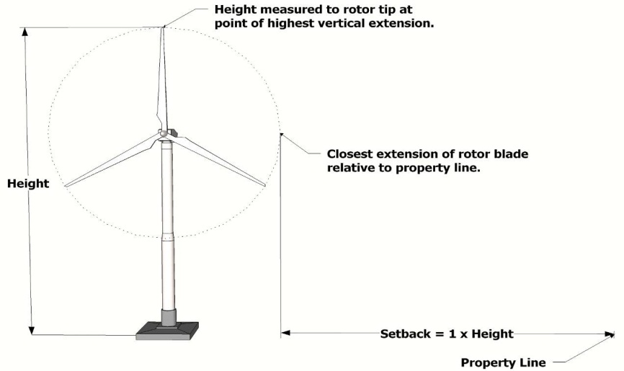
  - A property may have either ground mounted or building mounted WECS, but not both.
Ground Mounted WECS
  - Minimum Lot Area. A building mounted WECS shall be allowed on any lot, provided that all other requirements are met. The minimum lot area for installation of a ground mounted WECS shall be 30,000 square feet.
  - Power rating of the WECS turbine shall not be greater than twenty-five (25) kilowatts (kW).
  - The WECS shall provide energy only to the structures and uses on the same property upon which the tower is located and must be owned or leased by the owner of the same property; however, this does not prevent the distribution to the local utility company, through net metering, of any power that is generated beyond the needs of the structures or uses on the property.

- Ground-Mounted On-Site Service WECS

  - A ground mounted WECS shall not be located within a front yard; however, this shall not apply if the WECS is set back a minimum of two-hundred (200) feet from the road right-of-way line.
  - The WECS shall be located on the property so that it is set back from all property lines a minimum distance equal to the WECS height. The setback shall be measured from the property line (considered as a plane extending from the ground to the highest point of the WECS) to the closest extension of the rotor relative to the property line. No part of a WECS (including guy wire anchors) shall be located within or above any required setback.
  - The WECS height shall be limited by available setbacks as required in paragraph 2 above; however, no WECS shall exceed fifty (50) feet high on a property at least 30,000 square feet but less than one acre in area; seventy-five (75) feet high on a property one acre in area but less than three acres; and no more than one-hundred twenty-five (125) feet high on any property three acres in area or greater. Any WECS over 50 feet high is subject to site plan review according to Chapter 14, regardless of lot size.
  - The minimum rotor blade tip clearance from grade, any structure or utility line shall be fifteen (15) feet.
  - The diameter of the rotor shall be dependent upon maximum WECS height and rotor blade tip clearance, but in no case shall it exceed fifty (50) feet.

- Building Mounted On-Site Service WECS

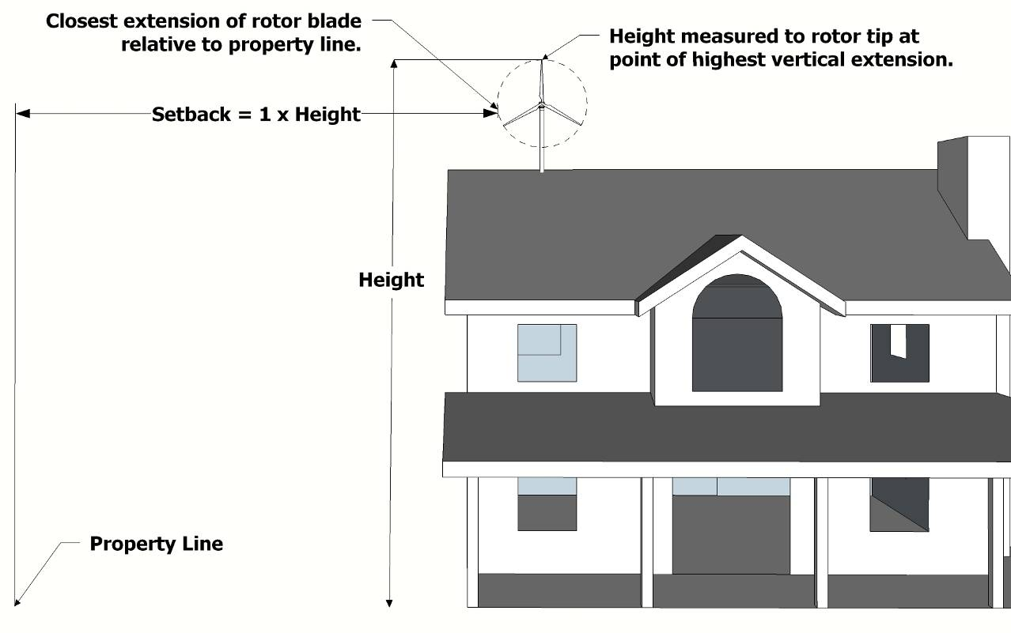
  - There may be more than one building mounted on-site service WECS on a single property; however, each individual WECS shall meet all of the requirements in this Subsection, and each WECS shall be separated from any other WECS no less than ten (10) feet, measured between the maximum extension of the rotors.
Building Mounted WECS
  - The WECS shall be mounted so that it is set back from adjoining property lines a minimum distance equal to the combined height of the WECS and the height of the portion of the building on which it is mounted. The setback shall be measured from the property line (considered as a plane extending from the ground to the highest point of the WECS) to the closest extension of the rotor relative to the property line.
  - The WECS height shall be limited by available setbacks as required in paragraph 2 above; however, no building mounted WECS shall exceed the maximum permitted height for principal buildings in the district, plus twenty (20) feet.
  - The diameter of the rotor shall not exceed twenty-five (25) feet.
  - A building mounted WECS shall not be mounted to the vertical face of a gable end or dormer that is visible from the road. To the greatest degree possible, the WECS shall be mounted to the building in the least visible location.
  - The mount and the structure used to support a building mounted WECS shall meet applicable standards, as certified by an engineer.

- Discretionary Conditions: The Township may impose other terms and conditions regulating the construction, installation, use, maintenance, repair and removal of any WECS. Such other terms and conditions may include, but are not limited to, the following:

  - The preservation of existing trees and other existing vegetation not required to be removed for installation of a WECS.

  - The reasonable replacement of trees or other vegetation removed or destroyed during the construction or installation of a WECS.
  - Altering the location of the WECS to prevent impacts on neighboring properties, provided that all other requirements of this Section are met.
  - Requiring a performance bond or letter of credit, in favor of the Township, and conditioned upon the timely and faithful performance of all required conditions of the special land use, including but not limited to the timely and complete removal of a WECS, regulated under the terms of the Section, when required. Such performance bond or letter of credit shall remain in effect during and after the operation of a WECS until its operations have ceased and it has been removed.

- Commercial Wind Energy Conversion Systems and WECS Testing Facilities associated with a Commercial WECS shall be a special land use reviewed and approved according to Chapter 13. Specific requirements can be found in Section 13.04. LL
[Amended September 20, 2012]

.

CHAPTER 4
R-A - RURAL RESIDENTIAL/AGRICULTURAL DISTRICT

SECTION 4.01 PURPOSE

Land use decisions within this District will support the continued use of land for agricultural purposes. Design standards will promote preservation through low density development and the use of cluster, or open space, development. It is the purpose of this District to promote the orderly development of Sullivan Township, and to preserve the economic value of agricultural and open lands of the township. All uses permitted within this District shall be conducted with due consideration for the potential effects which may result from authorized agricultural uses, in accordance with Public Act 94 of 1995, the Michigan Right to Farm Act.

SECTION 4.02 PERMITTED USES

Land and/or buildings in this District may be used for the following purposes:

- Farms, including farm houses, related accessory buildings, and roadside stands of less than two-hundred (200) square feet.

- Single family dwellings.

- Greenhouses, orchards, and nurseries. A residence may also be located on the same property.

- Production of forest crops.

- Campgrounds.

- State licensed residential care family facilities.

- Family day care facilities.

- Cemeteries.

- Public utility or service buildings, not requiring outside storage or materials.

- Accessory buildings and uses, as regulated by Section 3.08

- Home occupations, as regulated by Section 3.22

- Building mounted solar energy collectors [Amended September 20, 2012]

- On-site Service Wind Energy Conversion Systems [Amended September 20, 2012]

SECTION 4.03 SPECIAL LAND USES

The following uses are permitted in the R-A District by obtaining approval from the Planning Commission as a Special Land Use after all applicable standards of Chapter 13 are satisfied.
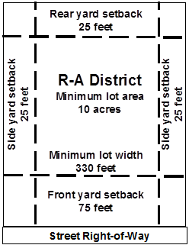
- Fairgrounds, riding stables, gun clubs, and publicly-owned athletic grounds and parks, country clubs/golf courses (excluding miniature golf) and other similar uses, including related uses, such as snack bars, small retail shops selling goods directly related to the primary use, and other similar uses integral to the main use.

- Intensive livestock operations.
- Bed and breakfast establishments.
- Kennels and veterinary hospitals. A residence may also be located on the same property.
- Radio, television, or telephone transmission towers, including towers in excess of one hundred (100) feet in height for commercial wireless telecommunication services.
- Schools and churches.
- Commercial removal and processing of soil, sand, gravel, or other minerals.
- Agricultural processing facilities.
- Roadside stands of two-hundred (200) square feet or greater.
- Planned Unit Developments (PUD).
- Group day care facilities [Amended March 7, 2007]
- Commercial Wind Energy Conversion Systems and WECS Testing Facilities associated with a Commercial WECS. [Amended September 20, 2012]
- Ground mounted solar energy collectors. [Amended September 20, 2012]
- Agricultural labor camp. [Amended August 20, 2017]

SECTION 4.04 DISTRICT REGULATIONS

The following dimensional requirements shall be met for any use found within this District, unless provided elsewhere.

R-A District Regulations
Minimum lot area | 10 acres
Minimum lot width | 330 feet
Minimum front yard setback | 75 feet
Minimum side yard setback | 25 feet
Minimum rear yard setback | 25 feet
Maximum building height | 3 stories; or 50 feet, [Amended 10/3/23]
Minimum dwelling unit size | 864 square feet  UFA on the first floor

CHAPTER 5
R-R - RURAL RESIDENTIAL DISTRICT

SECTION 5.01 PURPOSE

Land use decisions within this District will provide for larger lot residential uses as well as support the continued use of land for agricultural purposes. Design standards will promote preservation through low density development and the use of cluster, or open space, development. It is the purpose of this District to promote the orderly development of Sullivan Township, and to preserve the economic value of residential, agricultural and open lands of the township. All uses permitted within this District shall be conducted with due consideration for the potential effects which may result from authorized agricultural uses, in accordance with Public Act 94 of 1995, the Michigan Right to Farm Act.

SECTION 5.02 PERMITTED USES

Land and/or buildings in this District may be used for the following purposes:

- Farms, including farm houses, related accessory buildings, and roadside stands of less than two hundred (200) square feet.
- Single family dwellings.
- Greenhouses, orchards, and nurseries. A residence may also be located on the same property.
- Production of forest crops.
- Campgrounds.
- State licensed residential care family facilities.
- Family day care facilities.
- Cemeteries.
- Public utility or service buildings, not requiring outside storage or materials.
- Accessory buildings and uses, as regulated by Section 3.08.
- Home occupations, as regulated by Section 3.22.
- Building mounted solar energy collectors. [Amended September 20, 2012]
- On-site Service Wind Energy Conversion Systems. [Amended September 20, 2012]

SECTION 5.03 SPECIAL LAND USES

The following uses are permitted in the R-R District by obtaining approval from the Planning Commission as a Special Land Use after all applicable standards of Chapter 13 are satisfied.

- Fairgrounds, riding stables, public or private campgrounds, gun clubs, and publicly-owned athletic grounds and parks, country clubs/golf courses (excluding miniature golf) and other similar uses, including related uses, such as snack bars, small retail shops selling goods directly related to the primary use, and other similar uses integral to the main use.
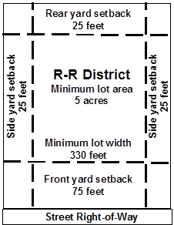
- Intensive livestock operations.
- Bed and breakfast establishments.
- Kennels and veterinary hospitals. A residence may also be located on the same property.
- Radio, television, or telephone transmission towers, including towers in excess of one hundred (100) feet in height for commercial wireless telecommunication services.
- Schools and churches.
- Commercial removal and processing of soil, sand, gravel, or other minerals.
- Agricultural processing facilities.
- Roadside stands of two hundred (200) square feet or greater.
- Planned Unit Developments (PUD)
- Group day care facilities [Amended March 7, 2007]
- Commercial Wind Energy Conversion Systems and WECS Testing Facilities associated with a Commercial WECS [Amended September 20, 2012]
- Ground mounted solar energy collectors [Amended September 20, 2012]

SECTION 5.04 DISTRICT REGULATIONS

The following dimensional requirements shall be met for any use found within this District, unless provided elsewhere.

R-R District Regulations
Minimum lot area | 5 acres
Minimum lot width | 330 feet
Minimum front yard setback | 75 feet
Minimum side yard setback | 25 feet
Minimum rear yard setback | 25 feet
Maximum building height | 3 stories; or 50 feet [Amended 10/3/23]
Minimum dwelling unit size | 864 square feet UFA on the first floor

CHAPTER 6
R-1 - LOW DENSITY RESIDENTIAL DISTRICT

SECTION 6.01 PURPOSE

This District recognizes that much of the land in this classification will eventually be converted from farm and vacant fields to residential use. This District is intended to preserve privacy and rural character, protect ground water quality, and recognize the limited ability of the township to provide costly services associated with higher densities.

SECTION 6.02 PERMITTED USES

The following uses are permitted within the R-1 Low Density Residential District:

- Farms, including farm houses, related accessory buildings, and roadside stands of less than two hundred (200) square feet.
- Single family dwellings.
- Greenhouses, orchards, and nurseries. A residence may also be located on the same property.
- Riding stables, gun clubs, and publicly owned athletic grounds and parks.
- Production of forest crops.
- Campgrounds.
- State licensed residential care family facilities.
- Family day care facilities.
- Cemeteries.
- Country clubs and golf courses, excluding miniature golf.
- Public utility or service buildings, not requiring outside storage or materials.
- Accessory buildings and uses, as regulated by Section 3.08
- Home occupations, as regulated by Section 3.22
- Building mounted solar energy collectors [Amended September 20, 2012]
- On-site Service Wind Energy Conversion Systems [Amended September 20, 2012]

SECTION 6.03 SPECIAL LAND USES

The following uses are permitted in the R-1 District by obtaining approval from the Planning Commission as a Special Land Use after all applicable standards of Chapter 13 are satisfied.

- Fairgrounds including related uses, such as snack bars, small retail shops selling goods directly related to the primary use, and other similar uses integral to the main use.
- Intensive livestock operations.
- Greenhouses and nurseries. A residence may also be located on the same property.
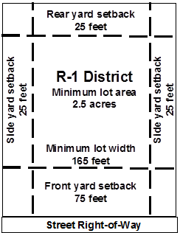
- Roadside stands not part of a farm.
- Group day care, hospitals, nursing homes, and housing for the elderly, but not including institutions for the mentally retarded, drug or alcohol patients, or correctional facilities.
- Municipal buildings and libraries.
- Bed and breakfast establishments.
- Radio, television, or telephone transmission towers, including towers in excess of one hundred (100) feet in height for commercial wireless telecommunication services.
- Kennels and veterinary hospitals. A residence may also be located on the same property.
- Planned Unit Developments (PUD)
- Commercial Wind Energy Conversion Systems and WECS Testing Facilities associated with a Commercial WECS [Amended September 20, 2012]
L. Ground mounted solar energy collectors [Amended September 20, 2012]

SECTION 6.04 DISTRICT REGULATIONS

The following dimensional requirements shall be met for any use found within this District, unless provided elsewhere.

R-1 District Regulations
Minimum lot area | 2½ acres
Minimum lot width | 165 feet
Minimum front yard setback | 75 feet
Minimum side yard setback | 25 feet
Minimum rear yard setback | 25 feet
Maximum building height | 3 stories; or 50 feet, [Amended 10/3/2023]
Minimum dwelling unit size | 864 square feet UFA  on the first floor

CHAPTER 7
R-2 - MEDIUM DENSITY RESIDENTIAL DISTRICT

SECTION 7.01 PURPOSE

This District is intended to preserve those elements which contribute to rural character yet allow a higher development density than that which is permitted in the R-1 District. Higher density land use in designated R-2 areas is intended for development that will be sensitive to existing land uses, consider the need to protect groundwater resources, and be designed to limit effects on traffic and natural features. Code enforcement within this District will be of particular importance due to the frequency of construction as well as the degree of potential damage that may result if regulations are not followed.

SECTION 7.02 PERMITTED USES

Land and/or buildings in this District may be used for the following purposes:

- Farms, including farm houses, related accessory buildings, and roadside stands of less than two hundred (200) square feet.
- Single family dwellings.
- Greenhouses, orchards, and nurseries. A residence may also be located on the same property.
- Publicly owned athletic grounds and parks.
- State licensed residential care family facilities.
- Family day care facilities.
- Cemeteries.
- Accessory buildings and uses, as regulated by Section 3.08.
- Home occupations, as regulated by Section 3.22.
- Building mounted solar energy collectors [Amended September 20, 2012]
- On-site Service Wind Energy Conversion Systems [Amended September 20, 2012]

SECTION 7.03 SPECIAL LAND USES

The following uses are permitted in the R-2 District by obtaining approval from the Planning Commission as a Special Land Use after all applicable standards of Chapter 13 are satisfied.

- Schools and churches.
- Public utility or service buildings, not requiring outside storage or materials.
- Group day care, hospitals, nursing homes, and housing for the elderly, but not including institutions for the mentally retarded, drug or alcohol patients, or correctional facilities.
- Municipal buildings and libraries.
- Kennels and veterinary hospitals. A residence may also be located on the same property.
- Planned Unit Developments (PUD)
- Commercial Wind Energy Conversion Systems and WECS Testing Facilities associated with a Commercial WECS [Amended September 20, 2012]

SECTION 7.04 DISTRICT REGULATIONS
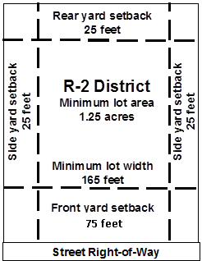
The following dimensional requirements shall be met for any use in this District, unless otherwise provided. [Amended October 4, 2005]

R-2 District Regulations
Minimum lot area | 1.25 acres  (54,450 square feet)
Minimum lot width | 165 feet
Minimum front yard setback | 75 feet
Minimum side yard setback | 25 feet
Minimum rear yard setback | 25 feet
Maximum building height | 3 stories; or 50 feet, [Amended 10/3/23]
Minimum dwelling unit size | 864 square feet UFA  on the first floor

CHAPTER 8
R-3 - HIGH DENSITY RESIDENTIAL DISTRICT

SECTION 8.01 PURPOSE

In recognition of the need to provide areas for more intensive residential growth, the R-3 District, High Density Residential, has been established. The presence of adequate public streets and the proximity of public utilities and services enable this District to accommodate intensive residential use. Development design must be sensitive to neighboring, existing uses to limit any potential negative effects.

SECTION 8.02 PERMITTED USES

Land/buildings within this District are allowed to be used for the following purposes:

- Single family dwellings.
- Publicly owned athletic grounds and parks.
- State licensed residential care family facilities.
- Family day care facilities.
- Cemeteries.
- Public utility or service buildings, not requiring outside storage or materials.
- Accessory buildings and uses, as regulated by Section 3.08
- Home occupations, as regulated by Section 3.22
- Building mounted solar energy collectors [Amended September 20, 2012]
J. On-site Service Wind Energy Conversion Systems [Amended September 20, 2012]

SECTION 8.03 SPECIAL LAND USES

The following uses are permitted in the R-3 district by obtaining approval from the Planning Commission as a Special Land Use after all applicable standards of Chapter 13 are satisfied.

- Two family dwellings.
- Multiple family dwellings.
- Schools and churches.
- Public utility or service buildings, not requiring outside storage or materials.
- Group day care.
- Hospitals, nursing homes, and housing for the elderly, but not including institutions for the mentally retarded, drug or alcohol patients, or correctional facilities.
- State licensed residential care group facilities.
- Municipal buildings and libraries.
- Kennels and veterinary hospitals. A residence may also be located on the same property.
- Planned Unit Developments (PUD)
- Commercial Wind Energy Conversion Systems and WECS Testing Facilities associated with a Commercial WECS [Amended September 20, 2012]

SECTION 8.04 DISTRICT REGULATIONS

The following dimensional requirements shall be met for any use in this District, unless otherwise provided.

R-3 District Regulations
Minimum lot area | Single family dwellings - 10,000 square feet
 | Two family dwellings - 20,000 square feet
Multiple family dwellings - 2 acres for first 4 units
Plus 2,500 square feet for each unit over 4.
Overall net density shall not exceed eight (8) units per acre
 | Nonresidential uses - 1 acre
Minimum lot width | Single family dwellings- 100 feet
 | Two family dwellings - 165 feet
 | Multiple family dwellings - 200 feet
 | Nonresidential uses - 200 feet
Minimum front yard setback | 40 feet
Minimum side yard setback | 25 feet
Minimum rear yard setback | 25 feet
Maximum building height | 3 stories; or 50 feet [Amended 10/3/23]
Minimum dwelling unit size | Single and two family dwellings  864 square feet per unit UFA on the first floor
Multiple Family Dwellings:
One bedroom - 750 square feet UFA per unit
Two bedrooms - 864 square feet UFA per unit
Over two bedrooms - 950 square feet UFA per unit

CHAPTER 9
R-4 - MANUFACTURED HOME PARK DISTRICT

SECTION 9.01 PURPOSE

To provide for manufactured home park development, of long-term duration of stay, in areas which are appropriate by means of traffic access and public utilities and services. Public water and sewer facilities, or a suitable alternative method of providing such services shall be provided for each development. This development is to be located near essential community services and abutting paved public streets. All manufactured home parks shall comply with the applicable requirements of Public Act 419 of 1976, as amended, and Public Act 96 of 1987, as amended, and all other applicable local, county, or state regulations.

SECTION 9.02 PERMITTED USES

Land and/or buildings in this District may be used for the following purposes:

- Manufactured homes when located within an approved manufactured home park.
- Public parks, playgrounds, play fields, and similar public open space recreation uses, not including campgrounds.
- Family day care.
- Accessory buildings and uses, as regulated by Section 3.08
- Home occupations, as regulated by Section 3.22
- State licensed residential care family facilities. [Amended March 7, 2007)
- Building mounted solar energy collectors [Amended September 20, 2012]
- On-site Service Wind Energy Conversion Systems [Amended September 20, 2012]

SECTION 9.03 REGULATIONS

All manufactured home parks shall comply with the applicable requirements of P.A. 419 of 1976 as amended, provided further that said developments meet the standards and conditions and all other provisions as herein established.

SECTION 9.04 INSTALLATION AND OCCUPATION OF MANUFACTURED HOMES

- No manufactured home shall be placed or parked or installed in a manufactured home park until such time as a building permit is obtained from the Township Building Inspector. Such permit shall be issued by the Building Inspector after making a finding that said manufactured home meets construction standards as approved by the Department of Housing and Urban Development (HUD) Code, or has been certified by a manufacturer as constructed according to the requirements of the HUD code.

- No manufactured home shall be occupied by any person as a residence or for any other purpose until such time as said manufactured home is placed or situated on a specific lot in the manufactured home park and has been inspected by the Township Building Inspector and issued an Occupancy Permit. Such inspection shall include the placement, connection to utilities, and compliance with all necessary State, Township or other ordinances and regulations. Such permit shall be issued by the Building Inspector on payment of inspection fee as may be authorized by resolution of the Township Board from time to time. In the event said manufactured home is moved to another lot or another manufactured home is placed on the specific lot, a new Occupancy Permit must be obtained by the owner or resident from the Township Building Inspector.

SECTION 9.05 APPLICATION PROCEDURES

- Rezoning Approval: The application for rezoning for a manufactured home park requires the approval of the Township Board upon recommendation from the Planning Commission. In reviewing the application the following shall be among the major considerations of both bodies prior to official action being taken:

  - Whether the proposal is in general accordance with the Master plan.
  - Whether the proposal meets all the design standards of this Ordinance and other applicable local codes, regulations, or ordinances.
  - Whether the development density of the proposed development could adversely affect adjacent properties and land uses.
  - Whether the proposed development can be reasonably expected to constitute a health hazard or public nuisance to adjacent properties because of inappropriate or inadequate sanitation and/or drainage facilities.
  - Whether the proposed development produces an extreme or undue demand on available fire and police protection or other Township or County services.
  - Whether the traffic characteristics of the proposed development can be expected to place an extreme or undue burden on adjacent vehicular and/or pedestrian circulation facilities.

- Site Plan: Any application for the extension, alteration, or construction of a manufactured home park shall be accompanied by a site plan of the proposed development and all permanent buildings indicating the proposed methods of compliance with these requirements. Said site plan shall be conformance with the provisions and requirements of Chapter 14 of this Ordinance.

SECTION 9.06 STANDARDS AND REGULATIONS

- Minimum site size for a manufactured home park shall be ten (10) acres.

- Minimum number of manufactured home spaces shall be twenty five (25). Required streets and utilities shall be completed for at least twenty five (25) manufactured home spaces along with related improvements before first occupancy.

- Each manufactured home park shall have direct access to a County Primary Road, as defined in the Township Master Plan.

- No access to the site shall be located closer than two hundred (200) feet from the intersection of any two (2) arterial streets. Minimum street widths within the manufactured home park shall be accordance with the following schedule:

Parking | Direction | Minimum Street Width
No on-street parking | one (1) way | 14 feet
 | two (2) way | 21 feet
Parallel parking one side | one (1) way | 24 feet
 | two (2) way | 31 feet
Parallel parking both sides | one (1) way | 34 feet
 | two (2) way | 41 feet

E. No manufactured home or other building or structure for residential purposes shall be in excess of two and one half (2½) stories, or in excess of a maximum height of twenty five (25) feet.

F. Each manufactured home lot, exclusive of streets, shall have a minimum size of five thousand (5,000) square feet and a minimum width of forty (40) feet, as measured at the minimum building setback line. No more than one (1) manufactured home shall be parked on any one (1) lot, and no manufactured home shall be occupied by more than one (1) family.

G. The minimum setback between any part of any manufactured home and/or structure permanently or temporarily attached thereto (excluding hitch), or used in conjunction therewith, including, but not by way of limitation, storage sheds, cabanas, and porches:

  - fifteen (15) feet from the inside of the sidewalk;
  - ten (10) feet from any rear lot line;
  - ten (10) feet from the side lot line on the entry side, and five (5) feet from the side yard on the non-entry side.
  - A manufactured home may be placed on the side lot line, provided there is minimum of fifteen (15) feet open space between said lot line and any other structure or manufactured home, including but not by way of limitation, storage sheds, cabanas or porches.

H. Each lot shall front on sidewalks at least four (4) feet in width, located directly next to and parallel to the street.

I. Each lot shall provide a minimum of four hundred (400) square feet of paved off-street parking.

J. The front, back and side yards of every lot shall be suitably landscaped and properly maintained with lawn area, and there shall be one (1) shade tree provided for every two (2) lots.

K. The manufactured home park shall provide a buffer zone strip separating the manufactured home park from adjacent property. The buffer zone shall be properly planted with trees or shrubbery or other nursery stock of varying height, so as to provide a density sufficient to block the view of the manufactured home park and buildings up to a minimum of five (5) feet in height. No part of the buffer zone shall be used for any structure, board fences, right-of-way, or parking purposes. The buffer zone shall be maintained by the owner of the park.

1. In the event the back yard of any lot or lots within a manufactured home abuts adjacent property, the rear ten (10) feet of each rear yard may be used as part of the buffer strip, provided further that no buildings, houses or other structures may be constructed with said strip.
2. The width of the buffer strip shall be in accordance with the following schedule:

Zoning of Adjacent Property | Width of Buffer
R-A, R-R | 15 feet
R-1, R-2, R-3 | 15 feet
Nonresidential Districts | 25 feet

L. The manufactured home park shall have minimum setback from any public street of one hundred (100) feet, which shall be properly landscaped with grassed area and maintained by the owner and operator of the manufactured home park.

M. All streets within the manufactured home park shall be of bituminous aggregate or similar surface meeting AASHTO public street construction specifications, and provided with proper curbing.

N. The manufactured home park shall contain one (1) or more open space areas intended primarily for the use of park residents on a minimum ratio of two hundred fifty (250) square feet for every manufactured home lot provided that buffer zone areas shall not be included as part of such requirement.

O. The manufactured home park shall provide one (1) or more storm shelters of size and capacity so as to accommodate all the residents of the park.

P. All street intersections and designated pedestrian crosswalks shall be illuminated by not less than .25 foot candles. All streets, parking bays and pedestrian walkways shall be illuminated by not less than .5 foot candles.

SECTION 9.07 UTILITY STANDARDS

- All utilities shall be underground.

- All lots shall be provided with a public water and sanitary sewer service, or such water and sanitary services that may be approved by the Muskegon County Health Department and other applicable agencies. All manufactured homes shall be connected thereto and all expenses of installation and connection shall be borne by the owner or operator of the manufactured home park, and no costs shall be applied or taxed against owners of any adjacent property or along any main extended from the manufactured home park to the present public sanitary sewer system, unless such adjacent owners shall install a sewer connection to such main.
- The manufactured home park shall provide sufficient storm sewer facilities, independent of sanitary sewers, to prevent flooding of either streets or lots within the park in accordance with the requirements of the Michigan Department of Health. All storm drainage and surface drainage facilities flowing from the park to adjacent areas shall be approved by the Muskegon County Drain Commissioner.

SECTION 9.08 MANUFACTURED HOME STANDARDS

- Every manufactured home shall be supported on a permanent concrete manufactured home pad or foundation at least twelve (12) feet in width with a minimum of six hundred (600) square feet, and four (4) inches thick; and all areas between the manufactured home and ground shall be enclosed by a skirt, providing said skirting is constructed or installed and is fire resistant.

- In the event the soil or topographic conditions of the proposed manufactured home park are such that other foundations or support are appropriate, and the developer provides to the Township Building Inspector a report by a certified engineer that piers are equal to or superior to the specifications as set forth in this Section, such foundations may be approved by the Building Inspector, provided such construction includes provisions for proper drainage and covering ground under each manufactured home.

- Every manufactured home shall be at least twelve (12) feet in width and have a minimum of seven hundred twenty (720) square feet of living area exclusive of porches and cabanas.

SECTION 9.09 MANUFACTURED HOME SALES

- No person desiring to rent a dwelling unit site shall be required, as a condition to such rental, to purchase a manufactured home from the owner or operator of the park as long as the manufactured home intended to be located on such rented site conforms in size, style, shape, price, etc. as may be required by any reasonable rules and regulations governing the operation of the manufactured home park.

- Nothing contained in this Ordinance shall be deemed as prohibiting the sale of a manufactured home lot by the individual owner or his agent, or those home occupations as permitted in the Zoning Ordinance, provided such sales and occupations are permitted by the park regulations. A commercial manufactured home sales lot shall not be permitted in this District.

CHAPTER 10
NC - NEIGHBORHOOD COMMERCIAL DISTRICT

SECTION 10.01 PURPOSE

The Neighborhood Commercial District provides locations within the township for small, convenient commercial areas. Uses considered to be appropriate for the NC District shall cater to the residents of Sullivan Township and nearby areas, remain small enough in scale to be well integrated into a neighborhood setting, and possess appropriate traffic safety components which will limit potential negative impacts resulting from a nonresidential use. Uses are prohibited which may create hazards; offensive or loud noises; or excessive vibration, smoke, glare, or heavy truck traffic.

SECTION 10.02 PERMITTED USES

Land and/or buildings in this District may be used for the following purposes:

- Retail food establishments which supply groceries, fruits, vegetables, meats, dairy products, baked goods, confections, or similar commodities for consumption off premises, and other retail businesses of a neighborhood character such as drug, variety, dry goods, clothing, notions, music, book, or hardware stores, conducting business entirely within enclosed buildings of less than ten thousand (10,000) square feet of GFA.
- Restaurants, not including drive-through facilities.
- Banks, credit unions, and similar financial institutions, not containing drive-in facilities.
- Personal service establishments which perform services on the premises, including barber and beauty shops, photographic studios, dry cleaners, electronics repair, and similar uses.
- Professional and business offices.
- Public buildings and public utility offices, but not including storage yards, substations, or regulator stations.
- Accessory buildings and uses, as regulated by Section 3.08
- Building mounted solar energy collectors [Amended September 20, 2012]
- On-site Service Wind Energy Conversion Systems [Amended September 20, 2012]

SECTION 10.03 SPECIAL LAND USES

The following uses are permitted in the NC District by obtaining approval from the Planning Commission as a Special Land Use after all applicable standards of Chapter 13 are satisfied.

- Retail food establishments which supply groceries, fruits, vegetables, meats, dairy products, baked goods, confections, or similar commodities for consumption off premises, and other retail businesses such as drug, variety, dry goods, clothing, notions, music, book, or hardware stores, conducting business entirely within enclosed buildings of ten thousand (10,000) square feet of GFA or greater.
- Drive-through establishments including banks, dry cleaners, pharmacies, and similar personal services with drive-through service.
- Drive-through restaurants.
- Mortuaries and funeral homes.
- Open air businesses.
- Vehicle service stations.
- Vehicle wash establishments.
- Commercial day care centers.
- Medical offices including clinics.
- Hotels and motels.
- Commercial recreation including mini-golf, driving ranges, bowling lanes, theaters, indoor skating rinks, billiard parlors, or similar uses.
L. Commercial Wind Energy Conversion Systems and WECS Testing Facilities associated with a Commercial WECS [Amended September 20, 2012]

SECTION 10.04 DISTRICT REGULATIONS

- The following dimensional requirements shall be met for any use in this District, unless otherwise provided.

NC District Regulations
Minimum lot area | 2 acres
Minimum lot width | 200 feet
Minimum front yard setback | 35 feet  No parking area, except for driveways, shall be located within the front yard. The front yard shall be landscaped.
Minimum side and rear yard setback | 25 feet
 | Side or rear yards adjoining any lot in a Residential District shall be screened by a compact hedge of deciduous or evergreen trees which reach a minimum of five (5) feet in height and five (5) feet in width after one (1) growing season; or a solid wall or opaque board fence six (6) feet in height.
Maximum building height | 3 stories; or 50 feet,  [Amended 10/3/23]
Maximum lot coverage | 25 percent

- Parking lots for uses in the NC District shall be adequately lit to ensure security and safety and shall meet the following requirements:

  - Light fixtures shall be no higher than twenty (20) feet and shall be provided with light cut-off fixtures that direct light downward. Lighting shall not be attached to buildings or other structures that permit light to be directed horizontally.
  - Lighting shall not be permitted to illuminate areas not within the parking lot or other areas related to the use for which the parking is intended.

CHAPTER 11
SC - SULLIVAN CORNERS

SECTION 11.01 PURPOSE

The Sullivan Corners District will focus on creating a commercial center within the township that remains sensitive to existing and planned residential development and yet is able to accommodate the commercial needs of township residents. In order to achieve this balance, regulations shall focus on site design including; building location, parking areas, driveway location, lighting, landscaping, street capacity, signs, noise and other potential nuisances, and location of activity areas.

SECTION 11.02 PERMITTED USES

Land and/or buildings in this District may be used for the following purposes:

- Any retail business whose principal activity is the sale of merchandise within an enclosed building.
- Service establishments, including printing, publishing, photo reproduction, blueprinting, and related trades or arts.
- Public buildings and service installations.
- Health and physical fitness establishments.
- Restaurants, not including drive-through facilities.
- Accessory buildings and uses, as regulated by Section 3.22
- Building mounted solar energy collectors [Amended September 20, 2012]
- On-site Service Wind Energy Conversion Systems [Amended September 20, 2012]

SECTION 11.03 SPECIAL LAND USES

The following uses are permitted in the SC District by obtaining approval from the Planning Commission as a Special Land Use after all applicable standards of Chapter 13 are satisfied.

- Drive-through establishments, including banks, dry cleaners, pharmacies, and similar personal services with drive-through service.
- Open air businesses.
- Commercial recreation including mini-golf, driving ranges, bowling lanes, theaters, indoor skating rinks, billiard parlors, or similar uses.
- Vehicle service stations.
- Vehicle wash establishments.
- Building materials sales, including building trade contractors and related storage yards.
- Funeral homes and mortuary establishments.
- Commercial day care centers.
- Hotels and motels.
- Veterinary hospitals, clinics, and kennels.
- Commercial storage warehouses.
- Assembly buildings including dance halls, auditoriums, churches, and private clubs.
- Commercial Wind Energy Conversion Systems and WECS Testing Facilities associated with a Commercial WECS [Amended September 20, 2012]

SECTION 11.04 DISTRICT REGULATIONS

- The following dimensional requirements shall be met for any use in this District, unless otherwise provided.

SC District Regulations
Minimum lot area | 1 acre
Minimum lot width | 100 feet
Minimum front yard setback | 35 feet  No parking area, except for driveways, shall be located within the front yard. The front yard shall be landscaped.
Minimum side and rear yard setback | 25 feet
 | Side or rear yards adjoining any lot in a Residential District shall be screened by a compact hedge of deciduous or evergreen trees which reach a minimum of five (5) feet in height and five (5) feet in width after one (1) growing season; or a solid wall or opaque board fence six (6) feet in height.
Maximum building height | 3 stories; or 50 feet, [Amended 10/3/23]
Maximum lot coverage | 25 percent

- Parking lots for uses in the SC District shall be adequately lit to ensure security and safety and shall meet the following requirements:

  - Light fixtures shall be no higher than twenty (20) feet and shall be provided with light cut-off fixtures that direct light downward. Lighting shall not be attached to buildings or other structures that permit light to be directed horizontally.
  - Lighting shall not be permitted to illuminate areas not within the parking lot or other areas related to the use for which the parking is intended.

CHAPTER 12
LI - LIGHT INDUSTRIAL

SECTION 12.01 PURPOSE

Due to the limited ability of Sullivan Township to provide a high level of public utility service, such as water and sewer, there is a limited number of industries which would be able to locate in the area. Sites which generally meet the following qualifications may be considered for light industrial development:

- adequate street capabilities to manage truck traffic;
- availability of public utilities;
- sufficient area for parking, loading, screening, and activities; and
- adequate separation from residential uses to prevent a nuisance.

SECTION 12.02 PERMITTED USES

- Industrial plants manufacturing, compounding, processing, packaging, treating, or assembling the following:
  - Agricultural products, including but not limited to, the production in greenhouses of flowers, plants, shrubs, trees, or other similar living products;
  - Food and kindred products including meat, dairy, fruit, vegetable, seafood, bakery, confectionery, beverage, and similar products (but not including slaughtering of animals, or rendering or refining of fats or oils);
  - Electrical machinery, equipment and supplies, electronic components and accessories; and
  - Engineering, measuring, optical, medical, scientific, photographic, and similar instruments and goods.

- Industrial plants manufacturing, compounding, processing, packaging, treating, or assembling materials or products from previously prepared materials including the following:

  - Textile mill products, including woven fabric, knit goods, dyeing and finishing, floor coverings, yarn and thread, and other similar products;
  - Apparel and other finished products including clothing, leather goods, and canvas products;
  - Lumber and wood products including mill work, prefabricated structural work products and containers;
  - Paper and paperboard containers and products;
  - Biological products, drugs, medicinal chemicals and pharmaceutical preparations;
  - Glass products;
  - Jewelry, silverware and plated ware, musical instruments and parts, toys, amusements, sporting, and athletic goods, pens, pencils, and other office and artist supplies and materials, notions, signs and advertising displays;
  - Pottery and figurines and other ceramic products using only previously pulverized clay; and
  - Fabricated metal products, except the production of heavy machinery and transportation equipment.

- Wholesale businesses, including automotive equipment , drugs, chemicals, dry goods, apparel, food, farm products, electrical goods, hardware, machinery, equipment, metals, paper products, and lumber.
- Warehousing, including refrigerated and general storage.
- Office buildings for executive, administrative, professional, accounting, drafting, and other similar professional activities.
- Research and development facilities, including production activities, which shall be limited to fifty (50) percent of the floor area of the building.
- Trade or industrial schools.
- New building materials sales and storage, including building trade contractors and related storage yards.
- Utilities and communications installations such as electrical receiving or transforming stations, microwave towers, and televisions and radio towers, including towers for commercial wireless telecommunication services.
- Utility and public service buildings, including storage yards.
- Landfills which meet State of Michigan standards.
- Accessory buildings and uses, as defined in Section 3.22.
- Building mounted solar energy collectors [Amended September 20, 2012]
- On-site Service Wind Energy Conversion Systems [Amended September 20, 2012]

SECTION 12.03 SPECIAL LAND USES

The following uses are permitted in the LI District by obtaining approval from the Planning Commission as a Special Land Use after all applicable standards of Chapter 13 are satisfied.

- Truck and freight terminals, and maintenance facilities.
- Junkyards and salvage yards.
- Restaurants, not including drive-through establishments.
- Sawmills.
- Removal and processing of soil, sand, gravel, or other mineral resources.
- Tool and die metal working shops.
- Adult uses.
- Commercial Wind Energy Conversion Systems and WECS Testing Facilities associated with a Commercial WECS [Amended September 20, 2012]
- Ground mounted solar energy collectors [Amended September 20, 2012]

SECTION 12.04 DISTRICT REGULATIONS

- The following dimensional requirements shall be met for any use in this District, unless otherwise provided.

LI District Regulations
Minimum lot area | 2 acres
Minimum lot width | 200 feet
Minimum front yard setback | 75 feet  No parking area, except for driveways, shall be located within the front yard. The front yard shall be landscaped.
Minimum side and rear yard setback | 25 feet
 | Side or rear yards adjoining any lot in a Residential District shall be screened by a compact hedge of deciduous or evergreen trees which reach a minimum of five (5) feet in height and five (5) feet in width after one (1) growing season; or a solid wall or opaque board fence six (6) feet in height.
Maximum building height | 35 feet
Maximum lot coverage | 50 percent

- Light fixtures for parking lot and other outdoor activity areas shall be no higher than twenty (20) feet and shall be provided with light cut-off fixtures that direct light downward. Lighting shall not be attached to buildings or other structures that permit light to be directed horizontally.

CHAPTER 13
SPECIAL LAND USES

SECTION 13.01 SCOPE

This Chapter provides a set of procedures and standards for special uses of land or structures which, because of their unique characteristics, require special consideration in relation to the welfare of adjacent properties and the community as a whole. The regulations and standards, herein, are designed to allow, on one hand, practical latitude for the applicant, but at the same time maintain adequate provision for the protection of the health, safety, convenience, and general welfare of Sullivan Township. For purposes of this Ordinance, all Special Land Uses within the various districts are subject to the conditions and standards of this Chapter. In addition, the following uses shall conform to the specific standards cited in Section 13.04, as applicable.

SECTION 13.02 APPLICATION AND REVIEW PROCEDURES

- An application shall be submitted through the Zoning Administrator. Each application shall be accompanied by:

  - the payment of a fee as established by the Township Board;
  - an completed application form, as provided by the Township; and
  - a complete site plan as specified in Chapter 14.

- Applications for a Special Land Use shall be submitted at least thirty (30) days prior to the next Planning Commission meeting.

- The application, along with the required site plan, shall be forwarded to the Planning Commission at its next scheduled meeting.

- The Planning Commission shall hold a public hearing on the application, providing the notice of such hearing in accordance with the Zoning Act. The Planning Commission shall then review the application and such other information available to it through the public hearing or from any other sources, including recommendations or reports from the Township planner, engineer, or other party, and shall recommend approval, approval with conditions, or deny the request, and incorporate the basis for the decision and any conditions which should be imposed. [Amended March 7, 2007]

- The Township Board, upon receipt of the recommendation from the Planning Commission, shall approve, approve with conditions, or deny the Special Land Use. The record shall contain the basis for the decision. [Amended March 7, 2007]

- No petition for Special Land Use approval, which has been disapproved, shall be resubmitted for a period of one (1) year from the date of disapproval, except as may be permitted after learning of new and significant facts or conditions which might result in favorable action upon resubmittal.

- A Special Land Use approved pursuant to this Chapter shall be valid for one (1) year from the date of approval. Each development shall be under construction within one (1) year after the date of approval of the Special Land Use, except as noted below.
  - The Planning Commission may grant one (1) six (6) month extension of such time period, provided the applicant requests the extension prior to the date of the expiration of the Special Land Use approval.
  - The extension shall be approved if the applicant presents reasonable evidence to the effect that said development has encountered unforeseen difficulties beyond the control of the applicant, and the project will proceed within the extension period.
  - If neither of the above provisions are fulfilled or the six (6) month extension has expired prior to construction, the Special Land Use approval shall be null and void.

- The Planning Commission shall have the authority to revoke any Special Land Use approval after it has been shown that the holder of the approval has failed to comply with any of the applicable requirements of this Chapter, other applicable sections of this Ordinance, or conditions of the Special Land Use approval. Prior to any action, the Planning Commission shall conduct a public hearing following the notification procedures for the original approval.

SECTION 13.03 GENERAL STANDARDS

In addition to the standards established for specific uses herein, an application for a Special Land Use shall be reviewed for compliance with the review standards for approval of site plans in Section 14.08 hereof, and conditions, as authorized and governed in Section 14.09 and Section 13.03. B, may be placed upon a Special Land Use.

- Each application shall be reviewed for the purpose of determining that the proposed special land use meets the following standards and, in addition, that each use of the proposed site will:

  - be designed, constructed, operated and maintained so as to be harmonious and appropriate in appearance, with the existing or intended character of the general vicinity and that such a use will not change the essential character of the area in which it is proposed;
  - be served adequately by essential public facilities and services such as highways, streets, police, fire protection, drainage structures, refuse disposal, water and sewage facilities;
  - not create excessive additional requirements at public cost for public facilities and services; and
  - not involve uses, activities, processes, materials, and equipment or conditions of operation that will be detrimental to any persons, property, or the general welfare by reason of excessive production of traffic, noise, smoke, fumes, glare, or odors.

- The Planning Commission may stipulate such additional conditions and safeguards deemed necessary to accomplish the following purposes. Failure to comply with such conditions may result in the revocation of the Special Land Use approval, pursuant to Section 13.02.G. Conditions imposed shall be those necessary to:

  - meet the intent and purpose of the Zoning Ordinance,
  - relate to the standards established in the Ordinance for the land use or activity under consideration,
  - insure compliance with those standards,
  - protect the general welfare,
  - protect individual property rights, and
  - ensure that the intent and objectives of this Ordinance will be observed.

SECTION 13.04 SPECIAL LAND USE SPECIFIC REQUIREMENTS

The general standards and requirements of Section 13.03.A, are basic to all Special Land Uses. The specific and detailed requirements set forth in the following Section relate to particular uses and are requirements which must be met by those uses in addition to the foregoing general standards and requirements.

- Adult uses.

  - In the development and execution of this subsection, it is recognized that there are some uses which, because of their very nature, have serious objectionable operational characteristics, particularly when several when concentrated in certain areas, or located in proximity to a residential zone, thereby having a detrimental effect upon the adjacent areas. Special regulation of these uses is necessary to insure that these adverse effects will not contribute to the blighting or downgrading of the surrounding neighborhood. These controls of this subsection are for the purpose of preventing a concentration of these uses within any one area, or to prevent deterioration or blighting of a nearby residential or other neighborhood. These controls do not legitimize activities which are prohibited in other Sections of the Zoning Ordinance.
  - Adult uses shall comply with the following requirements:

    - The use shall not be located within a 1,000 foot radius of any other such use.
    - All persons massaging any client or customer must be certified as a massage therapist by the American Massage Therapy Association or be a graduate of a School of Massage Therapy that is certified by the State of Michigan, or have such other similar qualifications which must be submitted to and approved by the Planning Commission. All massage clinics are subject to inspection from time to time by the Township Building Inspector and shall be required to file reports as may be required by the Township, at least annually, as to the names and qualifications of each person who administers massages under the authority or supervision of the massage establishment.
    - Establishments where uses subject to the control of this subsection are located shall not be expanded in any manner without first applying for and receiving the approval of the Planning Commission, as provided herein.

- Agricultural processing facilities.

  - The principle and accessory buildings for processing shall not be located within two hundred (200) feet of any Residential District or use property line.
  - The proposed site shall front upon a paved County Primary or County Local street. All ingress and egress shall be from said thoroughfare.

- Assembly buildings including dance halls, auditoriums, and private clubs.

  - The proposed site shall front upon a paved County Primary or County Local street. All ingress and egress shall be from said thoroughfare.
  - Public access to the site shall be located at least one hundred (100) feet from any intersection as measured from the nearest right-of-way line to the nearest edge of said access.
  - Minimum lot area shall be one (1) acre.
  - Parking shall not be permitted within any required yard.
  - Outside activities shall take place at least fifty (50) feet from any residential district or use.

- Bed and breakfast establishments.

  - The establishment shall be serviced by approved water and sanitary sewer services.
  - The establishment shall be located on property with direct access to a paved public street.
  - Such uses shall only be established in a detached single family dwelling.
  - Parking shall be located to minimize negative impacts on adjacent properties.
  - The lot on which the establishment is located shall meet the minimum lot size requirements of the zone district.
  - The total number of guest rooms in the establishment shall not exceed five (5), plus one (1) additional guest room for each ten thousand (10,000) square feet or fraction thereof by which the lot area of the use exceeds one (1) acre, not to exceed a total of nine (9) guest rooms.
  - Exterior refuse storage facilities beyond what might normally be expected for a detached single family dwelling shall be screened from view on all sides by a six (6) foot solid, decorative fence or wall.
  - One (1) sign shall be allowed for identification purposes. Such sign shall not exceed sixteen (16) square feet in area, and may not exceed four (4) feet in height. If illuminated, such illumination shall only be of an indirect nature; internally lighted signs are not permitted. Such sign shall be set back at least one half (½) of the front yard setback area setback of the zoning district in which the use is located and shall be located at least fifteen (15) feet from any side or rear lot line.
  - The establishment shall contain the principal residence of the operator.
  - Accessory retail or service uses to a bed and breakfast establishment shall be prohibited, including but not limited to gift shops, antique shops, bakeries, and other similar uses.
  - Meals may be served only to the operator's family, employees, and overnight guests.

- Building materials sales, including building trade contractors and related storage yards.

  - Minimum lot width shall be two hundred (200) feet.
  - The Planning Commission may require a six (6) foot fence or wall to be constructed along the rear and/or sides of the lot to keep trash, paper, and other debris from blowing off the premises.
  - Ingress and egress shall be provided as far as practicable from two (2) intersecting streets and shall be at least one hundred (100) feet from an intersection.
  - All lighting shall be shielded from adjacent residential Districts or uses.
  - The storage or materials display areas shall meet all the yard setback requirements applicable to any principal building in the District.

- Cemeteries.

  - The proposed site shall front upon a paved public street.
  - All grave sites, buildings and structures shall be setback at least fifty (50) feet from any side or rear property line.
- Churches and schools.

  - Minimum lot area shall be two (2) acres; plus an additional fifteen thousand (15,000) square feet for each one hundred (100) seating capacity or fraction thereof in excess of one hundred (100).
  - The property location shall be such that at least one (1) property line abuts and has access to a collector, major arterial, or minor arterial street.
  - A greenbelt shall be provided in accordance with Section 3.12 where, in the opinion of the Planning Commission, screening is required to minimize visual, noise, or other effects from the proposed development.

- Commercial recreation including mini-golf, driving ranges, bowling lanes, theaters, indoor skating rinks, billiard parlors, or similar uses.

  - The proposed site shall front upon a paved County Primary, or County Local street. All ingress and egress shall be from said thoroughfare.
  - Public access to the site shall be located at least one hundred fifty (150) feet from any intersection as measured from the nearest right-of-way line to the nearest edge of said access.
  - Any lot line abutting a Residential District shall provide a fifty (50) foot wide greenbelt in accordance with Section 3.12.
  - The principal and accessory buildings and structures shall not be located within one hundred (100) feet of any Residential District or permitted use.
  - Golf driving ranges shall be sufficient in size to retain balls within the site by means of landscaping, berms or a six (6) foot high fence. Netting shall be prohibited unless the Planning Commission determines that it would be compatible with surrounding uses.

- Commercial removal and processing of topsoil, stone, rock, sand, gravel, lime or other soil or mineral resources.

  - No soil, sand, gravel, or other earth material shall be removed from any land within the township without Special Land Use approval, with the following exceptions:

    - When the earth removal is incidental to an operation for which a building permit has been issued by the Township;
    - When the earth removal involves any normal landscaping, driveway installation and repairs, or other minor projects;
    - The earth removal will not alter predominate drainage patterns or cause drainage impacts to adjoining properties;
    - The earth removal involves less than three hundred (300) cubic yards;
    - The earth removal is for the purpose of construction of a swimming pool.
    - The soil removal will not be in violation of any other section of this ordinance, other Township ordinance, Soil Erosion and Sedimentation Control Act of 1972, or any other applicable state or federal law.

  - In addition to the materials required by this Chapter, the application for special land use approval shall include the following:

    - A written legal description of all of the lands proposed for the use.
    - Ten (10) copies of a plan for mineral removal, drawn and sealed by a registered civil engineer, and including the following, at a minimum:

      - A north arrow, scale, and date;
      - shading indicating the extent of land area on which mineral removal operations and activities will take place;
      - the location, width, and grade of all easements or rights-of-way on or abutting the lands;
      - the location and nature of all structures on the lands;
      - the location and direction of all water courses and flood control channels which may be affected by the mineral removal operations;
      - existing elevations of the lands at intervals of not more than five (5) feet;
      - typical cross sections showing the estimated extent of overburden, estimated extent of mineral material location in or on the lands, and the water table;
      - mineral processing and storage areas;
      - proposed fencing, gates, parking areas, and signs;
      - streets for ingress to and egress from the lands, including on-site streets, other areas to be used for movement of vehicles and a description of the proposed measures to limit dust generated by mineral removal activities and movement of vehicles;

        - a map showing access routes between the subject lands and the nearest County Primary street; and
        - areas to be used for ponding.

    - A narrative description and explanation of the proposed mineral removal operations and activities; including the date of commencement, proposed hours and days of operation, estimated by type and quantity of mineral materials to be removed, description of extraction and processing methods, including proposed equipment and the noise rating of each type thereof, and a summary of the procedures and practices which will be used to ensure compliance with the conditions of this subsection.
    - A site rehabilitation plan including the following:

      - A written description of planned site rehabilitation and end-use(s), including potential methods of accomplishment and phasing;
      - a plan showing final grades of the lands as rehabilitated, at contour intervals not exceeding five (5) feet; water courses, ponds, or lakes, if any; landscaping and plantings; areas of cut and fill; and all of the components of the proposed end-use(s); and
      - a description of the proposed methods or features which will ensure that the end-use(s) are feasible and can comply with all applicable requirements of this Ordinance.

    - The Planning Commission may require an environmental impact statement, engineering data, or other additional information concerning the need for and consequences of such extraction if it is believed that the extraction may have an adverse impact on natural topography, drainage, water bodies, floodplains, or other natural features.

  - Each site rehabilitation plan shall be reviewed by the Planning Commission and shall comply with all of the following standards and requirements:

    - Topsoil shall be replaced on the site to a depth of not less than six (6) inches, except where the end-use activities or features do not involve the planting of lawns or growing of vegetation. Slopes shall be graded and stabilized to such extent as will accommodate the proposed end-use. The plan shall indicate the phasing of site rehabilitation, if the same is to take place in phases, and if so, topsoil shall be replaced and slopes shall be graded and stabilized before mineral removal operations or activities are commenced in another area of the site.
    - Final slopes shall have a ratio of not more than one (1) foot of elevation to three (3) feet of horizontal distance.
    - Plantings of grass, shrubs, trees, and other vegetation shall be made so as to maximize erosion protection, screen less attractive areas of end-uses, and enhance the beauty of the site as rehabilitated.

  - No machinery shall be erected or maintained within one hundred (100) feet of any exterior property line. No cut or excavation shall be made closer than fifty (50) feet to any street right-of-way line or property line in order to ensure sub-lateral support to surrounding property. The Planning Commission may require greater distances for the location of machinery, storage or parking of equipment, or limits of excavation where the site is located within two hundred (200) feet of any Residential District.
  - The Planning Commission shall recommend routes for truck movement to and from the site in order to minimize the wear on public streets and to prevent hazards and damage to properties in the community. Access roads within the area of operation shall be provided with a dustless surface and the entry road shall be hard surfaced for a distance established by the Planning Commission to minimize dust, mud, and debris being carried onto the public street.
  - Proper measures, as determined by the Zoning Administrator shall be taken to minimize the nuisance of noise and flying dust or rock. Such measures may include, when considered necessary, limitations upon the practice of stockpiling excavated material upon the site.
  - During activities and operations for the removal of mineral material, no mineral material or other excavated materials shall be left during weekends or overnight in such condition or manner as to constitute a danger to children or others who may enter the removal areas. All banks of excavated material shall be graded to slopes having a vertical to horizontal ratio of not greater than one (1) foot of elevation for each two (2) feet of horizontal distance, after the cessation of daily operations, provided, however, that the Planning Commission may require some lesser daily grading requirement if the applicant provides a substantially constructed and maintained welded wire fence, or fence of equally substantial material, of at least four (4) feet in height, so located that any slopes steeper than one (1) foot of elevation for each two (2) feet of horizontal distance cannot inadvertently be approached by any persons who may enter the removal area.
  - The Planning Commission may require compliance with such other conditions as may be necessary to ensure compliance with the terms of this subsection. Such conditions may include, though need not be limited to, time limits, weed controls, erosion and sedimentation controls, fencing and visual screening, requirements for groundwater monitoring wells, preservation of trees and other vegetation, and fuel loading and storage requirements.
  - An applicant for a permit shall submit a performance bond in accordance with the requirements of this Ordinance, naming the Township of Sullivan as the insured party and conditioned upon the timely and faithful performance by the applicant of all of the terms and conditions of the permit. The bond shall have such other terms and shall be in such amount as is recommended by the Planning Commission as reasonably necessary to ensure compliance with all of the terms and conditions of this subsection and the permit.

    - The performance bond shall not be refunded, reduced, or transferred until the mineral removal operations and activities, land reclamation or restoration, and all other required activities have received final inspection by the Zoning Administrator and until the Planning Commission has determined that the applicant, or its successor, has fully complied with all of the terms, conditions, site rehabilitation and restoration requirements, and all other matters required of the applicant under the terms of the permit.
    - The timely and faithful compliance with all of the provisions of the performance bond shall be a condition of any mineral removal operations. In the absence of any such compliance with the terms of the performance bond, or if the same is revoked or it expires or is not renewed, the Planning Commission need not approve the renewal of any permit, even if the applicant has otherwise complied with all other terms and provisions of the current permit.

- Commercial storage warehouses.

  - Minimum lot area shall be three (3) acres.
  - A residence may be permitted on the premises for security personnel or on-site operator. The residence shall conform to the minimum requirements for a single family detached dwelling in the R-1 District.
  - One (1) parking space shall be provided for each ten (10) storage cubicles, equally distributed throughout the storage area. The parking requirement may be met with the parking lanes required for the storage area.
  - Two (2) parking spaces shall also be required for the residence of security personnel or on-site operator employed on the premises.
  - One (1) parking space shall also be required for every twenty (20) storage cubicles, up to a maximum of ten (10) spaces, to be located adjacent the rental office, for the use of customers.
  - Parking lanes and access aisles adjacent the individual storage facilities shall be required. The parking lanes may be eliminated when the access aisle does not serve storage cubicles.
  - All driveways, parking, loading, storage, and vehicular circulation areas shall be paved
  - All lighting shall be shielded from adjacent residential Districts or uses.

- Drive-through restaurants and establishments, including banks, dry cleaners, pharmacies, and similar personal services with drive-through service.

  - Sufficient stacking capacity for the drive-through portion of the operation shall be provided to ensure that traffic does not extend into the public right-of-way. A minimum of ten (10) stacking spaces for the service ordering station shall be provided. Stacking spaces shall be located so as not to interfere with vehicular circulation and egress from the property by vehicles not using the drive-through portion of the facility.
  - In addition to parking space requirements, at least three (3) parking spaces shall be provided, in close proximity to the exit of the drive-through portion of the operation, to allow for customers waiting for delivery of orders.
  - Parking areas shall have side and rear yard setbacks of at least ten (10) feet.
  - Public access to the site shall be located at least one hundred (100) feet from any intersection or other driveway on the same side of the street, as measured from the nearest right-of-way line to the nearest edge of said access.
  - The parking and maneuvering areas of the site shall be fenced and screened from the view of any abutting Residential District or use by a decorative fence or wall, or a landscaped equivalent.
  - Outdoor speakers for the drive through facility shall be located in a way that minimizes sound transmission toward neighboring property and uses.

- Fairgrounds, riding stables, public or private campgrounds, and publicly-owned athletic grounds and parks, and other similar uses, including related uses, such as snack bars, small retail shops selling goods directly related to the primary use, and other similar uses integral to the main use.

  - The use shall be located on property with direct access to a public street.
  - Any outdoor activity areas shall be set back a minimum of one hundred (100) feet from any Residential District or use.
  - Lighting for parking areas or outdoor activity areas shall be shielded to prevent light from spilling onto any Residential District or use.
  - Access driveways shall be located no less than one hundred fifty (150) feet from the nearest part of the intersection of any street or any other driveway.
  - Buildings housing animals, storage equipment, or other similar buildings shall be located at least fifty (50) feet from any lot line.
  - Public or private campgrounds shall comply with the following:

    - Direct vehicular access to a public street shall only be permitted for the main entrance to the campground site.
    - Public stations, housed in all-weather structures, containing adequate water outlet, waste container, toilet and shower facilities shall be provided.
    - No commercial enterprise shall be permitted to operate on the lot, except that a convenience shopping facility may be provided on a lot containing more than eighty (80) sites. Such convenience store, excluding laundry and similar ancillary uses, shall not exceed a maximum floor area of one thousand (1,000) square feet GFA.
    - Each lot shall provide hard surfaced, dust free vehicle parking areas for site occupant and guest parking. Such parking area shall be located within four hundred (400) feet of the site it is intended to serve (except in the case of sites specifically designated only for tent camping).
    - Each site shall contain a minimum of one thousand five hundred (1,500) square feet. Each site shall be set back at least seventy five (75) feet from any public or private right-of-way or property line.
    - Each travel trailer site shall have direct access to a hard surfaced, dust free roadway of at least twenty four (24) feet in width for two way traffic and twelve (12) feet in width for one way traffic. Parking shall not be allowed on any roadway. Sites specifically designated for, and only used for, tent camping, need not have direct vehicular access to any street or road.
    - Any open drainage ways must have seeded banks sloped at least 3:1 and designed to properly drain all surface waters into the County drain system, subject to approval by the Drain Commissioner of Muskegon County.
    - All sanitary facilities shall be designed and constructed in strict conformance to all applicable County health regulations.
    - A minimum distance of fifteen (15) feet shall be provided between all travel trailers and tents.

- Funeral homes and mortuary establishments.

  - Minimum lot area shall be two (2) acres with a minimum width of one hundred fifty (150) feet.
  - A well designed and landscaped off-street vehicle assembly area shall be provided to be used in support of funeral procession activity. This area shall not obstruct internal circulation within the required off-street parking area or its related maneuvering space. Access driveways shall be located no less than fifty (50) feet from the nearest part of the intersection of any street or any other driveway.
  - A caretaker’s residence may be provided within the principal building.
  - The proposed site shall front upon a paved County Primary or County Local street. All ingress and egress shall be from said thoroughfare.

- Greenhouses and nurseries.

  - The lot area used for parking, display, or storage shall be provided with a permanent, durable and dustless surface, and shall be graded and drained so as to dispose of all surface water.
  - Access driveways shall be located no less than fifty (50) feet from the nearest part of the intersection of any street or any other driveway.
  - Lighting for outdoor storage areas and parking shall be shielded to prevent light from illuminating into any Residential District or use property line.
  - Any display materials or equipment stored or displayed outside of an enclosed building shall not extend into any required yard or occupy any required parking or maneuvering areas for vehicles.

- Group and commercial day care homes and facilities including state licensed residential care group facilities.

  - There shall be provided, equipped and maintained, on the premises, a minimum of one hundred fifty (150) square feet of usable outdoor recreation area for each client of the facility.
  - The outdoor recreation area shall be fenced and screened from any abutting Residential District or use by a decorative fence or wall, or a landscaped equivalent.
  - Required off-street parking, as well as off-street pick-up and drop-off areas shall be provided.
  - The applicant shall provide evidence of the ability to comply with all applicable State licensing requirements.
  - For group day care homes, in addition to the above, a Special Land Use Permit shall be issued when all of the following requirements are met:

    - The group day care home is not located closer than 1,500 feet, measured along the adjacent streets, to any of the following:
    - Another licensed group day care home;
    - Another adult foster care small group home or large group home licensed under the Adult Foster Care Facility Licensing Act, Public Act 218 of 1979 (MCL 400.701-400.737)
    - A facility offering substance abuse treatment and rehabilitation service to seven (7) or more people licensed under Article 6 of the Public Health Code, Public Act 368 of 1978 (MCL 333.6101-333.6523)
    - A community correction center, resident home, halfway house, or other similar facility which houses an inmate population under the jurisdiction of the Michigan Department of Corrections.

  - The group day care home shall maintain the property consistent with the visible characteristics of the neighborhood. For the purposes of this Ordinance, this shall mean that there shall be no exterior evidence that the home is used in any manner different from other single family homes in the neighborhood.
  - The group day care home shall not exceed 16 hours of operation during a 24 hour time period. The Planning Commission may limit but not prohibit the operation of a group day care home between the hours of 10 PM and 6 AM.

[Amended March 7, 2007]

- Hospitals, nursing homes, and housing for the elderly (not including institutions for the mentally retarded, drug or alcohol patients, or correctional facilities).

  - Minimum lot size shall be five (5) acres.
  - The proposed site shall front upon a paved County Primary, or County Local street. The ingress and egress for off-street parking facilities for guests, patients, employees and staff shall be directly from said major thoroughfare.
  - Minimum main and accessory building setbacks from all property lines shall be one hundred (100) feet.
  - Ambulance and emergency entrance areas shall be visually screened from view of adjacent residential uses by a structure or by a sight-obscuring wall or fence of six (6) feet or more in height. Access to and from the ambulance and delivery area shall be directly from a major or minor arterial street.
  - No more than twenty five (25) percent of the gross site area shall be occupied by buildings, excluding parking structures.

- Hotels and motels.

  - Minimum lot area shall be four (4) acres and minimum lot width shall be two hundred (200) feet.
  - Parking areas shall have a minimum twenty (20) feet setback in the side and rear yard setbacks.
  - Access driveways shall be located no less than fifty (50) feet from the nearest part of the intersection of any street or any other driveway.

- Intensive livestock operations.

  - Minimum lot area shall be forty (40) acres.
  - The area of the site upon which the proposed operation is located shall be set back a minimum of seven hundred fifty (750) feet from any property line of any adjacent property not under the control of the owner of the operation, and from a standing body or water or flowing stream.
  - No storm water runoff from the area of the site upon which the proposed operation is located shall be permitted to any adjacent property not under the control of the owner of the operation.

- Salvage and junk yards.

  - Requests for a Special Land Use approval for establishment of a salvage or junk yard shall also require submission of a detailed proposal identifying the predominant type of salvage or junk to be received, the methods of separation and/or recycling, and ultimate destination of waste materials. The applicant shall be required to submit written materials outlining measures taken to comply with all necessary state, county, and local laws.
  - The site shall be provided with suitable access to a paved County Primary Street to ensure safe, direct transport of salvage to and from the site.
  - No portion of the storage area shall be located within twenty (20) feet of any Residential District or use property line.
  - Any outdoor storage area shall be completely enclosed by a fence or wall at least six (6) feet in height constructed of a sturdy, durable material and sufficiently opaque to ensure that salvage is not visible from outside the storage area. The fence or wall shall have a minimum of two (2) nontransparent gates not exceeding forty eight (48) feet in width providing access to the storage area for vehicles but shall not allow direct view of the storage area from adjacent properties or streets. Said fence or wall shall be continuously maintained in good condition and shall contain only approved signs.
  - Stored materials shall not be stacked higher than ten (10) feet, and stored in a manner so as not to be visible from adjoining properties or rights-of-way. In no case shall salvage or junk be stored at a height exceeding the height of the storage area fence or wall.
  - The fence or wall enclosing the storage area shall meet the applicable building setback requirements.
  - A management office shall be provided on site. A residence may be permitted for security personnel or on-site operator.
  - Conditions within the storage area shall be controlled to minimize the hazards of fire and other threats to health and safety.
  - All portions of the storage area shall be accessible to emergency vehicles.
  - Vehicles or vehicle bodies shall be stored in rows with a minimum of twenty (20) foot continuous loop drives separating each row of vehicles.
  - All batteries shall be removed from any vehicle, and all radiator and fuel tanks shall be drained prior to the vehicle being placed in the storage yard. Such drainage shall take place in a confined, hard surfaced area with adequate containment facilities to retain spillage. Salvaged batteries, oil and other such substances shall be removed by a licensed disposal company or be stored in a manner which prevents leakage of battery fluid. No fluids removed from vehicles shall be applied as a dust control method.
  - Vehicle parts shall not be stored, loaded, unloaded, or dismantled outside the fence enclosing the salvage yard.
  - Minimum site size for such facilities shall be six (6) acres.
  - All fences shall be setback a minimum of twenty (20) feet from any Residential District or use property line.
  - In order to protect surrounding areas, the crushing of vehicles or any part thereof shall be limited to daylight hours.
  - The Planning Commission may impose other conditions, such as greenbelts, landscaping, and other items, which have a reasonable relationship to the health, safety and general welfare of the Township. These conditions can include a provision for an annual inspection by the Zoning Administrator to ensure continuing compliance with the above standards.

- Kennels, animal clinics, and veterinary hospitals.

  - The minimum lot area shall be one (1) acre for the first four (4) animals and an additional one third (1/3) acre for each additional animal, except that no more than three (3) acres of total lot area shall be required. Animals counted toward this total shall include the total capacity for overnight boarding/keeping.
  - Buildings wherein animals are kept, dog runs, and/or exercise areas shall not be located nearer than one hundred (100) feet to any adjacent occupied dwelling or any adjacent building used by the public, and shall not be located in any required front, rear or side yard setback area.
  - All principal use activities, other than outdoor dog run areas, shall be conducted within a totally enclosed main building.

- Medical offices including clinics.

  - The proposed site shall front upon a paved county Primary or County Local street.
  - Public access to the site shall be located at least one hundred fifty (150) feet from any intersection as measured from the nearest edge of said access.

- Municipal buildings and libraries.

  - The proposed site shall front upon a paved County Primary or County Local street. All ingress and egress shall be from said thoroughfare.
  - Buildings and structures shall be setback at least one hundred (100) feet from all property lines and street rights-of-way.

- Planned Unit Development (PUD)

  - Scope
Traditional zoning with its rigid separation of uses into different zones under very restricted placement controls may be inappropriate to many medium and large scale developments. Planned developments, which modify the traditional forms of zoning, permit a developer to secure advantages which can be passed on to the general public by virtue of more desirable and more economical development. This Chapter provides a controlled degree of flexibility in the placement of structures and lot sizes and types of residential uses, while maintaining adequate planning and development standards. The Planned Unit Development (PUD) provisions shall be applied as a separate zoning district, in accordance with the following additional regulations.

  - Objectives
The objectives, principles, and standards are intended to guide the applicant in the preparation of the land use and development plan and they shall be used as the basis for the evaluation of the plan by the Planning Commission and Township Board. The following objectives shall be considered in reviewing an application for PUD zoning in order to realize the inherent advantages of coordinated, flexible, comprehensive, and long range, planning and development of such PUD.

    - To provide more desirable living, shopping and working environments by preserving the natural character of open fields, stands of trees, brooks, ponds, floodplains, hills, and similar natural assets.
    - To encourage with regard to residential use the provision of open space and the development of recreational facilities in a generally central location and within reasonable distance of all living units.
    - To encourage developers to use a more creative and imaginative approach in the development of residential areas.
    - To provide more efficient and aesthetic use of open areas.
    - To encourage innovation in the physical development pattern of the Township by providing a variety of housing arrangements with well designed access and circulation.

  - Application Procedure

    - Preliminary sketch plan. Before submitting an application for a PUD, the applicant shall submit a preliminary sketch plan including maps and written statement, in ten (10) copies, to the Planning Commission. Applications for sketch plan approval for PUDs shall be submitted to the Zoning Administrator at least thirty (30) days prior to the date of first consideration by the Planning Commission. The Planning Commission shall review the preliminary sketch plan to determine its conformance with the Purpose and Objectives of this Chapter and the Township Master Plan.

      - The Preliminary Sketch Plan shall show enough of the surrounding area to demonstrate the relationship of the PUD to adjoining uses, both existing and proposed. The preliminary sketch plan may be in general, schematic form and must contain the following, unless the Planning Commission determines that some of the required information is not reasonably necessary:

        - A legal description of the site, reflecting area size and boundary line dimensions. A current, properly notated surveyor's map may be acceptable.
        - Existing and proposed land uses and their approximate location.
        - Existing topographic character of the site.
        - The character and approximate net residential density being proposed.
        - Circulation patterns including arterial, collector, and pedestrian.
        - Public uses including schools, parks, open space, etc.
        - Existing flood plains, bodies of water and other unbuildable areas.

      - The written statement to be included in the preliminary sketch plan must contain the following information:

        - An explanation of the character of the PUD, the manner in which it has been planned to take advantage of the PUD regulations, and the manner in which it reflects the Objectives of the PUD as stated in this Chapter.
        - A statement of ownership of all land within the proposed PUD.
        - A general indication of the expected schedule of development.
        - A general indication of the expected public interest to be served by the PUD and conformance of the PUD to the Township Master Plan.
        - The estimated population and bedroom distribution.
        - An indication of any contemplated private deed restrictions or covenants.
        - A description of how the PUD meets the requirements of Section 13.03, A.

    - Final PUD

Within one (1) year from the preliminary sketch plan approval the applicant shall submit a final PUD application and a petition for PUD rezoning to the Planning Commission on a form supplied by the Zoning Administrator. Such application shall be submitted to the Zoning Administrator at least thirty (30) days prior to the date of first consideration by the Planning Commission and shall be accompanied by the following:

      - An application fee as established by the Township Board.
      - A final site plan as specified in Chapter 14. If the PUD is to be developed in phases, the final site plan may be prepared for one (1) or more phases. Review, including public hearing and Township Board action, may be performed prior to the development of each individual phase. All phases must be consistent with the PUD as depicted in the preliminary sketch plan.
      - A development schedule indicating:

        - Approximate date for commencement of construction.
        - Stages or phases in which the project will be built including the expected starting and completion dates of each phase.
        - Size and location of each area of common use for recreation or open space purposes which will be complete at each phase.

      - Agreements, provisions, or other covenants which will govern use, maintenance, and continued protection of the PUD and any of its common use or open space areas.
      - A general grading plan reflecting the slope and drainage characteristics before and after development, with explanation of any potential impact on the environment, such as loss of natural resources, increased erosion and sedimentation potential, increased flood hazard or other impacts.
      - The PUD shall not cause significant adverse effects upon nearby or adjacent lands.

    - Planning Commission Review
Upon receipt of the application, the petition for rezoning, and accompanying materials, the Planning Commission shall conduct a public hearing, notice of which shall be given in accordance with the Zoning Act. In formulating its recommendation to the Township Board, the Planning Commission shall consider the following:

      - Conformance of the PUD request with the Township Master Plan.
      - The overall objectives of PUD as stated in Section 13.04, W, 2.
      - The qualifying conditions and permitted uses for the PUD.
      - The site plan review standards of Section 13.
      - Compatibility of the proposed PUD and its specific uses with existing and proposed development in the surrounding area.

    - Township Board Decision
After receiving the recommendation of the Planning Commission, the Township Board shall review the application for PUD rezoning and the Planning Commission recommendation. The Township Board shall then, make its findings as to denial or approval of the rezoning in accordance with the proposed PUD plan, using the standards noted in Section 13.04, W, 3, c, of this Section.

      - An approval shall not be considered final until the applicant submits a written acceptance of the approved PUD plan to the Township Board. No building permits may be issued until such final approval is granted. After final approval, the following requirements shall be met, if applicable:

        - Where the provisions of Act 288, Michigan Public Acts of 1967, as amended, (Land Division Act) shall apply, the applicant shall thereafter submit the information and plans as may be required by Act 288 and all other local procedures or regulations pertaining to planning approval.
        - The Township Board shall cause to have legal documents or contracts prepared which involve Sullivan Township and are required as a result of the conditions contained in the final approval. All contracts shall be in recordable form and executed and recorded in the office of the Muskegon County Register of Deeds. All costs for preparation or recording shall be paid by the applicant.

      - The Zoning Administrator shall inspect the development at each stage to insure reasonable compliance with the conditions of final approval, the final Site Plan and the approved schedule of improvements.

    - Changes to an Approved PUD
Changes to an approved Planned Unit Development shall be permitted only under the following circumstances:

      - The holder of an approved PUD plan shall notify the Zoning Administrator of any desired change to the approved PUD.
      - Minor changes may be approved by the Zoning Administrator upon determining that the proposed revision(s) will not alter the basic design nor any specified conditions imposed as part of the original approval. Minor changes shall include those as described in Section 14.07, B.
(3) A proposed change not determined by the Zoning Administrator to be minor shall be submitted as an amendment to the PUD and shall be reviewed in the same manner as the original PUD application.

Permitted Uses

    - The following uses of land and structures may be permitted within a PUD.

      - Single family detached dwellings.
      - Two family dwellings, provided that such units make up no more than twenty percent (20%) of the total number of residential dwelling units in the total PUD.
      - Multiple family dwellings, provided that such units make up no more than thirty percent (30%) of the total number of residential dwelling units in the total PUD.
      - Golf courses, indoor tennis clubs, and athletic clubs, including ancillary commercial activities such as pro shops, restaurants (excluding drive-in), and similar uses.
      - Any “Permitted Use” within the NC District, provided that:

        - the total site of the PUD is at least eighty (80) contiguous acres, unless the Planning Commission determines that a lesser acreage is appropriate to achieve the intent and purpose of the PUD;
        - the gross area designated for commercial use including parking, accessways, and yards or open space shall not exceed five percent (5%) of the gross site area of the PUD;
        - all such uses are integrated into the design of the project with similar architectural and site development elements, such as signs, landscaping, etc.;
        - such uses shall not materially alter the residential character of the neighborhood and/or the PUD;
        - all merchandise for display, sale or lease shall be entirely within an enclosed building(s); and
        - buildings designed for nonresidential uses are constructed according to the following schedule:

          - If the entire PUD contains fewer than twenty (20) dwelling units, seventy five percent (75%) of these units must be constructed prior to construction of any nonresidential use.
          - If the PUD contains more than twenty (20) dwelling units, fifty percent (50%) of these units shall be constructed prior to the construction of any nonresidential use.

        - No commercial uses shall be established without the construction and occupancy of at least twenty percent (20%) of the total number of planned residential dwelling units.

      - Accessory buildings, structures and uses customarily incidental to any of the above Permitted Uses as regulated by Section 3.08.

    - Development Requirements

      - Density: The maximum permitted density for any residential development within a PUD shall not exceed the average gross density established by the district in which the PUD is located, except as may be permitted by the provisions of Section 13.04, W, 5. If located in more than one (1) district the density shall be made proportional to the permitted density requirements of the area included in each district. The total permitted density shall be determined through the submission of a plan indicating the general design based on the requirements of the existing zone district.
      - Open Space: Any open space provided in the PUD shall meet the following considerations and requirements:

        - Open space may be established to separate use areas within the PUD.
        - Open space areas shall be large enough and of proper dimensions so as to constitute a usable area, with adequate access, through easements or other similar arrangements, such that all properties within the entire PUD may utilize the available open space.
        - Evidence shall be given that satisfactory arrangements will be made for the maintenance of such designated land to relieve the Township of the future maintenance thereof.
        - Open space may be provided where significant natural features may be preserved and/or be used for passive or active recreation.
        - All land set aside as open space shall be deed restricted to ensure that the open space remains in a natural and undisturbed condition in perpetuity. Land set aside for agriculture may, at the discretion of the property owner(s) be converted to open space, but shall not be used as land for the construction of additional dwellings, nor used for any other development.
        - All open space shall be in the joint ownership of the property owners within the PUD. A property owner’s association shall be formed which shall take responsibility for the maintenance of the open space.

      - The following minimum lot and yard requirements shall be met:

FRONT YARD | 30 feet
SIDE YARD | Single and Two Family Dwellings - 20 feet total/10 feet minimum
 | Multiple Family Dwellings and Non-Residential Buildings - 30 feet
REAR YARD | 30 feet
BUILDING HEIGHT | 35 feet or 2½ stories
LOT COVERAGE | 30%
AVERAGE MINIMUM LOT AREA | Single and Two Family Dwellings - 60,000 square feet
 | Multiple Family Dwellings - 2 acres for first 4 units plus 2,500 square feet for each unit over 4. Net density shall not exceed four (4) units per acre.
AVERAGE MINIMUM LOT WIDTH | 200 feet
MINIMUM FLOOR AREA | Single and Two Family Dwellings - 800 square feet GFA/600 square feet on ground floor
 | Multiple Family Dwellings - 800 square feet UFA per unit

      - Signs shall be as permitted in the most restrictive zone district in which the use requiring the sign is permitted, except as may be permitted otherwise by the Planning Commission and Township Board as part of the PUD approval process.
      - Parking requirements shall be as required in Chapter 15.
      - Utilities shall be installed underground, whenever reasonably possible.

  - Residential Cluster Development Regulations
The PUD may be approved as a residential cluster development in accordance with the following regulations. Residential cluster developments are not intended simply as a means to reduce lot sizes. The intent of the regulations is to foster the preservation of significant natural features, large open spaces, or active agricultural land that would otherwise be developed.
    - Qualifying Conditions. In addition to the provisions of Section 13.04, W, 1-4, residential cluster developments shall also comply with the following:

      - The minimum development size shall be forty (40) acres unless the Planning Commission determines that a lesser acreage is appropriate to achieve the intent and purpose of the PUD.
      - The applicant must demonstrate that the property proposed for such cluster development contains unique site conditions, significant natural features, large open spaces, or active agricultural land, which would be otherwise be developed but which is preserved as a result of the residential cluster development.
      - Development Regulations

        - The minimum lot area, width, setbacks and yard requirements for any lot designated for residential use shall be determined by the Planning Commission and Township Board, but in no case shall be less than the following:

Lot size | 30,000 square feet
Front yard | 50 feet
Side yard | 20 feet total/10 feet minimum
Rear yard | 20 feet
Lot coverage | 25%
Lot width | 110 feet

        - Land not proposed for development, but used for the calculation of overall density, shall be designated on the PUD plan and considered open space and shall be deed restricted or otherwise held as open space in perpetuity. Open space shall be subject to the requirements of this Section.
        - The total developed density of the residential cluster development shall not exceed one (1) dwelling unit per one and one half (1½) acres except that a density increase equal to an additional twenty five percent (25%) of the permitted number of dwelling units shall be permitted if all units within the cluster development utilize a public or private, common, joint domestic water and sanitary sewer system.
        - Minimum floor area and height regulations for dwelling units shall conform to the R-1 Low Density Residential District requirements.
        - No two family, multiple family, or commercial uses shall be permitted as part of the residential cluster development.

    - Review Standards
The following review standards will be used by the Planning Commission and Township Board in their consideration of a residential cluster development. Before such developments may be approved the Township Board shall find:

      - That the residential cluster development does not substantially alter the character of the general neighborhood in which the development is proposed;
      - That the location of the buildings of the residential cluster development do not unduly impact other single family uses in the vicinity of the proposed development;
      - That the residential cluster development preserves, in perpetuity, unique site conditions, such as significant natural features, large open space areas, or active agricultural land. The applicant must demonstrate that the land preserved would otherwise be capable of development under the existing zoning;
      - That the residential cluster development can accommodate adequate and safe disposal of sanitary sewer and can provide an adequate, assured source of water for domestic use.

        - The Planning Commission and/or Township Board may require specific evidence that groundwater sources will be protected and that other environmental concerns are met. Approval of the Muskegon County Health Department or other agencies, while required to develop the site, will not be the sole determining factor in this regard.
        - The Planning Commission and/or Township Board may specify what additional evidence it deems to be acceptable to make this determination, including additional soil borings, soil reports, hydrological tests, and other such evidence which will be submitted by the applicant and reviewed by the township prior to approval of the PUD. Such additional studies may be required by the Planning Commission and/or Township Board where one (1) or more of the following conditions are present:

          - Existing studies or reports showing evidence of groundwater contamination problems either on the lot or parcel on which the PUD is to be placed, or on lots or parcels within a one (1) mile radius of the PUD site;
          - Existing sites identified by Act 307 or the Michigan Public Acts of 1982, as amended (The Michigan Environmental Response Act) and Michigan Department of Environmental Quality identified LUST (Leaking Underground Storage Tanks) sites within a one (1) mile radius of the PUD site;
          - Existing licensed landfills (active or inactive) within a three (3) mile radius of the PUD site.
          - Industrially used or zoned sites within a one (1) mile radius of the PUD site.
          - Existing residential development within a one (1) mile radius of the PUD site that equals or exceeds a gross density (total acres divided by number of dwelling units) of one unit for every one and one half (1½) acres.
          - Existing agricultural development totaling more than five hundred (500) acres within a one (1) mile radius of the PUD site.

  - Conditions of Approval

    - As part of an approval to any PUD, the Planning Commission and Township Board may impose any additional conditions or limitations as in their judgment may be necessary for protection of the public interest.
    - Such conditions shall be related to and ensure that the review standards of this Chapter are met.
    - The conditions imposed shall be included in the Ordinance approving the PUD. The conditions shall remain unchanged unless an amendment to the PUD is approved in accordance with this Ordinance.

- Public utility and service buildings, not requiring outside storage or materials.

  - Any such buildings shall be generally compatible, with respect to materials and color, with the surrounding neighborhood.
  - Any such building shall comply with the yard setback requirements of the District in which it is located.

- Retail food establishments which supply groceries, fruits, vegetables, meats, dairy products, baked goods, confections, or similar commodities for consumption off premises, and other retail businesses such as drug, variety, dry goods, clothing, notions, music, book, or hardware stores, conducting business entirely within enclosed buildings of ten thousand (10,000) square feet of gross floor area (GFA) or greater.

  - The principal building with front parking shall be setback two hundred-fifty (250) feet from any public right-of-way or property line.
  - The site shall have access to at least one (1) paved County Primary or County Local street.
  - The design of the retail establishment shall ensure that vehicular circulation patterns reduce conflicts between vehicles and pedestrians on-site, and the impacts of traffic generated by the retail establishment on adjacent streets.
  - Access driveways shall be located no less than one hundred (100) feet from the nearest part of the intersection of any street or any other driveway.
- Open air businesses.

  - Minimum lot area shall be two (2) acres.
  - Minimum lot width shall be two hundred (200) feet.
  - The Planning Commission may require a six (6) foot fence or wall to be constructed along the rear and/or sides of the lot to keep trash, paper, and other debris from blowing off the premises.
  - All open air businesses shall comply with all applicable Health Department regulations regarding sanitation and general health conditions.
  - The lot area used for parking shall be hard surfaced and the display or storage areas shall be provided with a permanent, durable, and dustless surface, and shall be graded and drained so as to dispose of all surface water.
  - Ingress and egress shall be provided as far as practicable from two (2) intersecting streets and shall be at least one hundred (100) feet from an intersection.
  - All lighting shall be shielded from adjacent residential areas.
  - In the case of a plant materials nursery:

    - The storage or materials display areas shall meet all the yard setback requirements applicable to any building in the District.
    - All loading activities and parking areas shall be provided on the same premises (off-street).
    - The storage of any soil, fertilizer, or similar loosely packaged materials shall be sufficiently contained to prevent any adverse effect upon adjacent properties.

  - No display area shall be located within the required front yard or less than twenty (20) feet from any side or rear property line.

- Radio, television, or telephone transmission towers, including towers in excess of one hundred (100) feet in height for Commercial Wireless Telecommunication Services.

  - Antennas for Commercial Wireless Telecommunication Services shall be required to locate on any existing or approved tower within a two (2) mile radius of the proposed tower unless one (1) or more of the following conditions exists:

    - The planned equipment would exceed the structural capacity of the existing or approved tower or building, as documented by a qualified and registered professional engineer, and the existing or approved tower cannot be reinforced, modified, or replaced to accommodate planned or equivalent equipment at a reasonable cost.
    - The planned equipment would cause interference materially affecting the usability of other existing or planned equipment at the tower or building as documented by a qualified and registered professional engineer and the interference cannot be prevented at a reasonable cost.
    - Existing or approved towers and buildings within a one (1) mile radius cannot accommodate the planned equipment at a height necessary to function reasonably as documented by a qualified and registered professional engineer.
    - Other unforeseen reasons that make it infeasible to locate the planned equipment upon an existing tower or building.

  - Any proposed tower for Commercial Wireless Telecommunication Services shall be designed, structurally, electrically, and in all other respects, to accommodate both the applicant’s equipment and comparable equipment for at least two (2) additional users. Towers must be designed to allow for future rearrangement of equipment upon the tower and to accept equipment mounted at varying heights.
  - Towers shall be designed to blend into the surrounding environment through the use of color and architectural treatment, except in instances where color is dictated by other state or federal authorities. Towers shall be of a monopole design unless the Planning Commission determines that an alternative design would better blend into the surrounding environment.
  - Setbacks for antennas for commercial wireless telecommunication services apply as follows:

    - Towers.

      - Residential Districts: Two hundred (200) feet.
      - Nonresidential Districts: Towers shall be subject to the setbacks for principal buildings within the applicable zoning district, except that in no case shall towers be located less than twenty five (25) feet from any adjacent lot line or main building and no less than two hundred (200) feet from any Residential District lot line.
      - These provisions shall not apply to towers located on existing buildings, towers, or other existing structures.

    - Buildings and Equipment. Buildings and equipment associated with the tower shall be subject to the setbacks for principal buildings within the applicable zoning district.

[Amended November 8, 2018]

  - The Planning Commission may require such structures or equipment on the ground to be screened with landscaping, berms, walls, or a combination of these elements.
  - Towers shall not be illuminated unless required by other state or federal authorities. No signs or other advertising not related to safety or hazard warnings shall be permitted on any part of the tower or associated equipment or buildings.
  - Towers which are abandoned or unused shall be removed, along with any associated structures or equipment, within twelve (12) months of the cessation of operations, unless a time extension is granted by the Zoning Administrator. One (1) three (3) month extension shall be permitted only if the Zoning Administrator finds that the owner or former operator of the facility is taking active steps to ensure its removal.

- Restaurants, not including drive-through establishments.

  - The proposed site shall front upon a paved County Primary or County Local street.
  - Public access to the site shall be located at least one hundred fifty (150) feet from any intersection as measured from the nearest right-of-way line to the nearest edge of said access

- Roadside stands with two hundred (200) square feet or more of sales area.

  - The Planning Commission may require a five (5) foot fence or wall to be constructed along the rear and sides of the area used for such use, capable of keeping trash, paper, and other debris from blowing off the premises.
  - Access driveways shall be located no less than fifty (50) feet from the nearest part of the intersection of any street or driveway.
  - Any building or display area shall not extend into any required yard or occupy any required parking or maneuvering areas for vehicles.
- Sawmills.

  - The principal and accessory buildings and structures shall not be located within two hundred (200) feet of any Residential District or use property line.
  - Access driveways shall be located no less than fifty (50) feet from the nearest part of the intersection of any street or any other driveway.

- Theaters, or similar places of public assembly, as determined by the Zoning Administrator.

  - Lighting for parking areas or outdoor activity areas shall be shielded to prevent light from spilling onto any Residential District or use.
  - Main buildings shall be set back a minimum of one hundred (100) feet from any Residential District or use.
  - For uses exceeding a seating capacity of two hundred fifty (250) persons, a traffic impact study shall be required to be submitted by the applicant which describes internal circulation and projected impacts on traffic operations, capacity, and access on adjacent and nearby streets which are likely to provide access to the site.
  - Access driveways shall be located no less than one hundred (100) feet from the nearest part of the intersection of any street or any other driveway.

- Tool and die metal working shop.

  - The principal and accessory buildings and structures shall not be located within two hundred (200) feet of any Residential district or use property line.
  - Access driveways shall be located no less than fifty (50) feet from the nearest part of the intersection of any street or any other driveway.

- Truck and freight terminals.

  - Minimum lot size shall be three (3) acres.
  - The lot location shall be such that at least one (1) property line abuts a paved County Primary street. The ingress and egress for all vehicles shall be directly from said thoroughfare.
  - The main and accessory buildings shall be set back at least seventy five (75) feet from all property lines.
  - Truck parking and staging areas shall be fenced and screened from the view of any abutting Residential District or use by a decorative fence or wall, or a landscaped equivalent.
  - Access driveways shall be located no less than fifty (50) feet from the nearest part of the intersection of any street or any other driveway.

- Two family and multiple family dwellings.

  - Parking areas shall have a front yard setback of twenty (20) feet and side and rear yard setbacks of ten (10) feet.
  - Access driveways shall be located no less than fifty (50) feet from the nearest part of the intersection of any street or any other driveway for any other main building.
  - Buildings shall not be constructed nearer to any other building than a distance equal to one and one half (1½) times the height of the taller building.
  - Outdoor lighting for parking or activity areas shall be shielded to prevent light from spilling onto any adjacent property.
- Vehicle service stations.

  - All buildings, structures, and equipment shall be located not less than fifty (50) feet from any right-of-way line and not less than fifty (50) feet from any side or rear lot line abutting a Residential District.
  - No more than one (1) curb opening shall be permitted for every one hundred (100) feet of frontage (or major fraction thereof) along any street, with a maximum of one (1) per street when located on a corner lot, and two (2) for any other street.
  - No drive or curb opening shall be located nearer than seventy five (75) feet to any intersection nor more than twenty five (25) feet to any adjacent Residential District property line. No drive shall be located nearer than fifty (50) feet, as measured along the property line, to any other driveway. A driveway shall not be permitted where, in the opinion of the Planning Commission, it may produce a safety hazard to adjacent pedestrian or vehicular traffic.
  - A raised curb of six (6) inches in height shall be constructed along the perimeter of all paved and landscaped areas.
  - All areas of the site not paved or occupied by buildings or structures shall be landscaped.
  - All lubrication equipment, hydraulic hoists, and pits shall be enclosed entirely within a building. All gasoline pumps shall be located not less than forty (40) feet from any lot line, and shall be arranged so that vehicles shall not be supplied with gasoline or serviced while parked upon or overhanging any public sidewalk, street or right-of-way.
  - When adjoining residentially zoned property parking and storage areas shall be fenced and screened from the view of any abutting Residential District or use by a decorative fence or wall, or a landscaped equivalent.
  - All outside storage areas for trash, used tires, auto parts and similar items shall be enclosed by a six (6) foot sight obscuring wall or fence. No such outside storage area shall exceed an area of two hundred (200) square feet. Outside parking of disabled, wrecked, or partially dismantled vehicles shall not exceed a maximum of three (3) such vehicles.
  - The rental of trucks, trailers, and any other vehicles on the premises is expressly prohibited without specific approval by the Planning Commission. If such use is permitted, proper screening, landscaping, and additional parking area shall be provided in accordance with the requirements set forth by the Planning Commission.
  - The lot shall be located such that it is at least three hundred (300) feet from an entrance or exit to any property on which is situated a public library, public or private school, playground, play field, park, church or hospital.
  - All exterior lighting, including signs, shall be shielded to prevent the glare of such lights from view by adjacent property.
  - Where applicable, vehicle queuing space shall be provided in front of each service bay for at least two (2) vehicles.

- Vehicle wash establishments.

  - All washing activities must be carried on within a building.
  - Vacuuming activities may not be conducted in any required yard.
3. Sufficient space shall be provided to accommodate all vehicle queuing on the property, so no vehicles are required to wait on an adjoining street to enter the site.

- Ground-mounted solar energy collectors

  - Ground-mounted solar energy collectors shall be located only as follows:

    - The unit shall be subject to the side and rear setback requirements of the zoning district, but in no case may the unit be less than fifteen (15) feet from a side or rear lot line.
    - The unit may be located in the front yard only if permitted by the Planning Commission in its approval of the special land use, provided that the unit is no less than one hundred fifty (150) feet from the front lot line.
  - The minimum lot area to permit a ground mounted unit shall be three (3) acres. There shall be no more than one ground mounted solar energy collector per each five (5) acres. No more than five (5) ground mounted solar energy collection units shall be permitted, regardless of total lot area. No portion of any unit shall be less than ten (10) feet from any portion of any other unit.
  - The total area of ground-mounted solar energy collectors shall not exceed twenty-five percent of the yard in which the units are located; however, no single collector shall be more than eight hundred (800) square feet in surface area.
  - A ground mounted solar energy collector shall not exceed sixteen (16) feet in height, measured from the ground at the base of the unit.
[Amended September 20, 2012]

- Commercial Wind Energy Conversion Systems (WECS) and WECS Testing Facilities associated with a Commercial WECS.

  - Site Requirements

    - Compliance with General Requirements. In addition to the requirements of this Section, all requirements of Chapter 3, Section 3.36.B. General Requirements for All WECS, shall be met.
    - Minimum Area. Minimum project area shall be twenty (20) acres. Multiple parcels may be assembled to create a project area, but all parcels shall be contiguous along adjoining property lines for no less than fifty (50) feet. All setback requirements shall be measured from the project limits.
    - Height. The permitted maximum height of a WECS or WECS Testing Facility shall be two hundred and fifty (250) feet, subject to setback limitations. Towers shall be required to be less than two hundred and fifty (250) feet in height under the following circumstances:

      - Where setbacks require a lesser height per subparagraph d, below.
      - When state or federal regulations require a lesser height.
      - As part of special land use review, a determination is made that lesser tower heights would be more appropriate for a certain area of the community.

    - Setbacks. No part of a WECS or Testing Facility (including guy wire anchors) shall be located within or above any required front, side or rear yard setback. WECS towers shall be setback from the closest property line a minimum distance equal to one and a half (1.5) feet for every one (1) foot of WECS height. No portion of a WECS or WECS Testing Facility shall be located within thirty (30) feet of an above ground utility line.
    - Separation. Each WECS shall be separated from any other WECS a distance equal to or greater than the diameter of the largest rotor of any two adjacent WECS, plus ten (10) feet.
    - Rotor Clearance. Blade-arcs created by the WECS shall have a minimum of thirty (30) feet of clearance over any structure, overhead power line, land or tree.
    - Tower Access. To prevent unauthorized climbing, WECS and Testing Facility towers must comply with one of the following provisions:

      - Tower climbing apparatus shall not be located within twelve (12) feet of the ground.
      - A locked anti-climb device shall be installed on the tower.
      - A tower capable of being climbed shall be enclosed by a locked, protective fence at least six (6) feet high.

    - Signs. Each WECS and WECS Testing Facility shall have one sign, not to exceed three (3) square feet in area, posted near the base of the tower. The sign shall contain the following information:

      - Warning high voltage.
      - Manufacturer's name.
      - Emergency phone number.
      - Emergency shutdown procedures.

    - Utility Company Interconnection (Interconnected WECS).

      - No WECS shall be interconnected with a local electrical utility company until the utility company has reviewed and commented upon it. The interconnection of the WECS with the utility company shall adhere to the National Electrical Code as adopted by the Township.
      - All wiring from the WECS facility to the connection to the utility grid shall be underground.

  - Application Requirements. In addition to the application requirements for site plans in Chapter 14 and for special land uses in this chapter, an application for a Commercial WECS or WECS Testing Facility shall be accompanied by the following:

    - Site Plan requirements:

      - Lot lines and dimensions. All exterior lot lines of the project area shall include bearings and distances.
      - Location and height of all buildings, structures, towers, guy wires, guy wire anchors, security fencing, and other above ground structures associated with the WECS.
      - Locations and height of all adjacent buildings, structures, and above ground utilities located within three hundred (300) feet of the exterior boundaries of the site housing the WECS and/or Testing Facility. The boundaries shall include the outermost locations upon which towers, structures, fencing, facilities, and other items associated with a WECS are placed. Specific distances to other on-site buildings, structures, and utilities shall be provided.
      - Existing and proposed setbacks of all WECS and other structures located on the project site.
      - Sketch elevation of the premises accurately depicting each proposed WECS installation and its relationship to all structures within three hundred (300) feet. For wind farms in which numerous towers of similar height are planned, sketches are necessary only at borders of proposed project and when adjacent to other established structures within three hundred (300) feet.
      - Access road to the WECS and Testing Facility with detail on dimensions, composition, and maintenance.

    - Planned security measures to prevent unauthorized trespass and access.
    - WECS and Testing Facility Maintenance Programs – Provide a description of the maintenance program used to maintain the WECS and Testing Facility, including removal when determined to be obsolete.
    - Shadow flicker studies, to show how shadow flicker can be minimized or eliminated.
    - A copy of the manufacturer’s installation instructions and blueprints shall be provided to the Township.

      - Included as part of or as an attachment to the installation instructions shall be standard drawings of the structural components of the WECS and support structures, including base and footings provided along with engineering data and calculations to demonstrate compliance with the structural design provisions of the Building Code as adopted by the Township.
      - Drawings and engineering calculations shall be certified by a registered engineer licensed in the State of Michigan.

    - Additional detail as required by this Section.
    - At the Township’s request, the applicant shall fund an environmental assessment or impact study and/or other relevant report(s) or studies including, but not limited to, assessing the potential impact on endangered species, avian species and other wildlife, for review by the Township.

  - Approval of Testing Facilities. Township grant of a Special Land Use permit for a WECS Testing Facility does not guarantee subsequent approval of a Commercial WECS. Should the Testing Facility prove the viability of a Commercial WECS, a separate Special Land Use application to establish one or more Commercial WECS is required.
  - Performance Requirements

    - Inspection: The Township shall have the right upon issuing any WECS and WECS Testing Facility Special Land Use permit to inspect the premises on which the WECS facility is located at all reasonable times. The Township may hire a consultant to assist with any inspection of a WECS or Testing Facility at the applicant’s cost.
    - Each WECS and Testing Facility must be kept and maintained in good repair and condition at all times. If a WECS is not maintained in operational and reasonable condition or poses a potential safety hazard, the applicant shall take expeditious action to correct the situation. The applicant shall keep a maintenance log on each WECS which the Township can review on a monthly basis.
    - Security: If a Special Land Use is approved pursuant to this Chapter, the Township Board shall require a performance guarantee in accordance with the provisions of Section 17.10 of this Ordinance, which will be furnished by the applicant to the Township in order to ensure full compliance with this subsection and any conditions of approval.

      - When determining the amount of the required guarantee, the Township may also require an annual escalator or increase based on the Federal Consumer Price Index (or the equivalent or its successor).
      - The performance guarantee shall be deposited or filed with the Township Clerk after a Special Land Use has been approved but before approval of a building permit for construction of the WECS or WECS Testing Facility.
      - At a minimum, the performance guarantee shall be in an amount determined by the Township to be sufficient to have the WECS or Testing Facility fully removed (and all components properly disposed of and the land returned to its original state) should the structure or structures become abandoned, dangerous or obsolete, or not in compliance with this ordinance or the special use approval. The performance guarantee shall be kept in full force and effect during the entire time while a WECS or WECS Testing Facility exists or is in place.
      - The performance guarantee shall be irrevocable and non-cancelable (except by the written consent of both the Township and the then-owner of the WECS or WECS Testing Facility) for at least thirty (30) years from the date of the Special Land Use approval. Failure to keep the performance guarantee in full force and effect at all times while a WECS or WECS Testing Facility exists or is in place shall constitute a material and significant violation of a Special Land Use approval and this Ordinance, and will subject the applicant to all available remedies to the Township, including possible enforcement action and revocation of the Special Land Use approval.

    - Road repair: Any damages to a public road located within the Township resulting from the construction, maintenance, or operation of a WECS or Testing Facility shall be repaired at the applicant’s expense.
    - Liability: The applicant shall insure each Commercial WECS at all times for at least $2,000,000 for liability to cover the applicant, Township and land owner.
    - The applicant shall be responsible for compensation to persons damaged by a WECS, including damage caused by stray voltage from a WECS.

[Amended September 20, 2012]

- Agricultural labor camp.
  - An agricultural labor camp shall be located on an active farm operated by the agricultural labor camp operator.
  - An agricultural labor camp shall be located on a parcel 10 acres or greater.
  - Agricultural labor camps shall only be occupied when licensed by the State of Michigan. Buildings shall be secured to prevent unauthorized access when not licensed or occupied.
  - State of Michigan rules, regulations, and standards governing the licensing, occupancy, and operation of agricultural labor camps shall apply to all camps in Sullivan Township. Notwithstanding the occupancy requirements of the State of Michigan, working residents of agricultural labor camps in Sullivan Township shall be limited to those working on agricultural lands owned and operated by the associated agricultural labor camp operator.
  - Agricultural labor camp buildings and amenities shall be located at least 300 feet from public right-of-way and at least 100 feet from any other property line.
  - Agricultural labor camp buildings shall not exceed one story and each residential building is limited to six bedrooms.
  - One (1) residential building is permitted on the minimum acreage required for agricultural labor camps. Agricultural labor camps with multiple residential buildings may not exceed an overall building density of one (1) building per 20 acres.

    - For the purpose of determining overall building density, any contiguous combination of parcels under common ownership may be counted toward the total acreage considered in the density calculation, provided the parcels are not used for non-agricultural purposes.
    - For the purpose of this requirement, contiguous parcels qualify for determining total acreage if they share common boundary lines, or would share common boundary lines, if not for a dividing surface water feature or right-of-way.
    - Actions by the landowner such as transfer of ownership of a qualifying contiguous parcel, land division, or non-agricultural development, that result in the reduction of the total acreage will affect residential building density. The minimum parcel size and total acreage of qualifying contiguous parcels, if applicable, shall not be reduced to result in nonconforming residential building density required by this section.

  - The minimum distance between residential buildings in the camp shall be 30 feet.
  - Residential buildings in agricultural labor camps shall be located within 30 feet of an internal farm road or driveway to preserve direct access.
  - Clear and unrestricted access for emergency vehicles shall be maintained and site plans shall be subject to Fire Department review and approval.
  - General Requirements for Driveways and Parking.

    - Plans shall be drawn and sealed by a civil engineer licensed in the State of Michigan.
    - Two-foot maximum existing and proposed contour intervals shall be shown on submitted site plans.
    - Driveways and parking areas shall be designed with sufficient width, surface, and grade to assure safe passage and maneuverability of private vehicles, police, fire, ambulance, and other safety vehicles.
    - Driveways and parking areas shall be constructed and maintained to be passable in all weather conditions and shall readily afford emergency access to buildings and other structures at the agricultural labor camp.
    - The applicant shall demonstrate that regular dust control practices will be implemented, such as: as-needed watering or dust palliative application, paving high-use areas, or the application of millings.
    - Unpaved driveways, parking areas, and maneuvering lanes shall be gravel, stone, crushed rock, or a similar aggregate material acceptable to the Planning Commission, subject to the following depth requirements:

      - Aggregate surface: Six (6) inches minimum.
      - Sand sub-base: 12 inch minimum.

  - Driveway Requirements.

    - The minimum width of the aggregate driveway surface shall be 18 feet with a sand sub-base minimum width of 20 feet.
    - Driveways that are at least 400 feet but less than 800 feet in length shall provide a passing lane, 60 feet in length, with an aggregate surface of 20 feet wide and a sand sub-base of 22 feet wide. Driveways that exceed 800 feet shall provide a passing lane for each 400 feet in total length.
    - Aggregate surface and sand sub-base shall have a two (2) percent slope.
    - Driveways shall not exceed a maximum longitudinal grade of six (6) percent.
    - A minimum 30-foot horizontal clear area shall be maintained with a vertical clearance of 14 feet over the roadbed.

  - Parking Requirements.

    - Parking areas shall be setback at least 100 feet from property lines and public right-of-way.
    - Parking lots shall be graded and/or properly drained to dispose of all surface and storm water and to prevent drainage onto abutting properties.

  - Any deficiencies that arise shall be corrected by the agricultural labor camp operator or owner within 30 days of notification by a Township official.
  - If an agricultural labor camp is not licensed by the State of Michigan for five consecutive seasons, the associated residential buildings shall be removed by the landowner at the end of the calendar year of the fifth season. The agricultural labor camp operator owner may request an extension of this timeframe if the buildings are maintained, stabilized, safe, and if the site is not considered a blighted premise.
  - As a condition of approval, the Township may require an annual report from the applicant or may inspect the premises to ensure compliance with the special land use permit, conditions of approval, and the provisions of this section.

[Amended August 20, 2017]

NN. Ponds three (3) acres in size or larger.

- Application for approval of a Special Land Use Permit for a pond shall include:
a. The name of the person who is or will be the owner of the pond;
b. The location of the proposed or existing pond;
c. The safety precautions to be taken to protect those using the pond or who might be endangered by it;
d. The size, depth, and water capacity of the pond;
e. The method of filtration and treatment of the water, if required; and
f. For ponds five (5) acres or larger, a plan drawn and sealed by a civil engineer licensed by the State of Michigan, and certify.
g. Any further information necessary for the protection of public health, safety, and environment as may be required by the Planning Commission.

2. The application must include a plot plan of the land on which the pond is to be located. The plot plan shall include:
a. Lot lines;
b. Location of pond with respect to lot lines;
c. Location of wall, fence, or enclosure around pond; and
d. Location of gates or doors in the fence, wall, or enclosure. The application shall also include a description and sketch of the construction of the pond and of the wall, fence, or enclosure
e. A cross section of the proposed pond showing the slopes and depth
f. A timeline for completion [Amended Oct 3, 2023]

CHAPTER 14
SITE PLAN REVIEW

SECTION 14.01 PURPOSE

The purpose of this Chapter is to provide for consultation and cooperation between the applicant and the Planning Commission in order that the applicant may realize planned objectives in the use of land within the regulations of this Zoning Ordinance. It is also intended to ensure that the development be completed with minimum adverse effect on the use of adjacent streets and highways, and on the existing and future uses and the environment in the general vicinity.

SECTION 14.02 SITE PLANS REVIEWED

In accordance with the provisions of this Chapter, the Planning Commission shall be furnished a Site Plan of the proposed development prior to the creation of a use or the erection of a building in the Districts and conditions cited below:

All Permitted Uses within any District which includes the construction of a building addition with an enclosed floor area greater than 25 percent (25%) of the existing enclosed building floor area, and/or construction of a new building or structure with an enclosed floor area of five thousand (5,000) square feet or greater, except for single family detached and two family dwellings, farms, roadside stands with less than two hundred (200) square feet of sales area, state licensed residential family care facilities, family day care homes, and home occupations.

- Special Land Uses in all Zoning Districts.

C. Site condominiums in any district.

SECTION 14.03 SITE PLAN REVIEW REQUIREMENTS

- Preliminary Site Plan Review.
  - The applicant may, at his/her discretion, request review of a preliminary site plan by the Planning Commission prior to final site plan submittal. The purpose of such procedure is to allow discussion between the applicant and the Planning Commissioners, to better inform the applicant of the acceptability of the proposed plans prior to incurring extensive engineering and other costs which might be necessary for final site plan approval. [Amended March 7, 2007]
  - Preliminary site plans shall include the following, unless deemed unnecessary by the Planning Commission.
    - Small scale sketch of properties, streets and use of land within one half (1/2) mile of the area, including the zoning of surrounding property.
    - Ten (10) copies of a site plan at a scale not to exceed one (1) inch equals one hundred (100) feet (1" = 100'). The following items shall be shown on the plan:
      - Existing adjacent streets and proposed streets.
      - Lot lines and approximate dimensions.
      - Parking lots and access points.
      - Proposed buffer strips or screening.
      - Significant natural features; and other natural characteristics, including but not limited to open space, stands of trees, brooks, ponds, floodplains, hills, and similar natural assets.
      - Location of any signs not attached to the building.
      - Land proposed buildings.
      - General topographical features including contour intervals no greater than ten (10) feet.
      - All buildings and driveways within one hundred (100) feet of all property lines.

A narrative (shown on the site plan or submitted separately) describing in general terms the following items:

      - The overall objectives of the proposed development.
      - Approximate number of acres allocated to each proposed use and gross area in building, structures, parking, public and/or private streets and drives, and open space.
      - Dwelling unit densities by type, if applicable.
      - Proposed method of providing sewer and water service, as well as other public and private utilities.
      - Proposed method of providing storm drainage.

3. The Planning Commission shall review the preliminary site plan and make such recommendations to the applicant that will cause the plan to be in conformance with the review standards required by this article. The Planning Commission shall advise the applicant as to the general acceptability of the proposed plan, but shall not be bound by any statements or indications of acceptance of the plan.

B. Final Site Plan Review

If desired by the applicant, a final site plan prepared by a professional competent in such matters may be submitted for review without first receiving approval of a preliminary site plan. Applications for final site plan reviews shall include ten (10) copies of the site plan, including the following information, unless deemed unnecessary by the Planning Commission:

- The date, north arrow, and scale. The scale shall be not less than 1"=20' for property under three (3) acres and at least 1"=100' for those three (3) acres or more.
- The seal, name, and firm address of the professional individual responsible for the preparation of the site plan.
- The name and address of the property owner or petitioner.
- A location sketch.
- Legal description of the subject property.
- The size (in acres) of the subject property and approximate number of acres allocated to each proposed use and gross area in building, structures, parking, public and/or private streets and drives, and open space.
- Property lines and required setbacks shown and dimensioned.
- The location of all existing structures, driveways, and parking areas within one hundred (100) feet of the subject property's boundary.
- The location and dimensions of all existing and proposed structures on the subject property including dwelling unit densities by type, if applicable.
- The location of all existing and proposed drives (including dimensions and radii), acceleration/deceleration lanes, sidewalks, signs, exterior lighting, curbing, parking areas (including the dimensions of a typical parking space and the total number of parking spaces to be provided), and unloading areas.
- The location, pavement width and right-of-way width of all roads, streets, and access easements within one hundred (100) feet of the subject property.
- The existing zoning and use of all properties abutting the subject property.
- The location of all existing vegetation and the location, type, and size of all proposed landscaping, and the location, height and type of existing and proposed fences and walls.
- Size and location of existing and proposed utilities, including any proposed connections to public, or private community sewer or water supply systems.
- The location and size of all surface water drainage facilities.
- Existing and proposed topographic contours at a minimum of five (5) foot intervals.
- Recreation areas, common use areas, flood plain areas and areas to be conveyed for public use and purpose.

[Amended March 7, 2007]

SECTION 14.04 APPLICATION AND REVIEW

- Site plans, a completed application form, and an application fee shall be submitted to the Zoning Administrator, by the petitioner or his designated agent, at least thirty (30) days prior to the next regular Planning Commission meeting. The Zoning Administrator shall cause the submittal to be placed on the agenda of the next regular Planning Commission meeting.

- Notice of the public information meeting for the Final Site Plan Review shall be given in accordance with the following requirements:

  - A written notice of the public information meeting shall be sent by mail or personal delivery to the owners of property for which approval is being considered and to all persons to whom real property is assessed within three hundred (300) feet of the boundary of the property in question.
  - Such notice shall be given at least 10 days before the application will be considered.
  - The notice shall describe the nature of the site plan review request, state when and where the site plan review request will be considered, and indicate where and when written comments will be received concerning the request.

- The Planning Commission shall have the responsibility and authorization to approve, disapprove, or approve subject to conditions, the site plan, in accordance with the provisions of this Chapter and the purpose of this Ordinance.

- Any conditions or modifications desired by the Planning Commission shall be recorded in the minutes.

- Three (3) copies of the final approved site plan shall be signed and dated by the Secretary of the Planning Commission and the applicant. One (1) of these approved copies shall be kept on file by the Township Clerk, one (1) shall be kept on file by the Zoning Administrator, and one (1) shall be returned to the petitioner or his designated representative.

- Each development shall be under construction within one (1) year after the date of approval of the site plan, except as noted below.

  - The Planning Commission may grant one (1) six (6) month extension of such time period, provided the applicant requests, in writing, an extension prior to the date of the expiration of the site plan.
  - The extension shall be approved if the applicant presents reasonable evidence to the effect that said development has encountered unforeseen difficulties beyond the control of the applicant, and the project will proceed within the extension period.
  - If neither of the above provisions are fulfilled or the six (6) month extension has expired prior to construction, the site plan approval shall be null and void.

SECTION 14.05 PLAT REQUIREMENTS

In those instances in which Act 288, Public Acts of 1967, as amended, the Land Division Act, is involved, the owner shall, after Site Plan approval, submit the preliminary and final plats to the proper officer in conformance with Act 288, and in accordance with all other applicable codes, acts and ordinances. Such plats shall remain in conformance with the approved Site Plan.

SECTION 14.06 ADMINISTRATIVE FEES

Any Site Plan application shall be accompanied by a fee, in an amount to be established by the Township Board. Such fee shall be for the purpose of payment for the administrative costs and services expended by the Township in the implementation of this Chapter and the processing of the application. Such fee may be used to reimburse another party retained by the Township to provide expert consultation and advice regarding the application. No part of such fee shall be returnable.

SECTION 14.07 CHANGES IN THE APPROVED SITE PLAN

Changes to the approved site plan shall be permitted only under the following circumstances:

- The holder of an approved site plan shall notify the Zoning Administrator of any proposed change to an approved site plan.

- Minor changes may be approved by the Zoning Administrator upon determining that the proposed revision(s) will not alter the basic design nor any specified conditions imposed as part of the original approval. Minor changes shall include the following:

  - Change in the building size, up to five percent (5%) in total floor area.
  - Movement of buildings or other structures by no more than ten (10) feet.
  - Replacement of plant material specified in the landscape plan with comparable materials of an equal or greater size.
  - Changes in building materials to a comparable or higher quality.
  - Changes in floor plans which do not alter the character of the use.
  - Changes required or requested by the Township, the Muskegon County Road Commission, or other County, State, or Federal regulatory agency in order to conform to other laws or regulations.

- A proposed change not determined by the Zoning Administrator to be minor shall be submitted to the Planning Commission as a site plan amendment, including payment of required fees, and shall be reviewed in the same manner as the original application. [Amended March 7, 2007]

SECTION 14.08 REVIEW STANDARDS

The following standards shall be utilized by the Planning Commission in reviewing all site plans. These standards are intended to provide a frame of reference for the applicant in the preparation of site plans as well as for the reviewing authority in making judgment concerning them. These standards shall not be regarded as inflexible requirements. They are not intended to discourage creativity, invention, or innovation.

- The uses proposed will not adversely affect the public health, safety, or welfare. Uses and structures located on the site shall take into account topography, size of the property, the uses on adjoining property and the relationship and size of buildings to the site. The site shall be developed so as not to impede the normal and orderly development or improvement of surrounding property for uses permitted in this Ordinance.

- Safe, convenient, uncontested, and well defined vehicular and pedestrian circulation shall be provided for ingress/egress points and within the site. Drives, streets and other circulation routes shall be designed to promote safe and efficient traffic operations within the site and at ingress/egress points.

- The arrangement of public or private vehicular and pedestrian connections to existing or planned streets in the area shall be planned to provide a safe and efficient circulation system for traffic within Sullivan Township.

- Removal or alteration of significant natural features shall be restricted to those areas which are reasonably necessary to develop the site in accordance with the requirements of this Ordinance. The Planning Commission may require that landscaping, buffers, and/or greenbelts be preserved and/or provided to ensure that proposed uses will be adequately buffered from one another and from surrounding public and private property.

- Areas of natural drainage such as swales, wetlands, ponds, or swamps shall be protected and preserved insofar as practical in their natural state to provide areas for natural habitat, preserve drainage patterns and maintain the natural characteristics of the land.

- The site plan shall provide reasonable visual and sound privacy for all dwelling units located therein, and adjacent thereto. Fences, walls, barriers, and landscaping shall be used, as appropriate, to accomplish these purposes.

- All buildings and groups of buildings shall be arranged so as to permit necessary emergency vehicle access as requested by the Township Fire Department.

- All streets and driveways shall be developed in accordance with the Township Subdivision Control Ordinance, the Muskegon County Road Commission, or Michigan Department of Transportation specifications, as appropriate, unless developed as a private street in accordance with the requirements for private streets in this Ordinance. Except that the Planning Commission may impose more stringent requirements than those for the Road Commission or Department of Transportation with respect to driveway location and spacing. In addition, sidewalks may be required if determined to be necessary or appropriate for pedestrians and nonmotorized vehicles.

- Appropriate measures shall be taken to ensure that removal of surface waters will not adversely affect neighboring properties or the public storm drainage system. Provisions shall be made to accommodate stormwater, prevent erosion and the formation of dust. The use of detention/retention ponds may be required. Surface water on all paved areas shall be collected at intervals so that it will not obstruct the flow of vehicular or pedestrian traffic or create puddles in paved areas. Catch basins may be required to contain oil filters or traps to prevent contaminants from being discharged to the natural drainage system.

- Exterior lighting shall be arranged so that it is deflected away from adjacent properties and so that it does not interfere with the vision of motorists along adjacent streets. Lighting of buildings or structures shall be minimized to reduce light pollution and preserve the rural character of the Township.

- All loading and unloading areas and outside storage areas, including areas for the storage of trash, which face or are visible from Residential Districts or public streets, shall be screened by a vertical screen consisting of structural or plant materials no less than six (6) feet in height. The finished side of any wall, fence, or other screen shall face adjacent properties.

- Entrances and exits shall be provided at appropriate locations so as to maximize the convenience and safety for persons entering or leaving the site. The number of entrances to and exits from the site shall be determined with reference to the number of dwelling units or other land uses within the site, the nature and location of the surrounding streets, the effect of traffic in the area, nearby topography, and other factors.

- Site plans shall conform to all applicable requirements of County, State, Federal, and Township statutes and ordinances. Approval may be conditioned on the applicant receiving necessary County, State, Federal, and Township permits before final site plan approval or an occupancy permit is granted.

- Appropriate fencing may be required by the Planning Commission around the boundaries of the development if deemed necessary to minimize or prevent trespassing or other adverse effects on adjacent lands.

- The general purposes and spirit of this Ordinance and the Master Plan of Sullivan Township shall be maintained.

SECTION 14.09 CONDITIONS OF APPROVAL

- As part of an approval to any site plan, the Planning Commission, as applicable, may impose any additional conditions or limitations as in their judgment may be necessary for protection of the public interest.

- Such conditions shall be related to and ensure that the review standards of this Chapter are met and shall meet the requirements of the Zoning Act.

- Approval of a site plan, including conditions made as part of the approval, shall apply to the property described as part of the application and to all subsequent owners.

- A record of conditions shall be maintained. The conditions shall remain unchanged unless an amendment to the site plan is approved in accordance with this Ordinance.

- A record of the decision of the Planning Commission, the reason for the decision reached, and any conditions attached to such decision shall be kept and made a part of the minutes of the Planning Commission.

- The Zoning Administrator may make periodic investigations of developments for which site plans have been approved. Noncompliance with the requirements and conditions of the approved site plan shall be considered violations of this Ordinance.

SECTION 14.10 APPEAL

If any person shall be aggrieved by the action of the Planning Commission, appeal in writing to the Zoning Board of Appeals may be taken within five (5) days after the date of such action. The Zoning Board of Appeals shall fix a time and place for a public hearing to be published in a newspaper prior to the hearing. All interested parties shall be afforded the opportunity to be heard thereat. After such hearing, the Zoning Board of Appeals shall affirm or reverse the action of the Planning Commission, stating its findings and the reasons for its action and a written copy of such findings, reasons, and action shall be given to the appellant.

CHAPTER 15
PARKING AND SIGN REQUIREMENTS

SECTION 15.01 SCOPE

In all Zoning Districts, off-street parking facilities for the storage and parking of self propelled motor vehicles for the use of occupants, employees and patrons of the buildings hereafter erected, altered or extended after the effective date of this Ordinance, shall be provided as herein prescribed. Such space shall be maintained and shall not be encroached upon so long as said main building or structure remains, unless an equivalent number of such spaces are provided elsewhere in conformance with this Ordinance.

SECTION 15.02 LOCATION OF PARKING

The off-street parking required by this Chapter shall be provided in accordance with the following requirements.

- One and Two Family Dwellings. The off-street parking facilities required for one and two family dwellings shall be located on the same lot or plot of ground as the building they are intended to serve, but shall not be considered a parking lot under the provisions of this Chapter.

- Multiple Dwellings. The off-street parking facilities for multiple family dwellings shall be located on the same lot or plot of ground as the dwellings they are intended to serve, and shall consist of a parking lot as defined in this Chapter. In no event shall any uncovered parking space for any multiple family dwelling be located nearer than ten (10) feet to any main building.

- Manufactured Home Parks. The off-street parking required may be located on each site or in parking lots conveniently located and readily accessible to each site. Each parking space must meet the minimum area requirements.

- Other Land Uses. The off-street parking required may be located on each site or in parking lots within three hundred (300) feet of and readily accessible to each site.

SECTION 15.03 PARKING LOT REQUIREMENTS

- All parking facilities, access driveways, and commercial storage areas (excluding those for single and two family dwellings outside manufactured home parks) shall be hard surfaced with a pavement having an asphalt or concrete binder, shall be graded and drained so as to dispose of surface water which might accumulate within or upon such area, and shall be completely constructed prior to a Certificate of Occupancy being issued.

- In all zoning districts, the pavement surfacing of the portion of any driveway between the right-of-way and the edge of the roadway surface shall be hard surfaced if the roadway is hard surfaced.

- All illumination for all parking lots in the Commercial Districts, nonresidential uses, and multiple family developments shall be deflected away from adjacent residential areas and shall be installed in such a manner as to allow the reduction of the amount of light on other than normal parking hours each day. The source of illumination in all parking lots abutting a Residential District or use shall not be higher than fifteen (15) feet above the parking lot surface.

- When a required nonresidential parking lot is situated on a parcel which adjoins a Residential District, abutting directly or across a roadway, the respective side or rear yard in which said parking is located shall contain a minimum setback of twenty (20) feet excluding any parking or drives, unless a greater setback is required by any other provision of this Ordinance.

- Required nonresidential parking lots abutting a Residential District or use shall be effectively screened from neighboring Residential Districts and uses by a decorative fence or wall, or a landscaped equivalent.

- Adequate ingress and egress to the parking lot, by means of limited and clearly defined drives, shall be provided for all vehicles. Such drives shall be located so as to minimize traffic conflicts with adjoining uses and roadways.

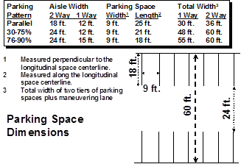
- Wheel stops shall be provided and so located as to prevent any vehicle from projecting over the lot or setback lines. Such devices shall be securely anchored into the parking lot to ensure that they remain stationary.

- Plans for the layout of off-street parking facilities shall be in accordance with the Parking Space Dimensions of this Ordinance. The minimum parking space dimensions for a layout not provided for in the regulations shall be nine (9) feet in width, eighteen (18) feet in length, and one hundred sixty two (162) square feet in area.

- Temporary and Overflow Parking. It is recognized that there may be special events or situations that occur infrequently which would result in the temporary reduction in the availability of required parking spaces or the need for temporary or overflow parking arrangements. Such events could include festivals, recreation and sporting activities, fairs, carnivals, church/school car washes, garage sales or other community or special events. The Zoning Administrator may authorize temporary parking arrangements subject to the requirements below while permanent overflow parking for special land uses and other uses that require site plan review shall be approved by the Township Board. Temporary and overflow parking areas are subject to the following requirements:
  - Parking areas shall be located and designed to ensure safe and efficient circulation for both pedestrians and vehicles, including designated maneuvering lanes, ingress and egress.
  - Aisles and parking rows shall meet the minimum widths required in this section.
  - Maneuvering lanes and parking rows shall be designated by temporary markings, such as paint, cones, flags or ribbons.
  - The Township may require supervision by attendants or staff during major events.
  - Overflow parking lots shall only be permitted if parking projections for periodic events or uses exceed the off-street parking requirements listed in Section 15.06 C or the existing availability of on-site parking. Overflow lots are subject to the following additional requirements:
    - Parking areas and maneuvering lanes shall be gravel, stone or a similar material, or shall be grassed. Grassed lots shall be maintained, mowed and seeded to ensure a passable and stable surface.
    - Parking lots shall be graded and/or properly drained to dispose of all surface and storm water and to prevent drainage onto abutting properties.
    - Overflow parking areas may not be used to satisfy minimum parking requirements for a site, excluding parking for fairgrounds and similar uses.
[Amended June 14, 2016]

SECTION 15.04 PARKING LOT PLANS

- The construction of any parking lot shall be in accordance with the requirements of the provisions of this Ordinance and such construction shall be completed and approved by the Zoning Administrator before actual use of the property as a parking lot and before a Certificate of Occupancy is issued.

- Plans for the development of any parking lot must be submitted to the Zoning Administrator, prepared at a scale of not less than one (1) inch equals fifty (50) feet and indicating existing and proposed grades, drainage, pipe sizes, dimensions of typical parking spaces, type of curbing, drive and aisle dimensions, lighting, adjacent main buildings, sidewalks, landscaping, surfacing and base materials to be used, and the layout of the proposed parking lot. The plans are to be prepared in a presentable form by person or persons competent in such work and shall conform to the provisions of Section 15.03.

SECTION 15.05 PARKING RESTRICTIONS

- In any District, it shall be unlawful to use required off-street parking areas for the storage or parking of vehicles in excess of twenty four (24) hours, except as may be permitted for a commercial use.

- It shall be unlawful for any person to park or store any motor vehicle without the express written consent of the owner, holder, occupant, lessee, agent, or trustee of such property. In no case shall vehicles be parked in any required off-street parking lot for the sole purpose of displaying such vehicle for sale, except in approved and licensed car sales lots.

- After the effective date of this Ordinance it shall be unlawful for the owner, holder, occupant, lessee, agent, or trustee of any lot in a Residential District to permit or allow the open storage or parking of trucks (over one (1) ton), semi trucks and trailers, manufactured homes, construction equipment, and/or any other similar equipment or machinery used for commercial purposes on an overnight bases. However, the owner, tenant, or lessee of a farm may openly store the machinery and equipment used on his farm; and equipment necessary to be parking overnight on a lot, parcel or tract of land during construction work thereon shall be excepted from this restriction.

- No vehicle storage, or display shall be permitted within any street right-of-way. On-street parking is permitted in locations specifically designated by public authority for on-street parking. On-street parking spaces shall not be counted toward the required parking for any use.

SECTION 15.06 OFF-STREET PARKING REQUIREMENTS

- When units of measurement determining the number of required off-street parking spaces result in the requirement of a fractional space that fraction shall require one (1) parking space.

- The Planning Commission may defer construction of the required number of parking spaces if the following conditions are met:

1. Areas proposed for deferred parking shall be shown on the site plan, and shall be sufficient for construction of the required number of parking spaces in accordance with the standards of this Ordinance for parking area design and other site development requirements.
2. Alterations to the deferred parking area may be initiated by the owner or required by the Zoning Administrator, and shall require the approval of an amended site plan, submitted by the applicant accompanied by evidence documenting the justification for the alteration.

- Required off-street parking spaces are noted in the table below for the uses listed. For those uses not specifically mentioned, the requirements for off-street parking shall be in accord with a use which the Zoning Administrator considers similar in type.

USE | PARKING SPACE PER UNIT OF MEASUREMENT
Residential
Single family dwellings | Two (2) for each dwelling unit
Two family dwellings | Two (2) for each dwelling unit
Multiple family dwellings | Two (2) for each dwelling unit, plus one (1) additional space for each two (2) units

Institutional
Group day care homes and group foster care homes | One (1) space for each four (4) clients
Churches, theaters, assembly areas, auditoriums, gymnasiums | One (1) space for each four (4) seats or each eight (8) feet of pew length or one (1) space for and each three (3) persons allowed within the maximum occupancy load established by any applicable codes or ordinances, whichever is greater
Schools, elementary and middle | Two (2) spaces for each three (3) employees, plus amount required for auditorium or gymnasium seating
Schools, secondary, trade, industrial, and institutions of higher learning | One (1) space for each eight (8) students, plus one and one half (1½) spaces for each classroom, plus amount required for auditorium or gymnasium seating

USE | PARKING SPACE PER UNIT OF MEASUREMENT
Commercial
Vehicle wash establishments (self service or automatic) | One (1) space for each five (5) stalls
Beauty/barber shop | Three (3) spaces for each chair
Bowling alleys | Four (4) spaces for each bowling lane plus required spaces for each accessory use
Assembly halls without fixed seats | One (1) space for each three (3) persons allowed within the maximum occupancy load established by any applicable codes or ordinances
Restaurants - without drive-through facilities | One (1) space for each one hundred (100) square feet UFA or one (1) space for each two (2) persons allowed within the maximum occupancy load established by any applicable codes or ordinances, whichever is greater
Restaurants with drive-through facilities | One (1) space for each one hundred (100) square feet of UFA or one (1) space for each one and one half (1½) persons allowed within the maximum occupancy load established by any applicable codes or ordinances, whichever is greater
Vehicle service stations | One (1) space for each service stall, plus one (1) space for each pump island
Personal service establishments not otherwise specified | One (1) space for each fifty (50) square feet UFA
Furniture, appliance and household goods retail sales | One (1) space for each one thousand (1000) square feet UFA
Funeral homes and mortuary establishments | One (1) space for each fifty (50) square feet UFA
Open air businesses | One (1) space for each two hundred (200) square feet of indoor UFA plus one (1) space for each one thousand (1000) square feet of outdoor display area
Retail stores not otherwise specified | One (1) space for each two hundred (200) square feet UFA
Hotels and motels | One (1) space for each guest room, plus required spaces for any accessory uses
Video rental stores | One (1) space for each one hundred (100) square feet UFA

USE | PARKING SPACE PER UNIT OF MEASUREMENT
Offices
Banks, credit unions, savings and loan associations and other similar uses | One (1) space for each one hundred fifty (150) square feet UFA plus three (3) spaces for each non drive-through automatic teller machine
Offices not otherwise specified | One (1) space for each three hundred (300) square feet UFA
Medical and dental offices and clinics | One (1) space for each seventy five (75) square feet of waiting room area plus one (1) space for each examining room, dental chair, or similar use area

USE | PARKING SPACE PER UNIT OF MEASUREMENT
Industrial
Manufacturing, processing, and research establishments and Industrial uses not otherwise specified | One (1) space for each one thousand (1000) square feet GFA plus those spaces required for offices located on the premises
Warehouses and wholesale establishments | One (1) space for each two thousand (2000) square feet GFA plus those spaces required for offices located on the premises

SECTION 15.07 OFF-STREET LOADING REQUIREMENTS

- On the same premises with every building or structure involving the receipt or distribution of vehicles, materials or merchandise there shall be provided and maintained on the lot adequate space for standing, loading and unloading. This space shall be placed so as to avoid undue interference with public use of dedicated rights-of-way and parking areas.

- In the NC and SC Districts all loading spaces shall be located in the rear yard in the ratio of at least ten (10) square feet per front foot of building and shall be computed separately from off-street parking requirements.

- Loading spaces for non-residential uses in Residential Districts shall not be facing or visible from the street. Loading space shall be provided in the ratio of at least five (5) square feet per front foot of building and shall be computed separately from off-street parking requirements.

- LI District

  - In the LI District at least one (1) loading space shall be provided. All loading spaces shall be at least ten feet by fifty feet (10’ x 50’), or a minimum of five hundred (500) square feet in area. A minimum fourteen (14) foot clearance height shall be provided.
  - Loading spaces shall only be permitted off-street and in the rear yard or interior side yard.

E. All dedicated loading spaces shall be provided with a pavement having an asphalt or concrete binder so as to provide a permanent, durable and dustless service.

SECTION 15.08 SIGNS - DESCRIPTION AND PURPOSE

These provisions are intended to regulate the size, number, location, and manner of display of signs in the Township, consistent with the following purposes:

- To protect the safety and welfare of Township residents; to conserve and enhance the character of the Township; and to promote the economic viability of commercial and other areas by minimizing visual clutter.

- To prevent traffic hazards and pedestrian accidents caused by signs which obstruct vision or are distracting or confusing.

- To promote uniformity in the size, number, and placement of signs within zoning districts.

- To promote the identification of establishments and premises in the Township.

SECTION 15.09 SIGNS - DEFINITIONS

For the purposes of the provisions of this Chapter related to signs, the following words and phrases are defined as follows:

- Construction Sign: A sign which identifies the owners, contractors, architects, and/or engineers of a building(s) or development project under construction.

- Commercial Establishment: A business operating independently of any other business located in a freestanding building; in a group of stores or similar establishments that are located side-by-side in a single building, sometimes call a strip mall, as a business completely separated from other businesses by walls from the ground up and separate entrances.

- Community Special Event Sign: A portable sign erected for a limited time for the purpose of calling attention to special events of interest to the general public and which are sponsored by governmental agencies, schools, or other nonprofit groups whose purpose is of a public, charitable, philanthropic, religious or benevolent nature.

- Directional Sign: A sign which gives directions, instruction, or information relating to location of buildings, designated routes for pedestrians and vehicles and other information for convenience or safety, such as parking information signs or entrance and exit signs.

- Freestanding Sign: A sign not attached to a building or wall and which is supported by one (1) or more poles or braces or which rests on the ground or on a foundation that rests of the ground.

- Governmental Sign: A sign erected or required to be erected by the Township, the County of Muskegon, or by the state or federal government.

- Memorial Sign: A sign, tablet, or plaque memorializing a person, event, structure, or site.

- Political Sign: A sign erected for a limited period of time for purposes of political campaigns for public office, for elections on public questions, or otherwise relating to public elections or public meetings held for the purpose of voting on or for public offices or public questions.

- Real Estate Sign: A sign advertising the real estate upon which the sign is located as being available for sale, rent, or lease.

- Sign: A device, structure, fixture, or placard using graphics, symbols and/or written copy designed specifically for the purpose of advertising or identifying an establishment, product, service, commodity, or activity, or displaying or depicting other information.

- Subdivision Identification Sign: A sign identifying or otherwise stating the name of a platted subdivision, site condominium development, multifamily development, or other residential development.

- Wall Sign: A sign painted or attached directly to and parallel to the exterior wall of a building, extending not greater than twelve (12) inches from the exterior face of the wall to which it is attached.

SECTION 15.10 SIGNS PROHIBITED

The following types of signs are expressly prohibited:

- Any sign which has flashing, moving, oscillating, or blinking lights, excluding time and temperature signs and barber pole signs, which are permitted.

- Signs imitating or resembling official traffic or governmental signs or signals.

- Any sign not expressly permitted by this Ordinance.

SECTION 15.11 SIGNS EXEMPTED

The following signs shall be exempt from the provisions of this Chapter.

- Governmental signs.

- Signs for essential services

- Historical markers.

- Memorial signs or tablets.

- Political signs, except that such signs shall be removed within the time stated in Section 15.14, D.

- Signs with an address and/or name of the owner or occupant, of not more than two (2) square feet in area, attached to a mailbox, light fixture, or exterior wall.

SECTION 15.12 MEASUREMENT OF SIGNS

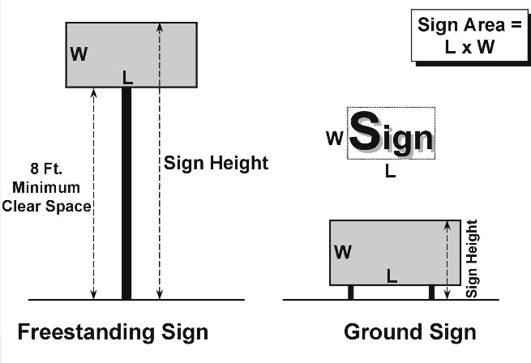
- The area of a sign shall be measured as the area within a single, continuous perimeter composed of any straight line geometric figure which encloses the extreme limits of writing, representation, emblem, logo and any other figure of similar character, together with any frame or other material or color forming an integral part of the display or used to differentiate the sign from the background against which it is placed, excluding only the structure necessary to support the sign.

- The area of a freestanding or ground sign that has two (2) or more faces shall be measured by including the area of all sign faces, except that if two (2) such faces are placed back to back and are of equal size, the area of the two (2) back to back faces shall be counted as one (1) face. If the two (2) back to back faces are of unequal size, the larger of the two (2) sign faces shall be counted as one (1) sign face.

- The height of a sign shall be measured as the vertical distance from the highest point of the sign to the grade of the adjacent street or the average grade of the ground immediately beneath the sign, whichever is less.

- Any freestanding sign not resting directly on the ground shall not exceed three (3) feet in height, or if supported on poles, shall have a clear area of at least eight (8) feet between the bottom of the sign and the grade of the adjacent street(s).

SECTION 15.13 SIGN APPLICATION AND PERMITS

- A sign permit shall be required for the erection, use, construction or alteration of all signs, except for those exempted by the terms of this Chapter. For purposes of this Section, alteration of a sign shall mean any substantial change therein, but shall not include normal maintenance or repair thereof.

- An application for a sign permit shall be made to the Township Zoning Administrator, and shall include submission of such fee as may be required by resolution or other action by the Township Board. The application shall include the following:

  - Name, address, and telephone number of the applicant and the person, firm, or corporation erecting the sign.
  - Address or permanent parcel number of the property where the sign will be located.
  - A sketch showing the location of the building, structure, or parcel of land upon which the sign is to be attached or erected, and showing the proposed sign in relation to buildings and structures, together with the depth of setback from lot lines.
  - Two (2) scaled blueprints or drawings of the plans and specifications for the sign and information on the method of construction and attachment to structures or the ground.
  - Any required electrical permit.
  - Identification of the zoning district in which the sign is to be located, together with any other information which the Zoning Administrator may require in order to determine compliance with this Chapter.

- All signs requiring electrical service shall be reviewed for compliance with the Township electrical code.

- The Zoning Administrator shall issue a sign permit if all provisions of this Chapter and other provisions of this Ordinance and other applicable Township ordinances are satisfied. A sign authorized by such a permit shall be installed or shall be under construction within six (6) months of the date of issuance of the sign permit. or the permit shall expire. A new permit may be issued upon the filing of a new application and payment of the required fee.

SECTION 15.14 SIGN REGULATIONS APPLICABLE TO ALL DISTRICTS

- It shall be unlawful for any person to erect, place, maintain, or continue a sign upon any lands in the Township except in accordance with the provisions of this Ordinance.

- All signs shall be stationary and shall pertain only to the business or activity conducted on the premises, except for political signs and community special event signs.

- Real estate signs shall be removed within thirty (30) days after completion of the sale or lease of the property.

- Political signs shall not exceed six (6) square feet and shall be removed within ten (10) days after the election or referendum to which the sign refers.

- No sign shall be placed in, or extend into, any public street right-of-way.

- Construction signs are permitted, subject to the following restrictions:

1. Construction signs shall not be larger than thirty two (32) square feet and shall not exceed twelve (12) feet in height.
2. Construction signs shall not be erected until a building permit has been issued for the building or project which is the subject of the proposed sign and construction activity has begun.
3. Construction signs shall be removed immediately upon issuance of any occupancy permit for the building or structure which is the subject of the construction sign.

- Community special event signs may be permitted for a period not to exceed thirty (30) days.

- Directional signs shall not exceed six (6) square feet in area per sign.

- No wall sign shall project above the building roof line.

- Flashing and intermittently illuminated signs are prohibited. Any sign lighting shall be shielded from vehicular traffic and adjacent residential properties.

SECTION 15.15 NONCONFORMING SIGNS

- Every permanent sign which, as of the adoption of this Ordinance or amendment thereto, does not conform to the height, size, area, or location requirements of this Chapter is deemed to be nonconforming.

- Nonconforming signs may not be expanded, enlarged, or extended, but they may be maintained and repaired so as to continue their useful life.

- A nonconforming sign may be diminished in size or dimension, or the copy on the sign may be amended or changed, without adversely affecting the status of the sign as a nonconforming sign.

SECTION 15.16 SIGNS IN RESIDENTIAL DISTRICTS

In addition to signs permitted and as regulated in all districts, the following signs are permitted in Residential Districts:

- One (1) non-illuminated subdivision identification sign per entrance street for each subdivision development, except that no two (2) such signs per subdivision shall be located closer to each other than one thousand three hundred twenty (1,320) feet. A subdivision identification sign shall not exceed sixteen (16) square feet in area and shall not be higher than four (4) feet.

- For permitted nonresidential uses, one (1) freestanding sign not to exceed sixteen (16) square feet in sign area and placed a minimum of fifteen (15) feet from each side lot line. Such sign shall not be illuminated and shall not be higher than four (4) feet.

- Not more than two (2) signs per property, advertising the sale of produce grown on the premises, each sign not to exceed sixteen (16) square feet and a height not exceeding four (4) feet.

SECTION 15.17 SIGNS IN COMMERCIAL AND INDUSTRIAL DISTRICTS

In addition to signs permitted and as regulated in all districts, the following signs are permitted in the NC Neighborhood Commercial District, the SC Sullivan Corners District, and the LI Light Industrial District:

- One (1) freestanding sign for each lot or parcel of land, not to exceed sixty four (64) square feet in sign area and not to exceed twenty (20) feet in height.

- Wall Signs in Commercial Districts

1. Each commercial establishment shall be permitted to have one (1) wall sign. For each commercial establishment on a corner lot, one (1) wall sign per public or private street frontage is permitted.

    - Commercial establishments located in a freestanding building with one hundred (100) feet or less of freestanding building frontage shall be permitted a wall sign area not to exceed one (1) square foot of sign for each lineal foot of street frontage of such freestanding building,
    - Commercial establishments with more than one hundred (100) feet of freestanding building frontage shall be permitted a wall sign area not to exceed one (1) square foot of sign for each of the first one hundred (100) lineal feet of freestanding building frontage and one and one half (1½) square feet of sign for each three (3) lineal feet in excess of one hundred (100) lineal feet.
    - Wall sign area for a commercial establishment consisting of a separate business located in a building with other businesses but with a separate and independent entrance shall be calculated in the same manner as in a freestanding building, using the building frontage of such commercial establishment.

2. The wall sign shall be attached to the same wall which is used to determine its size.

- Wall Signs in the Light Industrial District

1. Each industrial establishment shall be permitted to have one (1) wall sign. For each industrial establishment on a corner lot, one (1) wall sign per public or private street frontage is permitted. Each industrial establishment shall have not more than one (1) wall sign per wall.

2. The size of the wall sign shall comply with the following regulations:

    - Industrial establishments with up to one hundred (100) lineal feet of wall fronting a street are permitted to have a sign area not to exceed thirty two (32) square feet.
    - Industrial establishments with more than one hundred (100) lineal feet of wall fronting a street are permitted to have a sign area of thirty two (32) square feet plus one (1) additional square foot of sign area for each four (4) lineal feet of wall exceeding one hundred (100) lineal feet.

3. Wall signs shall not face a Residential District unless the district and the building are separated by a public or private street or other Nonresidential District.

4. The wall sign shall be attached to the same wall which is used to determine its size.

SECTION 15.18 SIGNS FOR OTHER LAND USES

- Signs in the Planned Unit Development District shall comply with the applicable sign provisions of Section 13.04, W.

- Signs for Special Land Uses shall comply with the sign requirements of the district in which the Special Land Use is located, except to the extent that such requirements may be altered or modified in the approved conditions for the Special Land Use.

CHAPTER 16
ZONING BOARD OF APPEALS

SECTION 16.01 AUTHORIZATION

In order that the objectives of the Ordinance may be more fully and equitably achieved, that there shall be provided a means of competent interpretation of this Ordinance, that adequate but controlled flexibility be provided in the application of this Ordinance, that the health, safety, and welfare of the public be secured, and that justice be done, there is hereby established a Zoning Board of Appeals.

SECTION 16.02 MEMBERSHIP - TERMS OF OFFICE

- The Zoning Board of Appeals shall consist of five (5) members. The first member of such Zoning Board of Appeals shall be a member of the Township Planning Commission; the second member shall be a member of the Township Board; the additional members shall be selected from the electors residing in the Township. All members shall be appointed by the Township Board. The additional members shall not be elected officers of the Township or employees of the Township Board. The additional members shall be appointed for three (3) year terms; the Planning Commission and Township Board representatives, who shall not be the same member, shall only serve while holding membership on those respective bodies. The Township Board member shall not serve as chair.

[Amended March 7, 2007]

- The Township Board may appoint up to two (2) alternate members with the same qualifications as regular members for the same terms as the regular members. An alternate may be called to serve as a regular member in the absence of a regular member if the regular member is absent from or will be unable to attend one (1) or more consecutive meetings. An alternate member may also be called to serve as a regular member for the purpose of reaching a decision on a case in which the regular member has abstained for reasons of conflict of interest. The alternate member shall serve in the case until a final decision is made and shall have the same voting rights as a regular member.

[Amended March 7, 2007]

SECTION 16.03 DUTIES AND POWERS

The Zoning Board of Appeals shall have the following specified duties and powers:

- Appeals. The Zoning Board of Appeals shall hear and decide appeals from and review any order, requirement, decision, or determination made by the Zoning Administrator or other administrative officer or body of the Township in the administration of this Ordinance.

- Interpretation. The Zoning Board of Appeals shall have the power to:

  - Hear and decide upon request for the interpretation of the provisions of this Ordinance; and
  - Determine the precise location of boundary lines between zoning districts upon appeal from a decision by the Zoning Administrator upon said subject.

- Variances. The Zoning Board of Appeals shall have the power to authorize specific variances from the requirements of this Ordinance.

- The Zoning Board of Appeals shall not have the authority to approve any sign type which is not permitted within a zoning district

SECTION 16.04 MEETINGS

Meetings shall be open to the public, and shall be held at the call of the Chairman and at such other times as the Zoning Board of Appeals shall specify in its rules of procedure.

SECTION 16.05 APPLICATIONS AND HEARINGS

- An application to the Zoning Board of Appeals shall consist of a completed application form, provided by the Township, a fee as established by the Township Board, which shall be paid to the Township Clerk at the time of filing, and a scaled drawing with sufficient detail to indicate the nature and necessity of the request. The Zoning Board of Appeals may request additional detail on the drawing or other information which they deem necessary to make a decision on the application.

- Upon receipt of a complete application for a variance the Secretary shall cause notices to be given in accordance with the Zoning Act. Upon receipt of a written request seeking an interpretation of the zoning ordinance or an appeal of an administrative decision, a notice stating the time, date, and place of the public hearing shall be published in a newspaper of general circulation within the Township and shall be sent to the person requesting the interpretation not less than fifteen (15) days before the public hearing. In addition, if the request for an interpretation ,appeal of an administrative decision or a variance involves a specific parcel, written notice stating the nature of the interpretation request and the time, date, and place of the public hearing on the interpretation request shall be sent by first class mail or personal delivery to all persons to whom real property is assessed within three hundred (300) feet of the boundary of the property in question and to the occupants of all structures within three hundred (300) feet of the boundary of the property in question. Notification need not be given to more than one (1) occupant of a structure, except that if a structure contains more than one (1) dwelling unit, notice shall be given to each dwelling unit. If a structure contains more than four (4) dwelling units, notice may be given to the owner or manager of the structure, who shall be requested to post the notice at the primary entrance to the structure. If a tenant's name is not known, the term "occupant" may be used. The Board may recess such hearings from time to time, and, if the time and place of the continued hearing be publicly announced at the time of adjournment, no further notice shall be required. [Amended March 7, 2007; July 7, 2009]

SECTION 16.06 DECISIONS

- The concurring vote of a majority of the membership of the Zoning Board of Appeals shall be necessary to reverse any order, requirement, decision, or determination of the Zoning Administrator; to decide in favor of any application on any matter upon which the Board is required to pass under this Ordinance; to effect any variance in this Ordinance.

- The Zoning Board of Appeals shall return a decision upon each case within a reasonable time after the scheduled hearing has been held, unless an extension of time is agreed upon with the applicant and the Board.
- The decision and orders of the Board shall become effective at the next meeting of the Zoning Board of Appeals upon approval of the minutes of the meeting at which the decision was rendered, unless the applicant requests, at the meeting when the decision is rendered, that the decision be provided at an earlier date, in which case the decision shall be certified in writing and presented to the applicant within ten (10) business days after the meeting at which the decision is rendered, or by a date requested by the applicant, whichever occurs later; however, the Board may find that the immediate effect of the order or decision is necessary for the preservation of personal or property rights, provided that a finding to this effect is approved by the Board and entered into the official record. [Amended July 7, 2009]
- The decision of the Zoning Board of Appeals shall be final; however, any person having an interest affected by any such decision shall have the right of appeal to the Circuit Court on questions of law and fact within thirty (30) days after the Board certifies its decision in writing or within twenty-one (21) days after the Board approves the minutes of its decision. [Amended March 7, 2007]
- Each decision entered under the provisions of this Chapter shall become null and void unless the construction or other action authorized by such decision has been started within one (1) year after the decision was made and is being carried forward to completion or occupancy of land, premises, or buildings.

- No application which has been denied wholly or in part by the Board shall be resubmitted for a period of one (1) year from the date of the last denial, except on grounds of changed conditions that would significantly change the nature of the request or affect the reasons for denial first ordered by the Board.

SECTION 16.07 APPEALS

- Appeals to the Zoning Board of Appeals may be taken by any person aggrieved, or by any officer, department or board of the Township. Applications for appeals shall be filed within five (5) days after the date of the decision which is the basis of the appeal. The appellant must file with the Zoning Administrator a notice of appeal specifying the nature and grounds for the appeal. The Zoning Administrator shall transmit to the Zoning Board of Appeals all the papers constituting the record upon which the action appealed from was taken.

- An appeal shall stay all proceedings in furtherance of the action appealed from unless the Zoning Administrator certifies to the Zoning Board of Appeals after the notice of the appeal shall have been filed with him that, for reason of facts stated in the certificate, a stay would, in his opinion, cause imminent peril to life or property, in which case proceedings shall not be stayed otherwise than by a restraining order, which may be granted by the Zoning Board of Appeals or, on application, by the Circuit Court when due cause can be shown.

SECTION 16.08 REVIEW STANDARDS FOR VARIANCES

- Non-Use Variance: A non-use or dimensional variance may be allowed by the Zoning Board of Appeals only in cases where there is reasonable evidence of practical difficulty in the official record of the hearing and that ALL of the following conditions are met:

  - Granting the variance will not be contrary to the public interest and will ensure that the spirit of this Ordinance is observed.
  - Granting the variance will not cause a substantial adverse effect to property or improvements in the vicinity or in the district in which the subject property is located.
  - The variance request is not one where the specific conditions pertaining to the property are so general or recurrent in nature as to make the formulation of a general regulation for such conditions reasonably practicable.
  - That there are practical difficulties in the way of carrying out the strict letter of these regulations which are caused by exceptional or extraordinary circumstances or conditions applying to the property involved, or to the intended use of the property, that do not generally apply to other property or uses in the vicinity in the same zoning district. Exceptional or extraordinary circumstances or conditions include:

a. exceptional narrowness, shallowness or shape of a specific property on the effective date of this Chapter;
b. exceptional topographic conditions;
c. any other physical situation on the land, building or structure deemed by the Zoning Board of Appeals to be extraordinary; or
d. by reason of the use or development of the property immediately adjoining the property in question.

  - That granting such variance is necessary for the preservation of a substantial property right possessed by other properties in the vicinity in the same zoning district.
- That the variance is not necessitated as a result of any action or inaction of the applicant.

CHAPTER 17
ADMINISTRATION AND ENFORCEMENT

SECTION 17.01 REPEAL OF PRIOR ORDINANCE

The Zoning Ordinance previously adopted by the Township on July 7, 1987, and all amendments thereto, are hereby repealed. The repeal of the above Ordinance and its amendments does not affect or impair any act done, offense committed or right accruing, accrued, or acquired, or liability, penalty, forfeiture or punishment incurred prior to the time enforced, prosecuted or inflicted.

SECTION 17.02 ZONE DISTRICTS

The Township of Sullivan is hereby divided into the following zoning districts:

- R-A Rural Residential/Agricultural District
- R-R Rural Residential District
- R-1 Low Density Residential District
- R-2 Medium Density Residential District
- R-3 High Density Residential District
- R-4 Manufactured Home Park District
- NC Neighborhood Commercial District
- SC Sullivan Corners
- LI Light Industrial District

SECTION 17.03 ZONING MAP

The locations and boundaries of the zoning districts are hereby established as shown on a map, as the same may be amended from time to time, entitled "The Zoning Map of Sullivan Township, Muskegon County, Michigan," which accompanies and is hereby made a part of this Ordinance. Where uncertainty exists as to the boundaries of zoning districts as shown on the zoning map, the following rules of construction and interpretation shall apply.

- Boundaries indicated as approximately following the centerline of streets, highways, or alleys shall be construed to follow such centerlines.

- Boundaries indicated as approximately following platted lot lines shall be construed as following such lot lines.

- Boundaries indicated as approximately following township boundaries shall be construed as following township boundaries.

- Boundaries indicated as approximately following shorelines or lake or stream beds shall be construed as following such shorelines or lake or stream beds, and in the event of change in the location of shorelines or lake or stream beds, shall be construed as moving with the shoreline and lake or stream bed.

- Lines parallel to streets without indication of the depth from the street line shall be construed as having a depth of two hundred (200) feet from the front lot line.

- Boundaries indicated as approximately following property lines, section lines or other lines of a government survey shall be construed as following such property lines, section lines or other lines of a government survey as they exist as of the effective date of this Ordinance or applicable amendment thereto.

SECTION 17.04 AREAS NOT INCLUDED WITHIN A DISTRICT

In every case where land has not been included within a district on the zoning map, such land shall be in the R-A District.

SECTION 17.05 INTERPRETATION

- In the interpretation and application, the provisions of this Ordinance shall be held to be minimum requirements adopted for the promotion of the public health, morals, safety, comfort, convenience, or general welfare.

- It is not intended by this Ordinance to repeal, abrogate, annul, or in any other way impair or interfere with existing provisions of other laws or ordinances, except those specifically repealed by this Ordinance, or of any private restrictions placed upon property by covenant, deed, or other private agreement; provided however that where any provision of this Ordinance imposes more stringent requirements, regulations, restrictions, or limitations upon the erection or use of land and buildings, or upon the height of buildings and structures, or upon safety and sanitary measures, or requires larger yards or open spaces than are imposed or required by the provisions of any other law or ordinance, or any said rules, regulations, permits, or easements, then the provisions of this Ordinance shall govern.

- Nothing in this Ordinance should be interpreted or construed to give rise to any permanent vested rights in the continuation of any particular use, district, zoning classification or any permissible activities therein; and they are hereby declared to be subject to subsequent amendment, change or modification as may be necessary to the preservation or protection of public health, safety, and welfare.

SECTION 17.06 REMEDIES AND ENFORCEMENT

Any building or structure which is erected, moved, placed, reconstructed, razed, extended, enlarged, altered, maintained or changed in violation of any provision of this Ordinance is hereby declared to be a nuisance, per se. A violation of this Ordinance constitutes a municipal civil infraction. Any person who violates, disobeys, omits, neglects or refuses to comply with any provision of this Ordinance, or any permit or approval issued hereunder, or any amendment thereof, or any person who knowingly or intentionally aids or abets another person in violation of this Ordinance, shall be in violation of this Ordinance and shall be responsible for a civil infraction. The civil fine for a municipal civil infraction shall be not less than those established by the Township Board in the Municipal Civil Infraction Ordinance of the General Law Ordinances of Sullivan Township, as amended, in the discretion of the Court, in addition to all other costs, damages, expenses and remedies provided by law. For purposes of this section, "subsequent offense" means a violation of the provisions of this Ordinance committed by the same person within twelve (12) months of a previous violation of the same provision of this Ordinance or similar provision of this Ordinance for which said person admitted responsibility or was adjudged to be responsible. Each day during which any violation continues shall be deemed a separate offense. [Amended March 7, 2007]

SECTION 17.07 PUBLIC NUISANCE PER SE

Any building or structure which is erected, repaired, altered, or converted, or any use of premises or land which is begun or changed subsequent to the time of passage of this Ordinance and in violation of any of the provisions thereof is hereby declared to be a public nuisance per se, and may be abated by order of any court of competent jurisdiction.

SECTION 17.08 ZONE CHANGES AND AMENDMENTS

- The Township Board may, from time to time, on recommendation from the Planning Commission, or on its own motion, or on petition, amend, supplement, modify or change this Ordinance in accordance with the authority of the Zoning Act, as amended.

- In reviewing an application for the rezoning of land, whether the application be made with or without an offer of conditions, factors that should be considered by the Planning Commission and the Township Board include, but are not limited to, the following:

1. Whether the rezoning is consistent with the policies and uses proposed for that area in the Township’s Master Land Use Plan;
2. Whether all of the uses allowed under the proposed rezoning would be compatible with other zones and uses in the surrounding area;
3. Whether any public services and facilities would be significantly adversely impacted by a development or use allowed under the requested rezoning; and
4. Whether the uses allowed under the proposed rezoning would be equally or better suited to the area than uses allowed under the current zoning of the land.

[Amended March 7, 2007]

SECTION 17.09 CONDITIONAL REZONING

- Intent. It is recognized that there are certain instances where it would be in the best interests of the Township, as well as advantageous to property owners seeking a change in zoning boundaries, if certain conditions could be proposed by property owners as part of a request for a rezoning. It is the intent of this Section to provide a process consistent with the provisions of Section 405 of the Michigan Zoning Enabling Act, by which an owner seeking a rezoning may voluntarily propose conditions regarding the use and/or development of land as part of the rezoning request.

- Application and Offer of Conditions.

  - An owner of land may voluntarily offer, in writing, conditions relating to the use and/or development of land for which a rezoning is requested. This offer may be made either at the time the application for rezoning is filed or may be made at a later time during the rezoning process.
  - The required application and process for considering a rezoning request with conditions shall be the same as that for considering rezoning requests made without any offer of conditions, except as modified by the requirements of this Section.
  - The owner’s offer of conditions may not purport to authorize uses or developments not permitted in the requested new zoning district.
  - The owner's offer of conditions shall bear a reasonable and rational relationship to the property for which rezoning is requested.
  - Any use or development proposed as part of an offer of conditions that would require a special land use permit under the terms of this Ordinance may only be commenced if a special land use permit for such use or development is ultimately granted in accordance with the provisions of this Ordinance.
  - Any use or development proposed as part of an offer of conditions that would require a variance under the terms of this Ordinance may only be commenced if a variance is ultimately granted by the Zoning Board of Appeals in accordance with the provisions of this Ordinance.
  - Any use or development proposed as part of an offer of conditions that would require site plan approval under the terms of this Ordinance may only be commenced if site plan approval for such use or development is ultimately granted in accordance with the provisions of this Ordinance.
  - The offer of conditions may be amended during the process of rezoning consideration provided that any amended or additional conditions are entered voluntarily by the owner. An owner may withdraw all or part of its offer of conditions any time prior to final rezoning action of the Township Board provided that, if such withdrawal occurs subsequent to the Planning Commission’s public hearing on the original rezoning request, then the rezoning application shall be referred to the Planning Commission for a new public hearing with appropriate notice and a new recommendation.

- Planning Commission Review. The Planning Commission, after public hearing and consideration of the factors for rezoning set forth in Section 17.08 of this Ordinance, may recommend approval, approval with recommended changes, or denial of the rezoning; provided, however, that any recommended changes to the offer of conditions are acceptable to and thereafter offered by the owner.

- Township Board Review. After receipt of the Planning Commission’s recommendation, the Township Board shall deliberate upon the requested rezoning and may approve or deny the conditional rezoning request. The Township Board's deliberations shall include, but not be limited to, a consideration of the factors for rezoning set forth in Section 17.08 of this Ordinance. Should the Township Board consider amendments to the proposed conditional rezoning advisable and if such contemplated amendments to the offer of conditions are acceptable to and thereafter offered by the owner, then the Township Board shall refer such amendments to the Planning Commission for a report thereon within a time specified by the Township Board and proceed thereafter in accordance with this Section and the Zoning Act, to deny or approve the conditional rezoning with or without amendments.

- Approval.

  - If the Township Board finds the rezoning request and offer of conditions acceptable, the offered conditions shall be incorporated into a formal written Statement of Conditions acceptable to the owner and conforming in form to the provisions of this Section. The Statement of Conditions shall be incorporated by attachment or otherwise as an inseparable part of the ordinance adopted by the Township Board to accomplish the requested rezoning.

  - The Statement of Conditions shall:

              - Be in a form recordable with the Register of Deeds of the County in which the subject land is located or, in the alternative, be accompanied by a recordable Affidavit or Memorandum prepared and signed by the owner giving notice of the Statement of Conditions in a manner acceptable to the Township Board.
              - Contain a legal description of the land to which it pertains.
    - Contain a statement acknowledging that the Statement of Conditions runs with the land and is binding upon successor owners of the land.
    - Incorporate by attachment or reference any diagram, plans or other documents submitted or approved by the owner that are necessary to illustrate the implementation of the Statement of Conditions. If any such documents are incorporated by reference, the reference shall specify where the document may be examined.
    - Contain a statement acknowledging that the Statement of Conditions or an Affidavit or Memorandum giving notice thereof may be recorded by the Township with the Register of Deeds of the County in which the land referenced in the Statement of Conditions is located.
    - Contain the notarized signatures of all of the owners of the subject land preceded by a statement attesting to the fact that they voluntarily offer and consent to the provisions contained within the Statement of Conditions.

  - Upon the rezoning taking effect, the Zoning Map shall be amended to reflect the new zoning classification along with a designation that the land was rezoned with a Statement of Conditions. The Township Clerk shall maintain a listing of all lands rezoned with a Statement of Conditions.
  - The approved Statement of Conditions or an Affidavit or Memorandum giving notice thereof shall be filed by the Township with the Register of Deeds of the County in which the land is located. The Township Board shall have authority to waive this requirement if it determines that, given the nature of the conditions and/or the time frame within which the conditions are to be satisfied, the recording of such a document would be of no material benefit to the Township or to any subsequent owner of the land.
  - Upon the rezoning taking effect, the use of the land so rezoned shall conform thereafter to all of the requirements regulating use and development within the new zoning district as modified by any more restrictive provisions contained in the Statement of Conditions.

- Compliance with Conditions.

  - Any person who establishes a development or commences a use upon land that has been rezoned with conditions shall continuously operate and maintain the development or use in compliance with all of the conditions set forth in the Statement of Conditions. Any failure to comply with a condition contained within the Statement of Conditions shall constitute a violation of this Zoning Ordinance and be punishable accordingly. Additionally, any such violation shall be deemed a nuisance per se and subject to judicial abatement as provided by law.
  - No permit or approval shall be granted under this Ordinance for any use or development that is contrary to an applicable Statement of Conditions.

- Time Period for Establishing Development or Use. Unless another time period is specified in the Ordinance rezoning the subject land, the approved development and/or use of the land pursuant to building and other required permits must be commenced upon the land within 18 months after the rezoning took effect and thereafter proceed diligently to completion. This time limitation may upon written request be extended by the Township Board if (1) it is demonstrated to the Township Board's reasonable satisfaction that there is a strong likelihood that the development and/or use will commence within the period of extension and proceed diligently thereafter to completion and (2) the Township Board finds that there has not been a change in circumstances that would render the current zoning with Statement of Conditions incompatible with other zones and uses in the surrounding area or otherwise inconsistent with sound zoning policy.
- Reversion of Zoning. If approved development and/or use of the rezoned land does not occur within the time frame specified under Subsection G above, then the land shall revert to its former zoning classification as set forth in the Zoning Act. The reversion process shall be initiated by the Township Board requesting that the Planning Commission proceed with consideration of rezoning of the land to its former zoning classification. The procedure for considering and making this reversionary rezoning shall thereafter be the same as applies to all other rezoning requests.

- Subsequent Rezoning of Land. When land that is rezoned with a Statement of Conditions is thereafter rezoned to a different zoning classification or to the same zoning classification but with a different or no Statement of Conditions, whether as a result of a reversion of zoning pursuant to Subsection H above or otherwise, the Statement of Conditions imposed under the former zoning classification shall cease to be in effect. Upon the owner's written request, the Township Clerk shall record with the Register of Deeds of the County in which the land is located a notice that the Statement of Conditions is no longer in effect.

- Amendment of Conditions.

  - During the time period for commencement of an approved development or use specified pursuant to Subsection G above or during any extension thereof granted by the Township Board, the Township shall not add to or alter the conditions in the Statement of Conditions.
  - The Statement of Conditions may be amended thereafter in the same manner as was prescribed for the original rezoning and Statement of Conditions.

- Township Right to Rezone. Nothing in the Statement of Conditions nor in the provisions of this Section shall be deemed to prohibit the Township from rezoning all or any portion of land that is subject to a Statement of Conditions to another zoning classification. Any rezoning shall be conducted in compliance with this Ordinance and the Zoning Act.

- Failure to Offer Conditions. The Township shall not require an owner to offer conditions as a requirement for rezoning. The lack of an offer of conditions shall not affect an owner’s rights under this Ordinance.

[Amended March 7, 2007]

SECTION 17.10 PERFORMANCE GUARANTEES

- The Zoning Administrator, Planning Commission, Zoning Board of Appeals, and Township Board are empowered to require a performance guarantee in the form of a bond, cashier's check, cash, or other suitable negotiable security, in an amount equal to the estimated cost of improvements associated with the project which is the subject of such guarantee.

B. Such performance guarantee shall be deposited with the Clerk of the Township at the time of the issuance of the permit authorizing the activity or project to insure faithful completion of the improvements indicated with the approved site plan. If said improvements are not completed such security shall be forfeited, either in whole or in part.

- The Township shall rebate a proportional share of cash deposits only when requested by the depositor, based on the percent of improvements completed, as attested to by the depositor and verified by the Zoning Administrator.

- In cases where the improvements indicated with the approved site plan have not been completed in accordance with the approval granted, the amount of the aforementioned performance guarantee may be used by the Township to complete the requirement improvements. The balance if any shall be returned to the depositor.

SECTION 17.11 FEES

- The Township Board shall, by resolution, establish fees for the administration of this Ordinance, including all proceedings and matters that may arise hereunder. A listing of current fees shall be available for review by the public during regular Township office hours at the Township Hall. Such fees may be changed from time to time by resolution of the Township Board.

- The applicant shall pay all applicable fees upon the filing of any application, proposed site plan, or any other request or application under this Ordinance for which a fee is required.

- In addition to regularly established fees, the Township Board in its discretion may also require an applicant to submit to the Township an amount of money determined by the Township to be a reasonable estimate of the fees and costs which may incurred by the Township in reviewing and acting upon any such application or related matters. Such estimated fee and costs shall be submitted prior to any Township review of an application or request.

- The Township shall not charge fees or assess costs to the applicant for the time expended by Township employees (except as authorized under appropriate provisions of the Freedom of Information Act) or for incidental costs and expenses, but may charge or assess the applicant for all other reasonable costs and expenses incurred by the Township during and in connection with the review process and other related proceedings, whether or not the application is granted either in whole or in part.

- Such costs and expenses to be charged or assessed to the applicant, for reimbursement of the Township’s reasonable costs and expenses, may include but shall not be limited to Township attorney fees, engineering fees, costs and fees for services or outside consultants, fees and expenses of other professionals who may assist the Township, costs and fees for studies and reports pertaining to the matters in question, special meeting costs, and other reasonable costs and expenses. The Township may charge a deposit for anticipated fees at the time of application, which shall be placed in a separate escrow fund, from which the above costs will be paid. The applicant shall maintain a minimum amount in this fund, in accordance with the escrow policy adopted by resolution by the Township Board. [Amended March 7, 2007]

- Any monies paid or deposited by an applicant which are not used or spent by the Township shall be refunded to the applicant.

SECTION 17.12 STOP WORK ORDERS

- Notice to Owner: Upon notice from the Zoning Administrator that any use is being conducted or that any work on any building or structure is being prosecuted contrary to the provisions of this Ordinance, such work or use shall be immediately stopped. The Stop Work Order shall be in writing and shall be given to the owner of the property involved, to the owner’s agent, or to the person doing the work and shall state the conditions, if any, under which work or the use will be permitted to resume.

- Unlawful Continuance: Any person who shall continue to work in or about the structure, land or building, or use after having been served with a Stop Work Order, except such work as that person is directed to perform to remove a violation or correct an unsafe condition, shall be in violation of this Ordinance.

SECTION 17.13 PROPERTY SURVEYS

If the Zoning Administrator in the performance of his duties under this Ordinance (or the Planning Commission, Zoning Board of Appeals, and Township Board pursuant to their zoning review and approval powers under this Ordinance) shall deem it necessary that a survey be done by a professional surveyor or engineer for property at issue (including a written drawing and stakes set on the property boundaries or corners) in order to insure that all requirements of this Ordinance will be met, such survey and related information may be required by the Township and shall be paid for and provided by the property owner or applicant and no building permit or other Township permit(s) shall be issued or approved until and unless such survey and related information has been provided to the Township.

SECTION 17.14 RIGHTS AND REMEDIES

The rights and remedies provided herein are cumulative and in addition to other remedies provided by law.

SECTION 17.15 SEVERABILITY

The Ordinance and various Chapters, sections, paragraphs, and clauses thereof, are hereby declared to be severable. If any Chapter, section, paragraph, or clause is adjudged unconstitutional or invalid, it is hereby provided that the remainder of the Ordinance shall not be affected thereby.

SECTION 17.16 GENERAL RESPONSIBILITY
The Township Board or its duly authorized representative is hereby charged with the duty of enforcing the Ordinance and said Board is hereby empowered, in the name of Sullivan Township, to commence and pursue any and all necessary and appropriate actions and/or proceedings in the Circuit Court of Muskegon County, Michigan, or any other Court having jurisdiction, to restrain and/or prevent any noncompliance with or violation of any of the provisions of this Ordinance, and to correct, remedy and/or abate such noncompliance or violation. And it is further provided that any person aggrieved or adversely affected by such a noncompliance or violation may institute suit and/or join the Township Board in such a suit to abate the same.

SECTION 17.17 ENACTMENT

The provisions of this Ordinance are hereby declared to be immediately necessary for the preservation of the public peace, health, safety, and welfare of the people and are hereby ordered to become effective seven (7) days following publication of a "Notice of Ordinance Adoption" in a newspaper circulating within Sullivan Township. The effective date of this Zoning Ordinance is January 3, 1999 with amendments through September 2012.

APPENDICES
SULLIVAN TOWNSHIP ZONING ORDINANCE

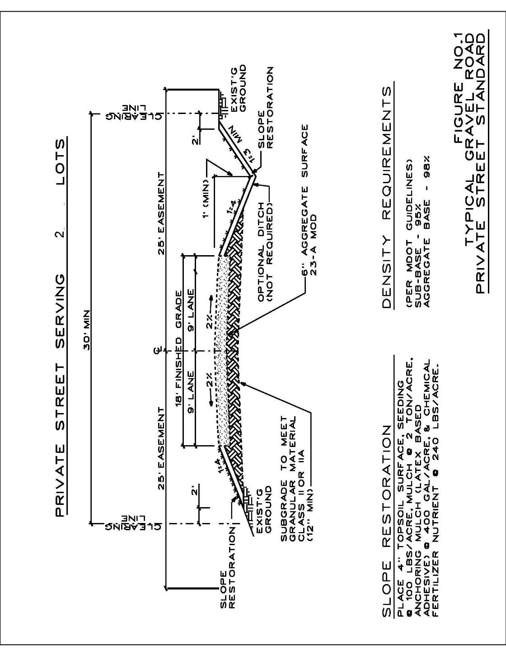
APPENDIX 1: PRIVATE STREET ILLUSTRATIONS

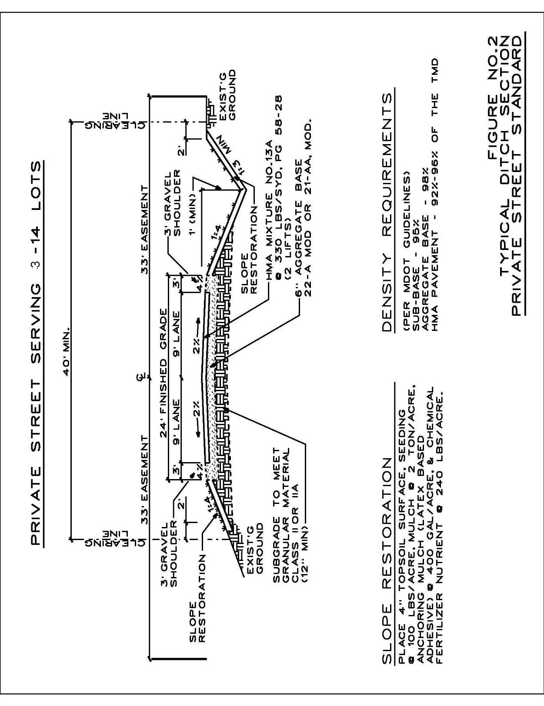

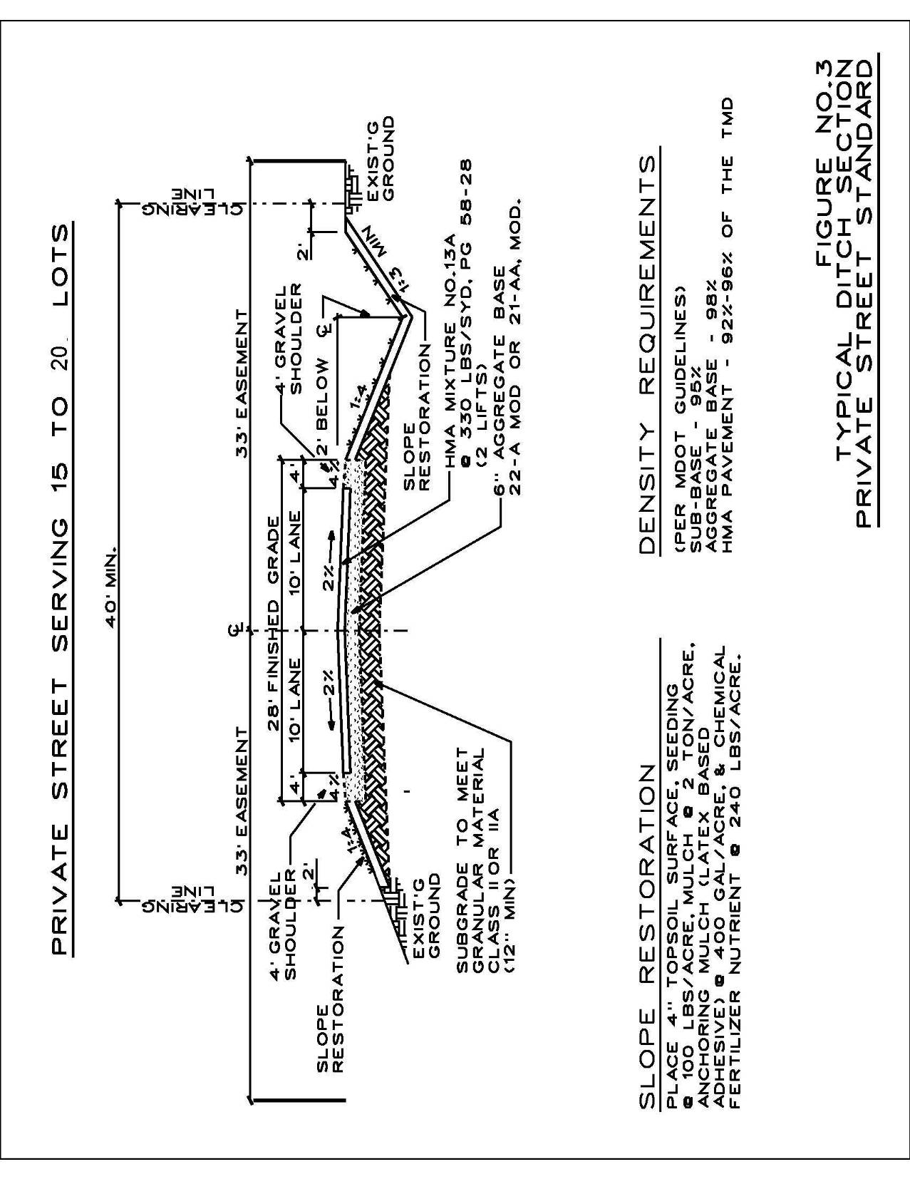

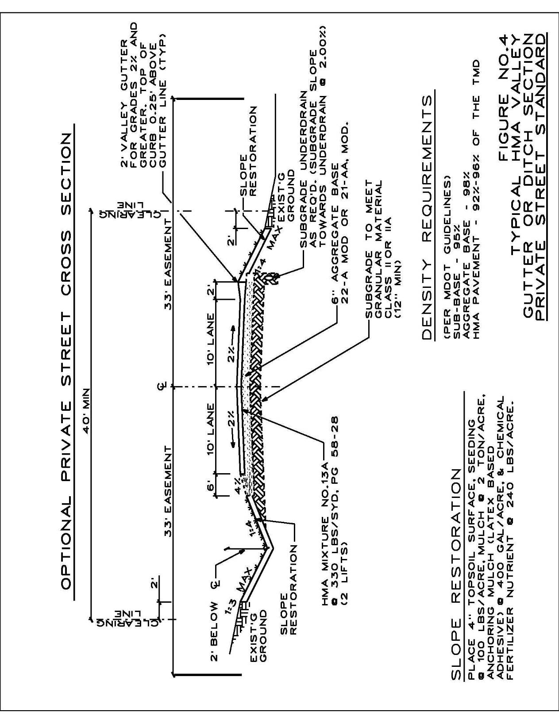

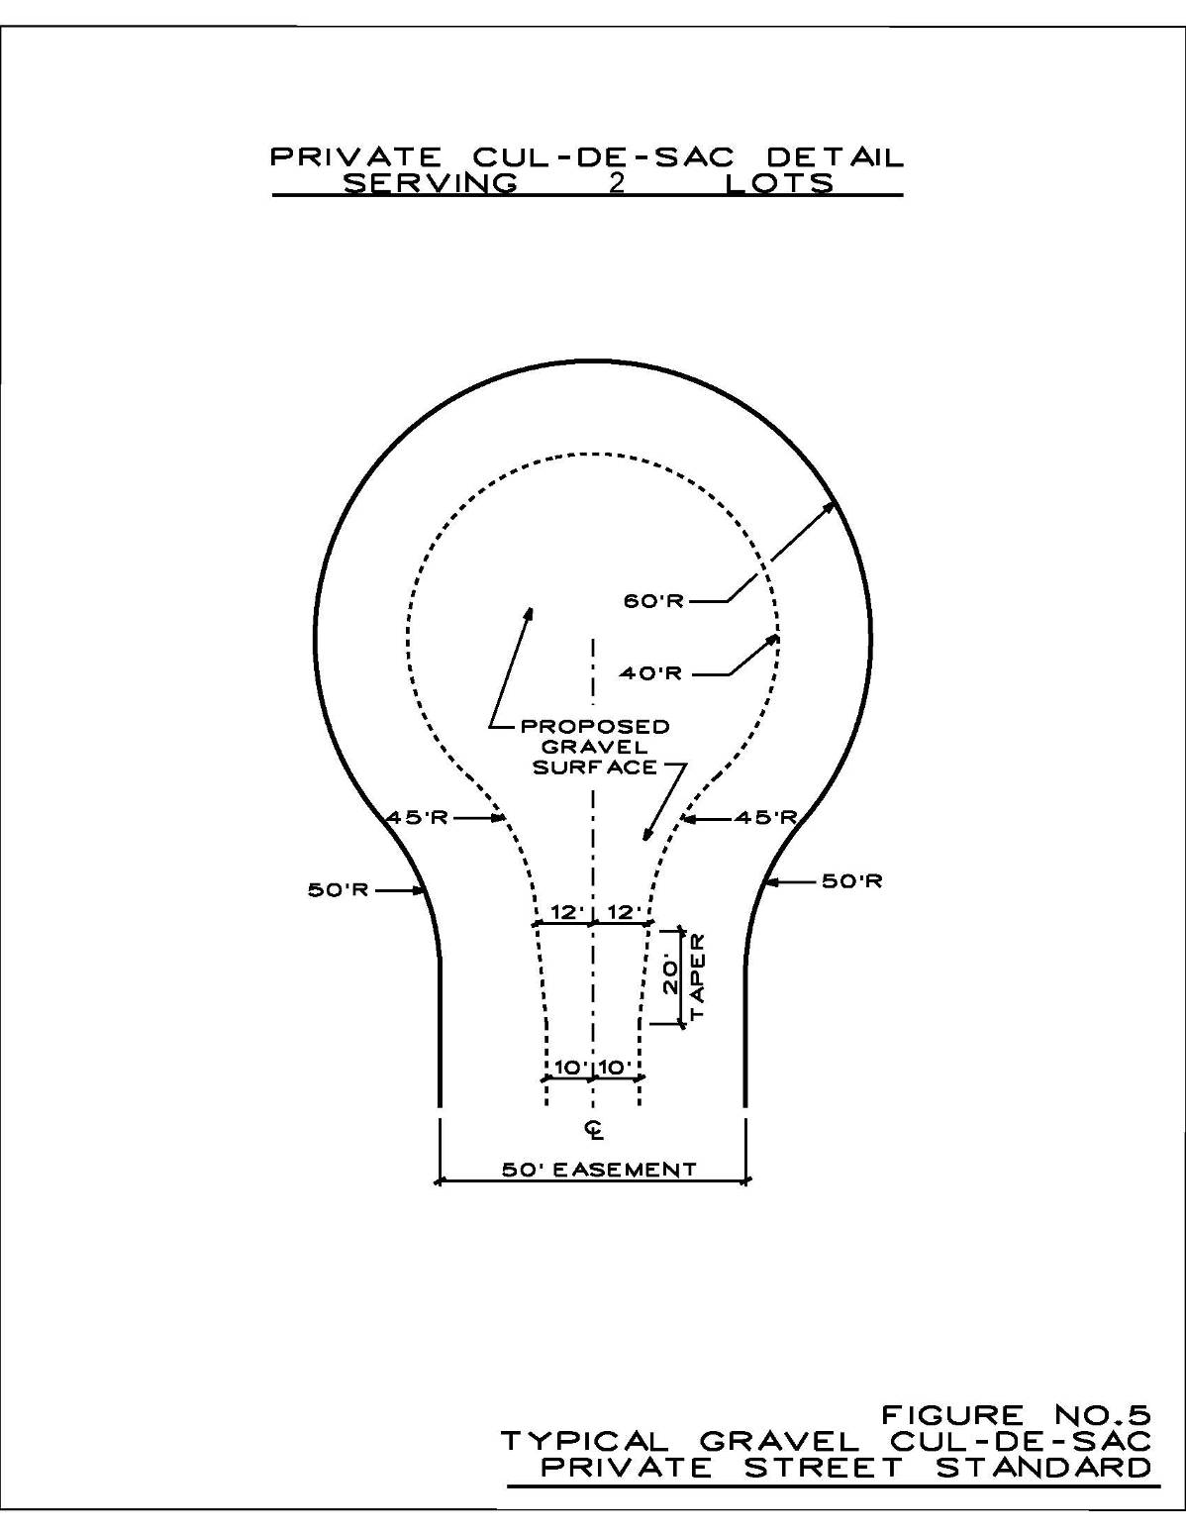
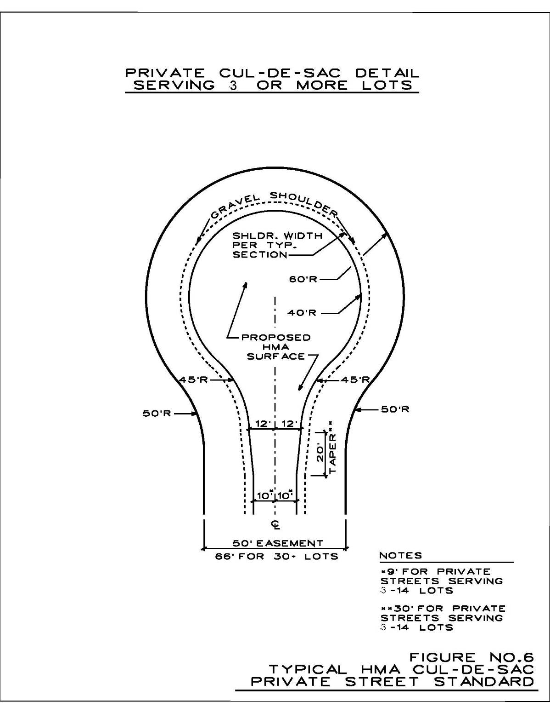
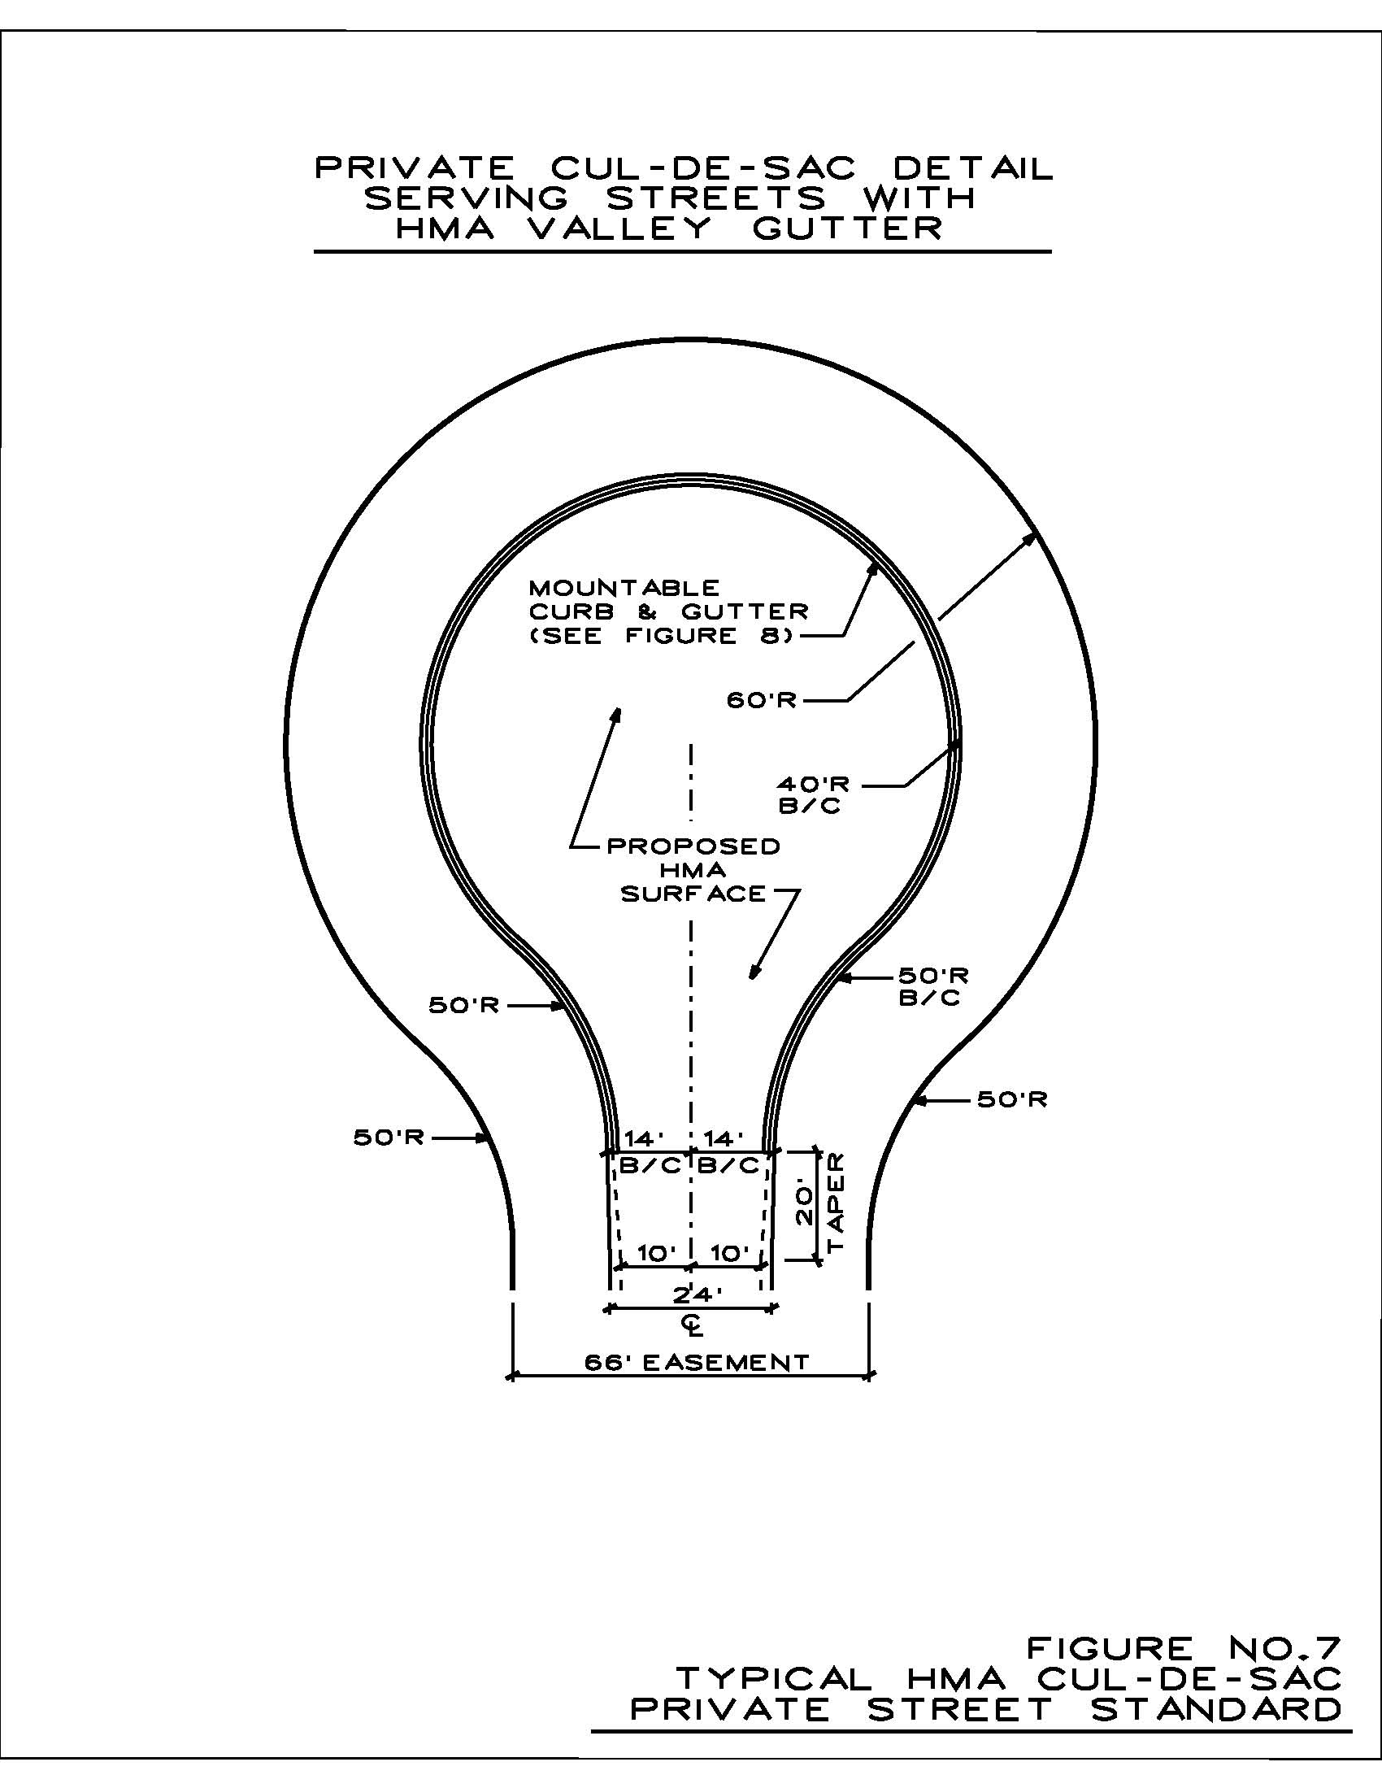

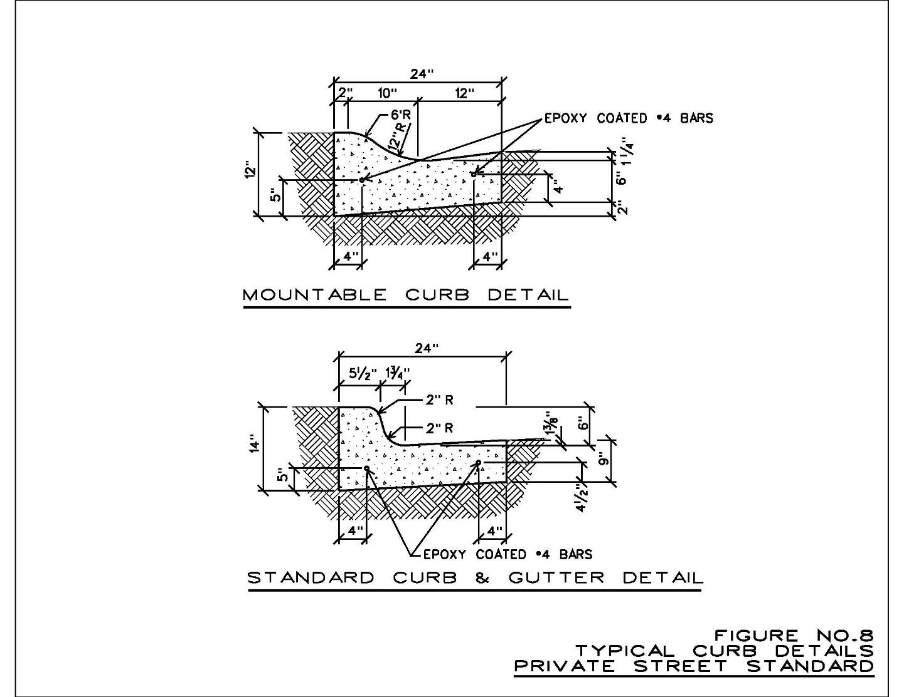

APPENDIX 2: SAMPLE PRIVATE STREET MAINTENANCE AGREEMENT

Agreement made ___________________________ by and between the following parties:

1.
2.

The above parties or their successors or assigns are collectively known as the “Parties”.

Whereas, the Parties own real estate with frontage on a private street known as
(“Private Street”), which provides access from the Parties’ parcels to a public street known as .

Whereas, the Private Street has been constructed or will be constructed in accordance with the Sullivan Township Zoning Ordinance concerning private streets, an engineering plan dated __________________________ and the conditions and requirements of site plan approval granted by Sullivan Township on ___________________________ (“Ordinance”).

Whereas, it is in the interest of the public health, safety and welfare of the residents of Sullivan Township that the Private Street be constructed and maintained in a safe and effective manner.

Whereas, the Parties wish to make certain agreements regarding the construction and maintenance of the Private Street and reduce all of their agreements to writing in this agreement.

Now, therefore, the Parties agree as follows:

1. All legal descriptions are for property located in Sullivan Township, Muskegon County, Michigan. The Private Street is described on attached Exhibit A. The Private Street serves the parcels described on attached Exhibit B (“Parcels”). The owners of the Parcels are also set forth on Exhibit B.

2. The Parties agree that all Parcels have a permanent non-exclusive easement to use the Private Street for ingress and egress to and from their respective Parcels. The easement also includes the right to construct (including reconstruction), maintain and repair utilities within the area of the Private Street. The easement across the Private Street shall also benefit any utility company or municipality providing utility services to Parcels and all emergency vehicles. The easement known as the Private Street shall benefit and run with all Parcels.

3. The Private Street has been constructed for use as a vehicular street and the Parties agree that it shall be maintained in accordance with the Ordinance. Said maintenance shall include all routine, emergency and long term maintenance, inspection, repair or replacement of the Private Street that may be required. It shall also include the implementation of necessary dust control practices and the elimination of any health, safety or nuisance conditions. It shall also include the removal of snow and ice. Each Party shall be responsible for an equal share of the cost of maintenance. When maintenance appears to be necessary, any Party may undertake such maintenance. The Parties grant to one another reasonable rights of passage over their respective Parcels for the purpose of performing maintenance on the Private Street. Each Party shall have the ability to contract for and initially pay all reasonable costs associated with maintenance, provided that such Party shall provide all other Parties with reasonable notice before undertaking the maintenance. All Parties shall work together to coordinate maintenance activities so as to make them as economical as possible. The Party incurring the expenses shall bill the other Parties for their share of the expense. The other Parties shall promptly pay their share of the expenses.

4. In the event that any Party causes any damage to the Private Street, or in the event that damage is caused by their guest or invitee, the Parties shall promptly repair the damage at their sole cost and expense. If a Party fails to promptly repair damage they caused or caused by their guest or invitee, another Party may make the necessary repairs and bill the responsible Party. The responsible Party shall promptly reimburse the Party making the repairs. If payment is not promptly made, the Party incurring the expenses may collect from the responsible Party according to the terms of this agreement.

5. If a Party fails to promptly pay any bill for expenses authorized by this agreement within 30 days after receipt, the amount due, together with interest at seven percent (7%), plus any expenses incurred to collect the amount due, including attorney fees, shall be a lien on the Parcel owned by the Party. Such lien shall be superior to all claims against the Parcel owned by the Party, except purchase money first mortgage and shall also be an enforceable personal obligation against the Party. The Party that is owed money may record a notice of a claim of lien against the responsible Party’s Parcel and thereafter pursue judicial action to foreclose the lien, subject only to a purchase money first mortgage, in a manner now or in the future permitted by law or equity with respect to mortgage liens. The proceeds received at a foreclosure sale shall be distributed first to pay the cost and expenses, interest and attorney fees incurred. The balance shall be applied to pay the lien being foreclosed upon and the surplus shall be distributed in accordance with the priorities established by law. An unpaid Party may, in addition to or instead of foreclosure, obtain a money judgment against the responsible Party.

6. The parties agree that Sullivan Township (“Township”) shall have the right to enforce the terms of this agreement against all Parties, jointly and severally. The Parties authorize the Township or its agents or employees to inspect, maintain, construct or reconstruct and otherwise enforce the terms of this agreement. The Parties acknowledge that the Township is not required to take any such action. The Township is authorized to enter any Parcel for the purpose of enforcing this agreement. The Parties agree to reimburse Township for any costs it incurs in enforcing the terms of this agreement, including any and all maintenance of the Private Street. Such costs shall include, but not be limited to, maintenance and repair costs, legal fees, engineering fees and any related costs and fees. Such costs shall be reimbursed within 30 days after the Parties are invoiced by Township.

As set forth in the Ordinance, any costs incurred by Township pursuant to this agreement shall be a lien on the Parcels and shall be enforceable in accordance with the procedures contained in Act No. 94 of the Public Acts of 1933, as amended from time to time. Any such charges that are delinquent for six months or more may be certified to the Township treasurer, who shall then enter the lien on the next tax roll against the Parcels and the costs shall be collected and the lien shall be enforced in the same manner as the collection of taxes assessed upon the tax roll and the enforcement of the lien for taxes. In addition to any other lawful enforcement action, Township shall have all other remedies authorized by Act No. 94 of the Public Acts of 1933, as amended.

7. The easement rights described in this agreement may not be further assigned by the Parties, except as an appurtenance to and in conjunction with the sale of their Parcel. In the event that an existing parcel is split such that there is more than one residence located thereon, each resulting parcel shall be considered a Parcel subject to the agreement and shall share equally any maintenance cost for the Private Street with the other Parties.

8. The Parties shall indemnify and hold Township harmless from any liability, loss, damage, injury or casualty to persons or property arising out of the Parties’ construction, maintenance or use of the Private Street. Notwithstanding the above, Township may, in its discretion, require a Party or Parties to post such bond or provide such other security as Township may request to assure adequate construction and maintenance of the Private Street and to other otherwise assure performance under this agreement.

9. This is the entire agreement between the Parties concerning the Private Street. Any amendments to this agreement shall be in writing and signed by the then current owner of each Parcel. This agreement shall be binding upon the Parties and their heirs, successors and assigns.

____________________________________

____________________________________

STATE OF MICHIGAN
County of Muskegon

Subscribed and sworn to before me on ____________________________________ by

_______________________________________________.

____________________________________
Notary Public
Muskegon County, MI
My Commission Expires: ______________

STATE OF MICHIGAN
County of Muskegon

Subscribed and sworn to before me on ___________________________________ by

______________________________________________.

____________________________________
Notary Public
Muskegon County, MI
My Commission Expires: ______________
Upon Recording Return To:
Sullivan Township
8138 Hts. Ravenna Road
Ravenna, MI 49451
EXHIBIT A
Private Street Legal Description

An easement for ingress and egress described as follows:

EXHIBIT B

Owner No. 1:

Owner No. 2:

All parcels are subject to the easement described in Exhibit A and other easements, restrictions and rights of way of record.

APPENDIX 3: INDEX OF ORDINANCE TEXT AMENDMENTS

Date | Section Number | Section Title | Summary
April 19, 2005 | Section 2.07 Section 3.11 | Fences | Created regulations for fences.
April 19, 2005 | Section 3.26 | Private Streets | Created regulations for private streets.
Oct. 4, 2005 | Section 3.08.G.1 | Accessory Building and Uses, Detached Accessory Buildings | Maximum total area for all detached accessory buildings added.
Oct. 4, 2005 | Section 7.04 | District Regulations | Dimensional requirements for the R-2 District changed.
March 7, 2007 | Section 2.05 | Definitions, Driveways | Defined "driveways" to distinguish from private streets.
March 7, 2007 | Section 2.19 | State Licensed Residential Care Facility | The definition of “State Licensed Residential Care Facility” is updated to reflect changes in the controlling public acts.
March 7, 2007 | Section 2.25 | Zoning Act Definition | The definition of “Zoning Act” is updated to reflect the revised Michigan Zoning and Enabling Act (MZEA).
March 7, 2007 | Section 3.22 | General Provisions: Home Occupations | Hours of operation limits for home occupations that are discernible from outside of the home have been added. Based on revised MZEA.
March 7, 2007 | Section 3.26 | General Provisions: Private Streets | Incorporated private street regulations into ordinance.
March 7, 2007 | Section 3.27 | General Provisions: Driveways | Created additional requirements for driveway.
March 7, 2007 | Section 4.03 | R-A Rural Residential/Agricultural District | Group day care facilities added special land uses.
March 7, 2007 | Section 5.03 | R-R Rural Residential District | Group day care facilities added special land uses.
March 7, 2007 | Section 9.02 | MHC Manufactured Home Community | State licensed residential care family facilities added to permitted uses.
March 7, 2007 | Section 13.02.D Section 13.02.E | Special Land Uses, Application and Review Procedures | Revised Special Land Use approval process. Must be approved by Township Board.
March 7, 2007 | Section 13.04.O | Special Land Use Specific Requirements | State group day care for children must be approved by special land use permit as required by MZEA.
March 7, 2007 | Section 14.03.A Section 14.03.B | Site Plan Review Requirements | Revised preliminary site plan requirements.
March 7, 2007 | Section 14.07. C | Site Plan Review, Changes in Approved Site Plan | Revised site plan fees.
March 7, 2007 | Section 16.02.A | Membership - Terms of Office | The member of the Township Board appointed to the Zoning Board of Appeals may not serve as the chair of the ZBA.
March 7, 2007 | Section 16.02.B | Membership - Terms of Office | An alternate on the Zoning Board of Appeals may be called in if a regular member will miss one or more meetings.
March 7, 2007 | Section 16.05.B | Applications and Hearings | Revised public notification standards, based on MZEA.
March 7, 2007 | Section 16.06.D | Decisions | Requires anyone aggrieved by the decision of the Zoning Board of Appeals to file in circuit court no more than 30 days after the ZBA certifies its decision in writing.
March 7, 2007 | Section 16.08 | Review Standards for Variance | Removed use variance process (formerly Section 16.08.B.).
March 7, 2007 | Section 17.06 | Administration and Enforcement, Remedies and Enforcement | Clarified, violation of zoning ordinance is violation of general law of ordinances of the Township.
March 7, 2007 | Section 17.08 Section 17.09 | Zone Changes and Amendments, Conditional Rezoning | Added enabling ordinance for conditional rezoning.
March 7, 2007 | Section 17.11 | Administration and Enforcement, Fees | Codifies the Township’s escrow fee policy for application review fees (formerly Section 17.09).
July 7, 2009 | Section 16.05.B | Zoning Board of Appeals, Applications and Hearings | Revised public hearing notice requirements.
July 7, 2009 | Section 16.06.C | Zoning Board of Appeals, Decisions | Inserts new requirements for appeals.
June 26, 2011 | Section 3.33 | Outdoor Wood Boilers | Establish guidelines and impose restrictions upon the construction and operation of outdoor wood boilers.
December 22, 2011 | Section 2.14 | Definitions, Medical Marihuana Dispensary | Medical marihuana dispensary definition added.
December 22, 2011 | Section 3.34 | Prohibition on Medical Marihuana Dispensaries | Prohibition on medical marihuana dispensaries.
September 20, 2012 | Section 2.19 | Solar energy collector | Add definition for solar energy collector.
September 20, 2012 | Section 2.23 | Wind Energy Conversion Systems | Add definition for Wind Energy Conversion System (WECS).
September 20, 2012 | Section 3.35 | General Provisions, Solar Energy | General requirements for solar energy collectors (formerly Section 3.33).
September 20, 2012 | Section 3.36 | General Provisions, Wind Energy | General requirements for wind energy conversion systems (WECS) (formerly Section 3.34).
September 20, 2012 | Section 4.02.L | R-A Rural Residential/Agricultural District | Building mounted solar energy collectors and on-site service wind energy conversion systems added to permitted uses .
September 20, 2012 | Section 4.03.L Section 4.03.M | R-A Rural Residential/Agricultural District | Commercial wind energy conversion systems and WECS testing facilities associated with a commercial WECS and Ground mounted solar energy collectors added to special land uses.
September 20, 2012 | Section 5.02.L Section 5.02.M | R-R Rural Residential District | Building mounted solar energy collectors and on-site service wind energy conversion systems added to permitted uses.
September 20, 2012 | Section 5.03.L Section 5.03.M | R-R Rural Residential District | Commercial wind energy conversion systems and WECS testing facilities associated with a commercial WECS and Ground mounted solar energy collectors added to special land uses.
September 20, 2012 | Section 6.02.N Section 6.02.O | R-1 Low Density Residential District | Building mounted solar energy collectors and on-site service wind energy conversion systems added to permitted uses.
September 20, 2012 | Section 6.03.K Section 6.03.L | R-1 Low Density Residential District | Commercial wind energy conversion systems and WECS testing facilities associated with a commercial WECS added to special land uses.
September 20, 2012 | Section 7.02.J Section 7.02.K | R-2 Medium Density Residential District | Building mounted solar energy collectors and on-site service wind energy conversion systems added to permitted uses.
September 20, 2012 | Section 7.03 | R-2 Medium Density Residential District | Commercial wind energy conversion systems and WECS testing facilities associated with a commercial WECS added to special land uses.
September 20, 2012 | Section 8.02.I Section 8.02.J. | R-3 High Density Residential District | Building mounted solar energy collectors and on-site service wind energy conversion systems added to permitted uses.
September 20, 2012 | Section 8.03 | R-3 High Density Residential District | Commercial wind energy conversion systems and WECS testing facilities associated with a commercial WECS added to special land uses.
September 20, 2012 | Section 9.02.G Section 9.02.H | R-4 Manufactured Home Park District | Building mounted solar energy collectors and on-site service wind energy conversion systems added to permitted uses.
September 20, 2012 | Section 10.02.H Section 10.02.I | NC Neighborhood Commercial District | Building mounted solar energy collectors and on-site service wind energy conversion added to permitted uses.
September 20, 2012 | Section 10.03 | NC Neighborhood Commercial District | Commercial wind energy conversion systems and WECS testing facilities associated with a commercial WECS added to special land uses.
September 20, 2012 | Section 11.02.G Section 11.02.H | SC Sullivan Corners District | Building mounted solar energy collectors and on-site service wind energy conversion systems added to permitted uses.
September 20, 2012 | Section 11.03 | SC Sullivan Corners District | Commercial wind energy conversion systems and WECS testing facilities associated with a commercial WECS added to special land uses.
September 20, 2012 | Section 12.02.M Section 12.02.N | LI Light Industrial District | Building mounted solar energy collectors and on-site service wind energy conversion added to permitted uses.
September 20, 2012 | Section 12.03.H Section 12.03.I | LI Light Industrial District | Commercial wind energy conversion systems and WECS testing facilities associated with a commercial WECS and ground mounted solar energy added to special land uses.
September 20, 2012 | Section 13.04.KK | Special Land Use Requirements | Establishes special land use standards for ground mounted solar energy collectors.
September 20, 2012 | Section 13.04.LL | Special Land Use Requirements | Establishes special land use standards for commercial wind energy conversion systems (WECS) and WECS testing facilities associated with a commercial WECS.
June 16, 2016 | Section 2.19 | Definitions | Added definitions for “Seasonal Worker Camp” and “Seasonal Worker Camp Operator.”
June 16, 2016 | Section 4.03.N | Special Land Uses | Added “Seasonal worker camps” to list of special land uses.
June 16, 2016 | Section 13.04.MM | Special Land Use Specific Requirements | Establishes special land use standards for seasonal worker camps.
June 16, 2016 | Section 15.03 | Parking Lot Requirements | Temporary and overflow parking requirements included for special events.
August 20, 2017 | Section 2.02 | Definitions | Added definitions for “Agricultural Labor Camps” and “Agricultural Labor Camp Operator.”
August 20, 2017 | Section 4.03.N | Special Land Uses | Added “Agricultural labor camp” to list of special land uses; replaced “seasonal worker camps.”
August 20, 2017 | Section 13.04MM | Special Land Use Specific Requirements | Establishes special land use standards for agricultural labor camps; replaced standards for “seasonal worker camps.”
November 8, 2018 | Section 13.04 AA.4 | Commercial Wireless Telecommunications | Clarified that the intent of the setbacks in Section 13.04 AA.4 is to apply to antennas and towers, not associated buildings and equipment.
November 8, 2018 | Section 3.27 | Driveways Serving One Lot or Dwelling Unit | Revised driveway requirements based on Fire Department input.
Amended October 1, 2019, Effective October 21, 2019 | Section 3.34 | Medical Marihuana Facilities and Recreational Marihuana Establishments Prohibited | Amendment to prohibit medical marihuana facilities and recreational marihuana establishments within Sullivan Township.
Amended July 14, 2020, Effective July 23, 2020 | Section 2.08 | Definitions- G | Amends Section 2.08 Definitions- G to include a revised definition of garage, detached.
Amended July 14, 2020, Effective July 23, 2020 | Section 3.08 | Accessory Buildings and Uses | Amends Section 3.08 Accessory Buildings and Uses to allow for larger and taller accessory buildings and detached garages, Planning Commission authority to allow oversized accessory buildings, and specified exemptions and restrictions in paragraphs G and H.
Amended July 14, 2020, Effective July 23, 2020 | Section 3.26 C | Private Streets | Amends Section 3.26 C.1.a to clarify road surface requirements.
Amended July 14, 2020, Effective July 23, 2020 | Section 3.26 C and G | Private Streets | Amends Sections 3.26 C.1.a, 3.26 C 2.c, 3.26 C 2.i, and 3.26 G 1.g to correct section reference errors.
Amended July 14, 2020, Effective July 23, 2020 | Appendix 1 | Appendix 1 | Amends Appendix 1 to re-insert figure 1, a cross-section for private streets serving two lots.

APPENDIX 4: PLANNING COMMISSION BY-LAWS

APPENDIX 5: ZONING MAP

APPENDIX 6: TOWNSHIP CHARGES & FEES

APPENDIX 7: PLANNING COMMISSION APPLICATION FORMS

APPENDIX 8: TOWNSHIP COMPLAINT FORMS

APPENDIX 9: TOWNSHIP GENERAL ORDINANCE LAWS

Appendices are provided for illustrative purposes and is not part of the Sullivan Township Zoning Ordinance. Please refer to the appropriate sections of the Zoning Ordinance for specific requirements.

